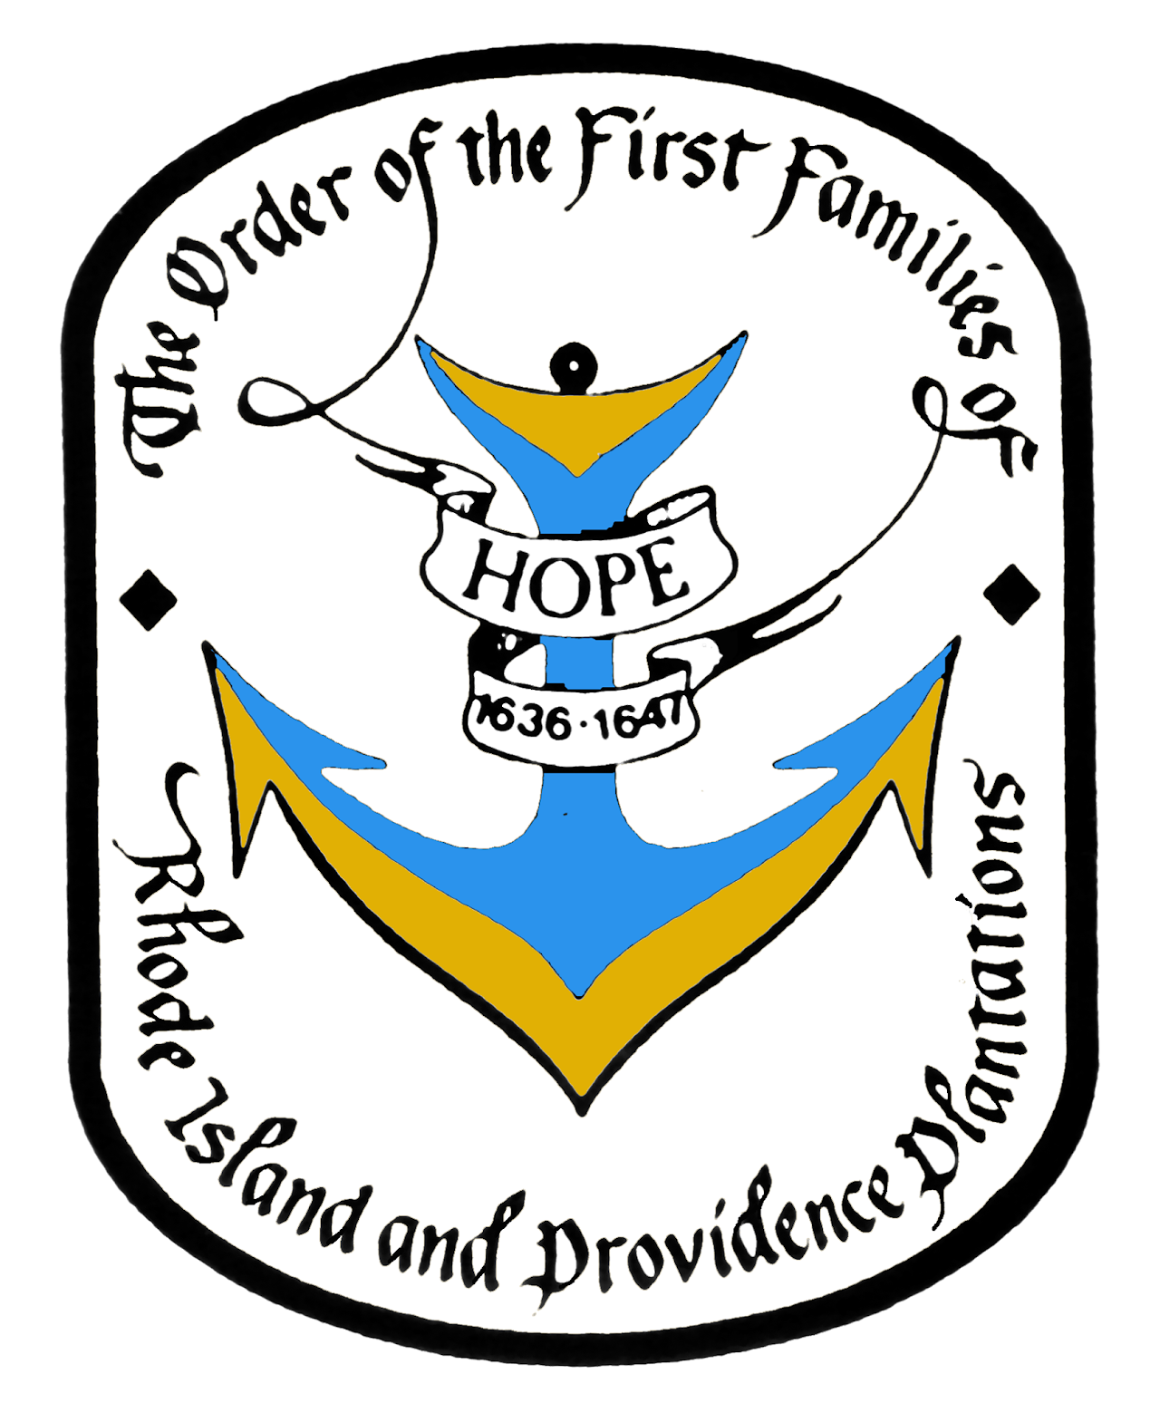

Order of the First Families of Rhode Island and Providence Plantations
Men and women, age 18 and older, who can prove lineal descent from an ancestor who was resident on land presently a part of the State of Rhode Island and the Providence Plantations prior to January 1, 1647/8, may be eligible for membership.

