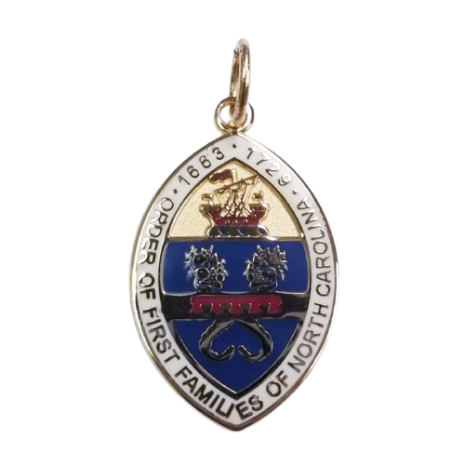

Order of First Families of North Carolina

The Order of First Families of North Carolina is composed of, and limited to, individuals lineally descended from a person who was a resident/colonist on or before the 12th day of July, Anno Domini, 1729, in that part of the PROVINCE OF CAROLINA which later became the STATE OF NORTH CAROLINA.

