Resources
Saint Michaels, Maryland - Wikipedia
The Best 10 Restaurants Near Saint Michaels Historic District | OpenTable
St. Michaels MD Visitor Information - St. Michaels Tourism, MD
Talbot County, Maryland Genealogy • FamilySearch
https://www.stmichaelsmuseum.org/

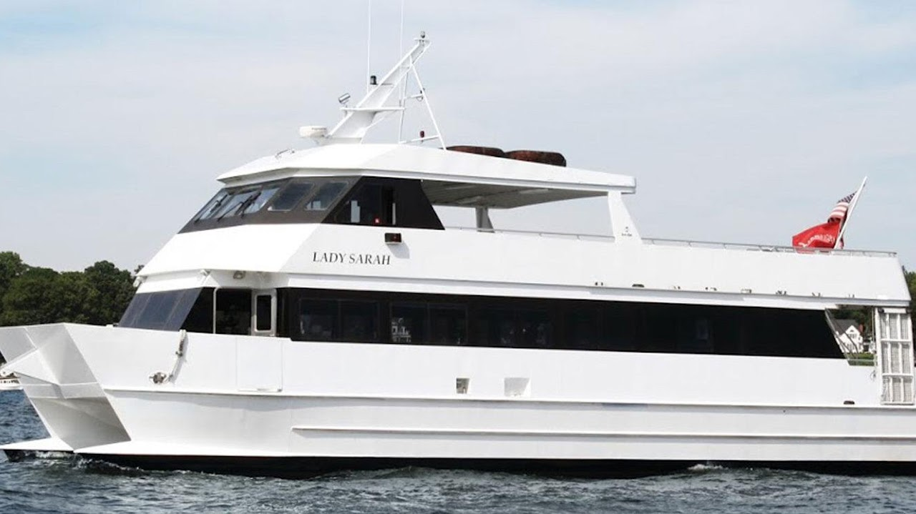

Day Cruise
Cruise across the Chesapeake Bay to St. Michaels on the Eastern Shore, and enjoy one complimentary non-alcoholic beverage on the way there! This quaint historic village offers fresh seafood, boutique shopping, and historic sites all within walking distance during your approximately 3 hours ashore, followed by the return cruise to Annapolis. Admission to the Chesapeake Bay Maritime Museum is included.
Price: $118/Adult $45/Child
10 AM - 5:30 PM
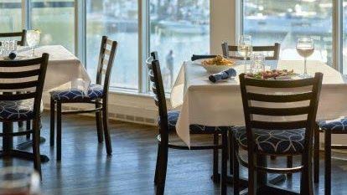

Harbour Inn, Marina & Spa
Call (410) 745-9001 Ext 3 for more info.
101 N Harbor Rd St. Michaels, MD 21663 rooms@harbourinn.com
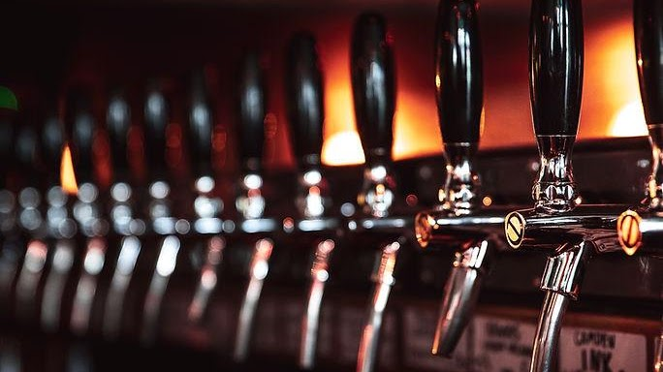

Talbot Tavern
Address: 209 S. Talbot St, Saint Michaels, MD 21663
Email: info@talbotsttavern.com
Phone: (410) 745-8005
Monday - Wednesday: 12pm - 11pm
Thursday: 12pm - 12am
​​Friday - Saturday: 12pm - 1am
Sunday: 12pm - 12am
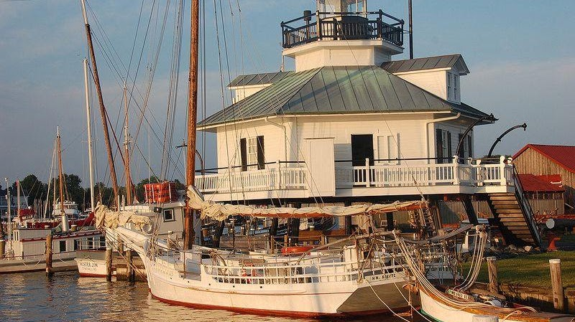

1879 Hooper Strait Lighthouse
213 N Talbot St Chesapeake Bay Maritime Museum, St Michaels, MD 21663
(410) 745-2916

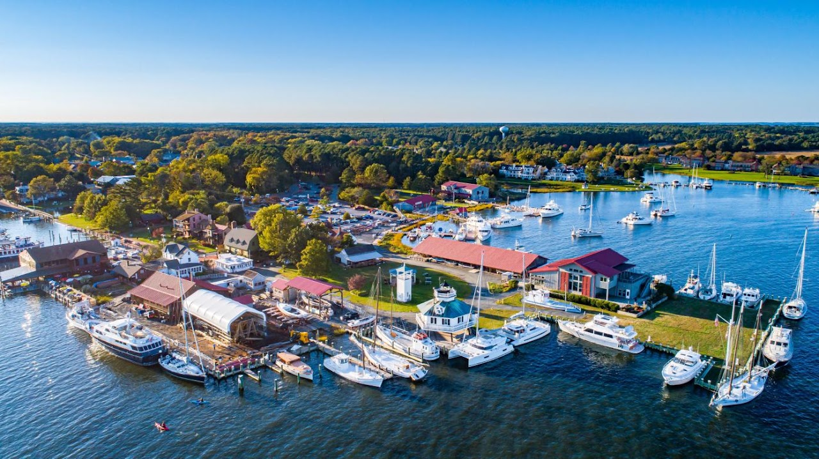

Chesapeake Bay Maritime Museum

213 North Talbot Street St. Michaels, Maryland, 21663
410-745-2916
havefun@cbmm.org
Water Taxi
410-819-9606

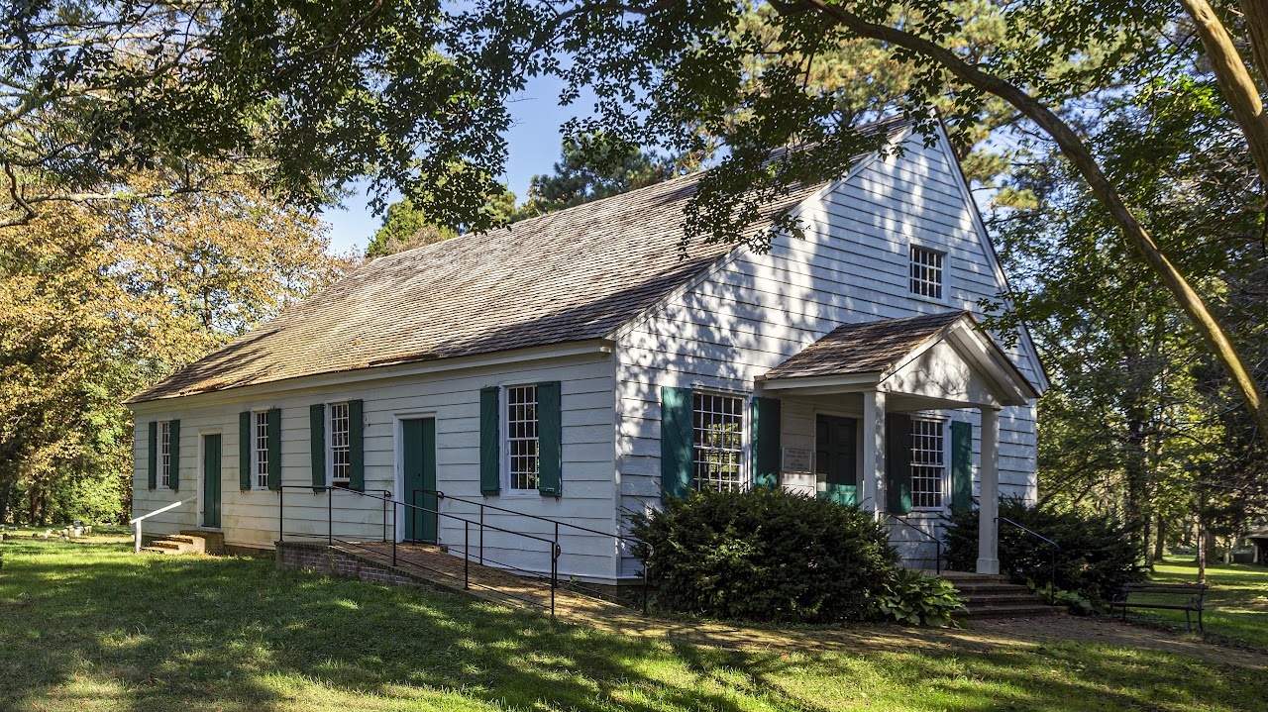

Third Haven Friends Meeting
405 S. Washington St., Easton, MD 21601; (410) 822-0293; 3rdhaven@gmail.com
George Fox, the founder of the Religious Society of Friends (Quakers), visited this vicinity in 1673 and upon his return to England sent a number of books to this Meeting. This was the beginning of the Meeting's library, often said to be the earliest public library in Talbot County and probably in the province (being established long before the Bishop of London, through Commissary Bray, introduced parochial libraries in this province).

