

Lincoln Fellowship of Pennsylvania

GETTYSBURG COLLEGE’S MAJESTIC THEATER, 25 Carlisle Street, Gettysburg, PA.
Susan Eisenhower, J’Nai Bridges, Graham Sibley, Harold Holzer, and Doris Kearns Goodwin to appear at Dedication Day Events in Gettysburg Sunday, Nov 19. (Gettysburg, PA)
The Lincoln Fellowship of Pennsylvania is honored to invite the public to the Majestic Theater on November 19th, 2023 for a special Dedication Day ceremony commemorating the 60th anniversary of the historic 1963 ceremony that marked the centennial of Lincoln’s Gettysburg Address. The venue change is due to a potential U. S. government shutdown. The Majestic Theater is located at 25 Carlisle St., Gettysburg; doors will open to the public at 9:30 a.m. The ceremony is free, however seats are limited, no tickets required. NO FIREARMS OR WEAPONS OF ANY KIND, REPLICA OR NOT, WILL BE ALLOWED IN THE THEATER.
Parking for the event can be found in Race Horse Alley Parking Garage immediately behind the theater, and limited street parking at parking meters on surrounding streets. Please be prepared to wait outdoors prior to entrance to the theater. For more information, visit www.lincolnfellowship.org.

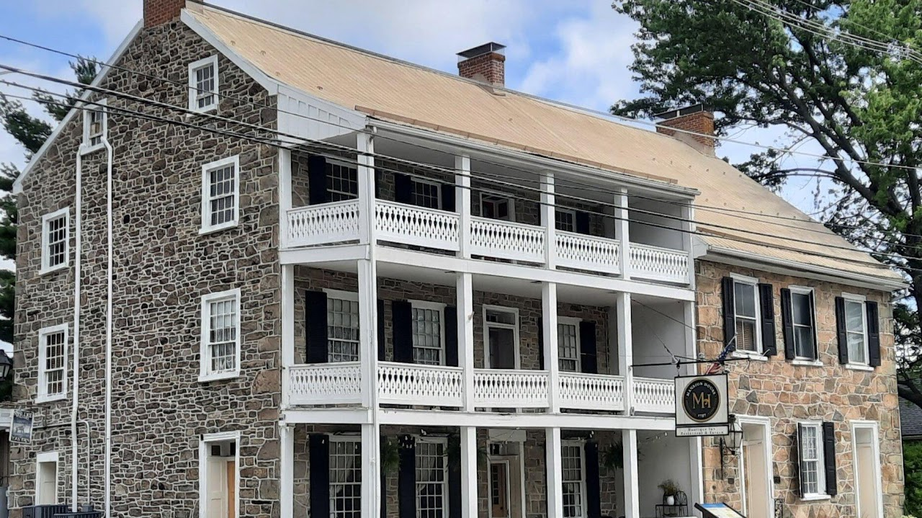

Mansion House 1757

Oldest Pub in Pennsylvania, Served General Robert E. Lee after the Battle of Gettysburg
Address: 15 W Main St, Fairfield, PA 17320
Phone: (717) 642-5410

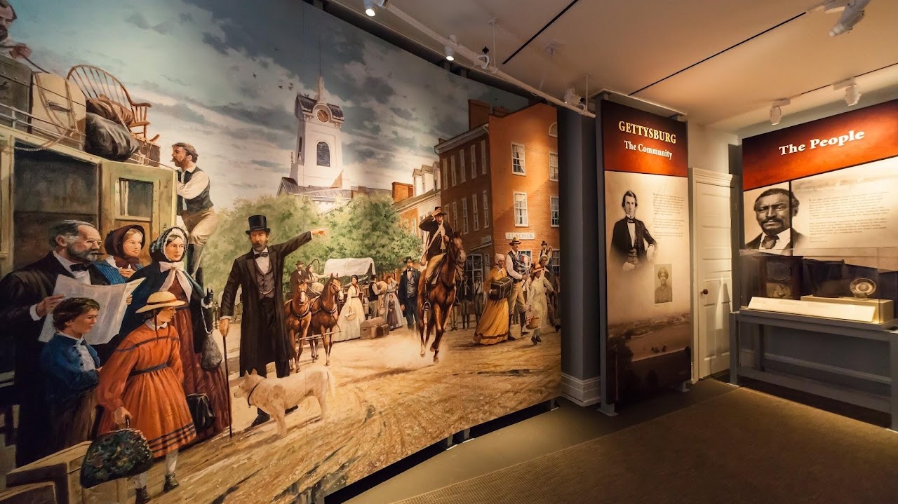

Seminary Ridge Museum

Gettysburg Address 160th Anniversary on the Ridge - Indoor Presentation 3:30 PM 4:30 PM
717-339-1300
info@seminaryridgemuseum.org
111 Seminary Ridge Gettysburg, PA 17325



Gettysburg Heritage Center

297 Steinwehr Ave. Gettysburg, PA 17325
Sunday - Thursday, 9am - 5pm
Friday & Saturday, 9am - 5pm
717-334-6245
info@GettysburgMuseum.com

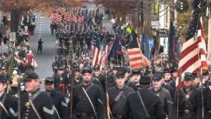

Remembrance Day Parade

Third Saturday in November at 1 PM
Join in honoring the soldiers and civilians of the American Civil War in this special annual parade. The parade lines up on Middle Street, proceeds to Baltimore Street and then turns onto Steinwehr Avenue. The annual event is sponsored by the Sons of Veterans Reserve, the Military Department of the Sons of the Union Veterans of the Civil War. Check out Facebook Page. For further information contact Major David Hann, Provost Marshal SVR. Cell 609-816-2012 or majorsvrprovost@gmail.com. Also see Gettysburg Community page; destination Gettysburg;

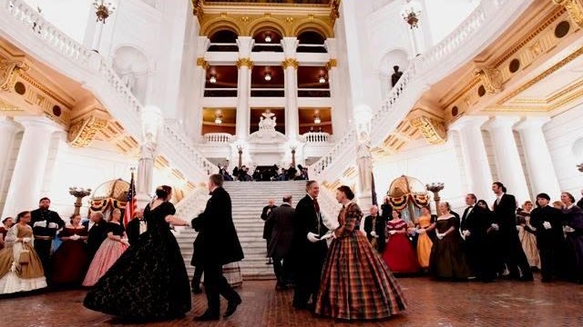

National Civil War Ball

Cap off a day of ceremonies by attending the original and official ball of Remembrance Day. Members of Civil War hereditary groups, both Union and Confederate, all military and civilian re-enactors, and supporters of Civil War preservation are welcome to join in the festivities. Period dress is encouraged by not required. However, proper attire is requested. Authentic Civil War music is played by the Philadelphia Brigade Band. Dancing is led by the Victorian Dance Ensemble. No dance experience is required. All dances are demonstrated and friendly instructors are on the floor to assist dancers. Make check payable to ” SVR Ball” and mail in advance to: Col. Steve Michaels, SVR, 6623 S. North Cape Rd., Franklin, WI 53132. Call 414-712-4655 or email lt.col.sm@gmail.com. Include your email and self-addressed stamped envelope with your check.

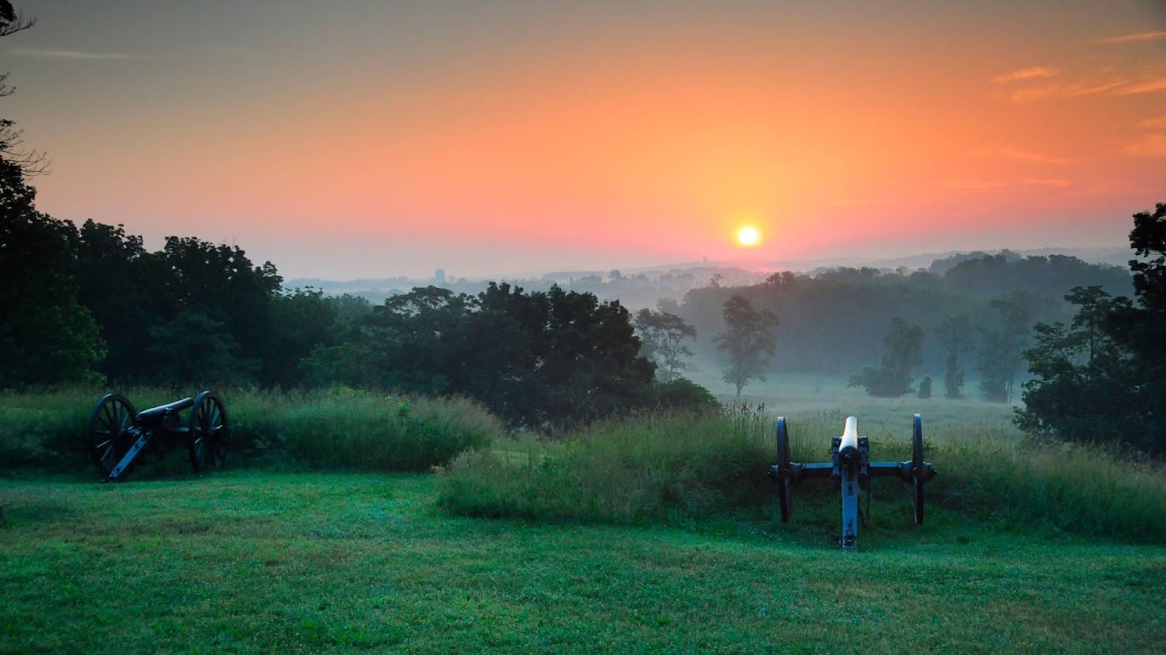

Gettysburg National Park

Nearly a million visitors a year come to Gettysburg National Military Park, where battlefields and memorials cover some 6,000 acres of rolling land just five miles north of the Mason-Dixon line. The site of one of the most consequential battles and most influential speeches in American history, Gettysburg shaped the country as we see it today.

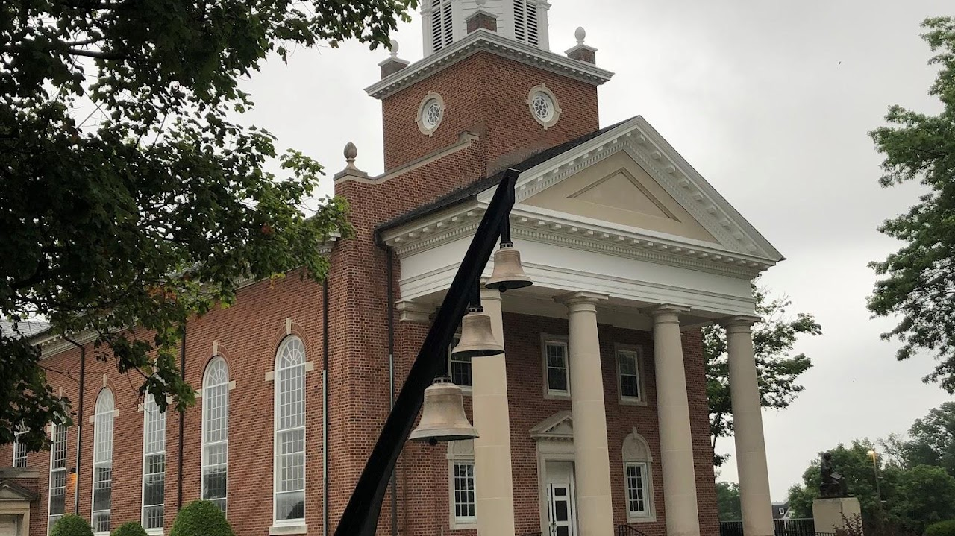

Lutheran Seminary & Church

Church of the Abiding Presence, Gettysburg campus
Divine Service Sunday Morning
https://goo.gl/maps/xK3Yaj61g39AAbZL8
The seminary was the oldest continuing Lutheran seminary in the United States!

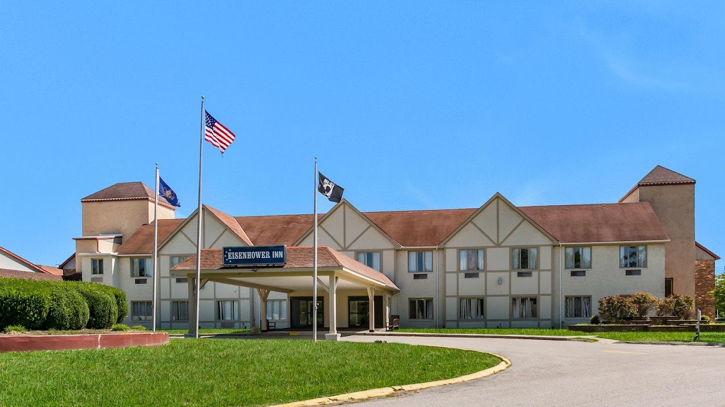

Eisenhower Hotel & Conference Center

EISENHOWER HOTEL & CONFERENCE CENTER
2634 EMMITSBURG ROAD, GETTYSBURG, PENNSYLVANIA 17325, UNITED STATES
PHONE #717-334-8121 | SALES@EISENHOWERCOMPLEX.COM

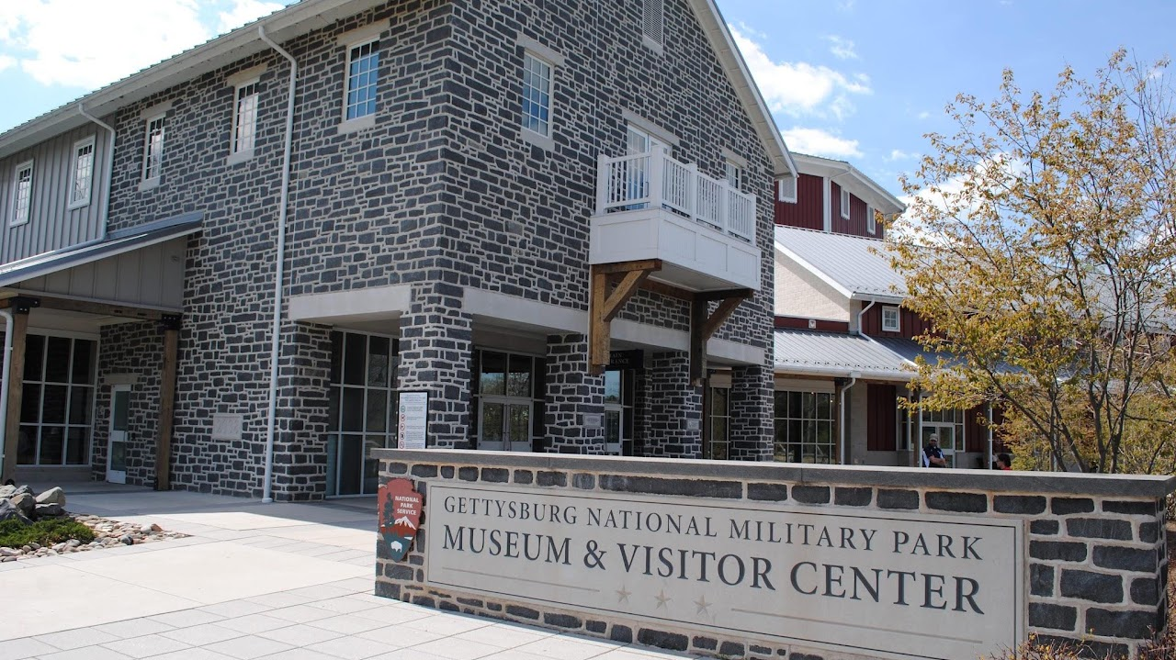

Visitor Center

1195 Baltimore Pike Gettysburg, PA 17325 717-334-2436 877-874-2478
Gettysburg offers a lot to do for everyone. Check out our suggested itineraries, tailored for different interests and time allotted:
Quick Raid (Half Day)
First-Time Visitor - 2 Day
First-Time Visitor - 1 Day
Returning Visitor - 1 Day
Returning Visitor - 2 Day
Paths of Presidents
Full Campaign

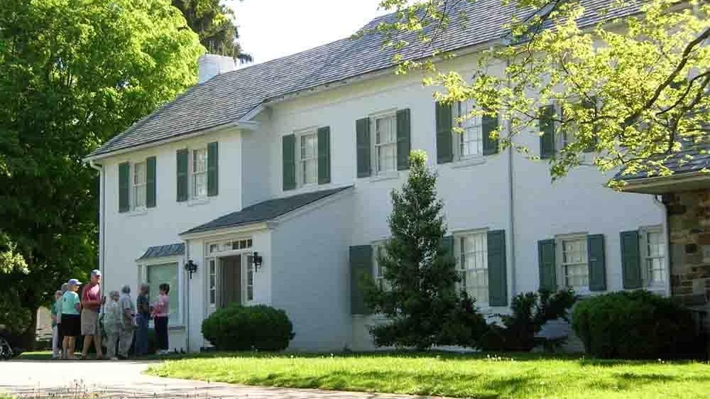

Eisenhower National Historic Site

The home and farm of our 34th President, the Eisenhower National Historic Site provides a warm and personal look at the home life of Dwight and Mamie Eisenhower.
Renovated in the early 1950s, the home served as a weekend getaway for the President and a meeting place for world leaders. Retiring to the farm in 1961, the Eisenhowers gifted the property to the federal government in 1967. The farm was designated as a National Historic Site in 1969.
Today, the site offers hospitality to guests through Ranger talks and self-guided tours of the home (when open seasonally) and property including its gardens, teahouse, skeet range, putting green and Angus cattle barns.

