Resources
Discover Lancaster | Pennsylvania Dutch Country | Amish Attractions, Shopping, Dining
Lancaster County, Pennsylvania - Wikipedia
Lancaster County, Pennsylvania Genealogy • FamilySearch
Lancaster County – Genealogical Society of Pennsylvania
Visiting the Archives | Lancaster County, PA - Official Website
Lancaster County PAGenWeb - Resources
Events Archive - LancasterHistory
Map

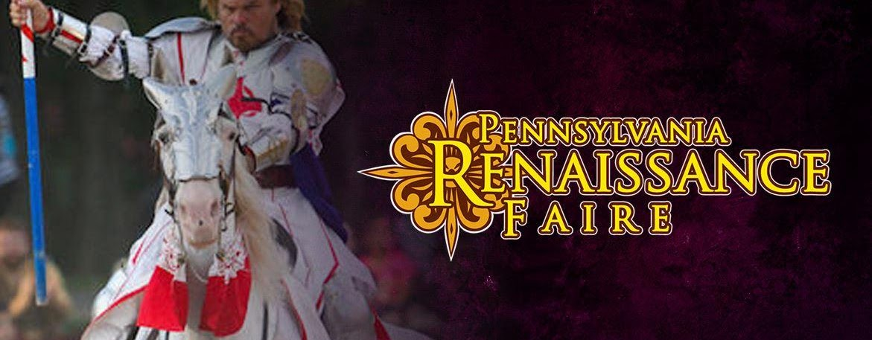

Renaissance Faire

Gates Open at 11AM Each Public Faire Date • Faire site closes at 8PM. Merchants, food and beverages begin closing at 7PM. Ticket Pricing for August 19 till last weekend in October. General Admission: $32.95 Children (5-11): $16.95 Children 4 and Under Free, No Ticket Required
After 4PM Sunset Ticket Pricing for August 19 - till last weekend in October. Tickets go on sale the day of at 3 PM. General Admission: $19.95 Children (5-11): $7.95 Children 4 and Under Free, No Ticket Required
Location: 2775 Lebanon Rd. Manheim, PA 17545
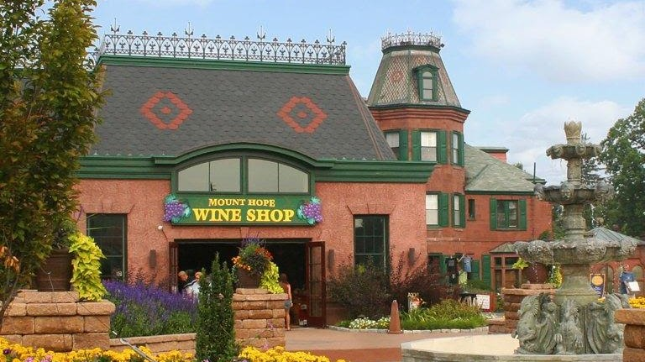

Mount Hope
PA’s original winery, brewery, cidery and distillery is the premiere destination for all who appreciate hand-crafted beverages, food and historic properties. Craft Memories at Mount Hope.
WED-SUN: 11AM-6PM *Plus Extended Hours During Events*
2775 Lebanon Road Manheim, PA 17545
717.665.7021
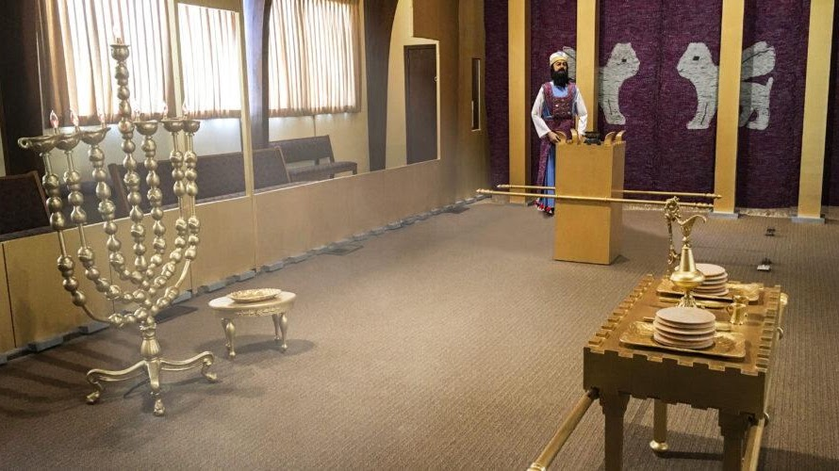

Lancaster Mennonite Historical Society
Our friendly team will help you find experiences that meet your curiosity about Mennonites. The Visitors Center also hosts our Biblical Tabernacle experience. Your visit to what was formerly known as Lancaster Mennonite Historical Society and the Mennonite Information Center starts here.
215 Millstream Road, Lancaster, PA 17602-1499 United States T:717-393-9745

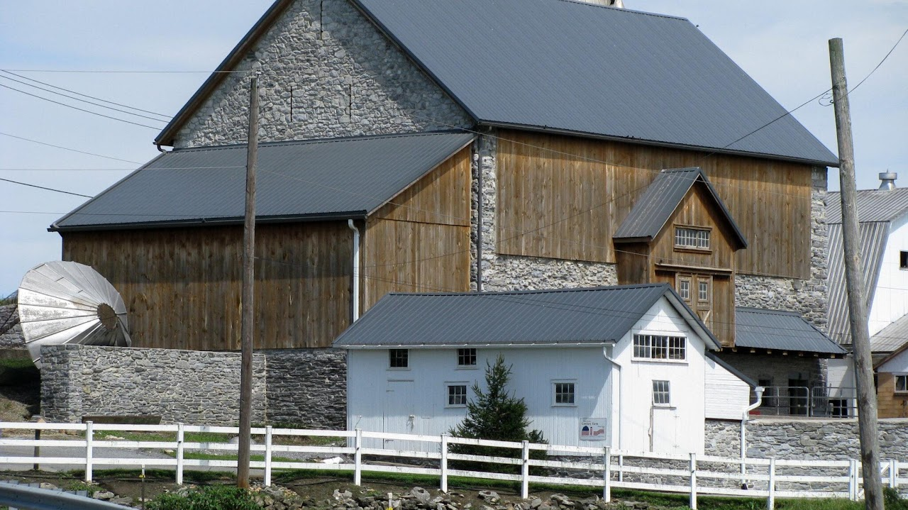

Mennonite Guest Homes

Take your Lancaster County Mennonite experience to the next level by staying with Mennonites eager to host you and make your stay all you’d hoped it would be.
Contact guest homes directly to arrange a stay.
This list is for your convenience; Mennonite Life appreciates these small business Mennonite hosts but makes no specific endorsements regarding their services.

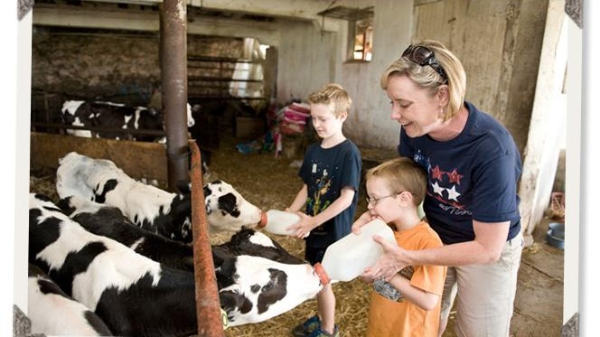

Verdant View Farm

Operated by 4th generation farmers at Verdant View Farm, the educational tours are suitable for adults and children. Join a guided tour and/or learn a new skill in a farm workshop. TOURS OFFERED MON-SAT DURING THE SUMMER MONTHS.
429 Strasburg Rd. Paradise, PA 17562
717-687-7353 reservations@verdantview.com


Sight & Sound Theatre
Growing up on a dairy farm in rural Lancaster County, our founder Glenn Eshelman was so inspired by the beauty of the world around him that he began painting landscapes as a boy. As he grew up, Glenn continued to pursue his artistic interests, eventually buying a camera to take reference photos for his paintings. Photography quickly became his passion. After marrying his wife, Shirley, Glenn sold his artwork out of the trunk of his car to make ends meet. But in 1964, his side show became the main act. After presenting his scenic photography at a local church using a slide projector, a turntable for musical underscore and a microphone for narration, the audience response was overwhelming. This first unofficial “Sight & Sound” show became a humble success.
300 Hartman Bridge Road Ronks, PA 17572

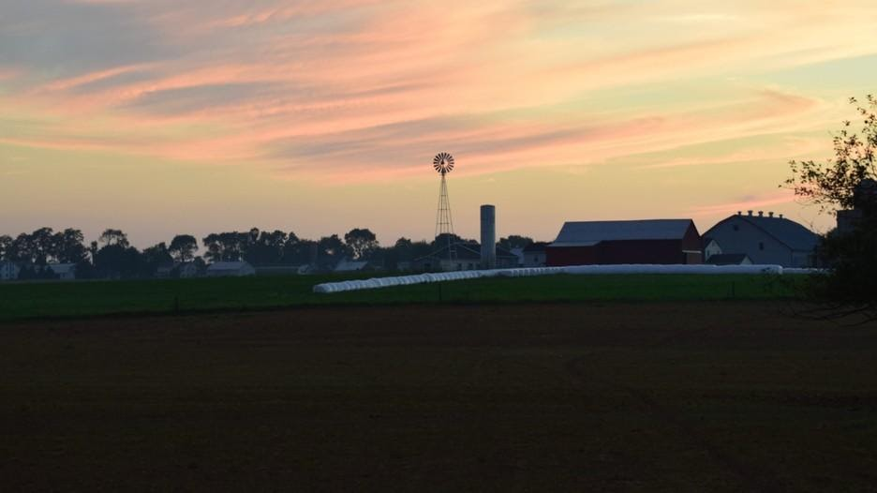

Sunset Dinner Tours
The experience starts with a visit to see the animals on our 15-acre farm and a house tour through our historic 1805 farmhouse. Then you’ll board our small bus at 5:00pm and meander the back roads of Amish country. Along the way, you’ll pass beautiful Amish homes, farms, and schools. We’ll stop at our Amish friend’s house where you’ll enjoy a traditional Amish dinner in their home which is surrounded by miles of countryside. As the evening winds down, enjoy traditional desserts and engaging conversation with the Amish family.
Please Note: If you would like to take the house tour, please arrive by 3:45pm.
Due to the unique nature of this tour, pets are not permitted on the Sunset Dinner Tour. Pets are welcome on all of our other tour options.
Unfortunately, this tour is not handicap accessible. We apologize for any inconvenience.
To learn more, visit our Sunset Dinner Tour Page.

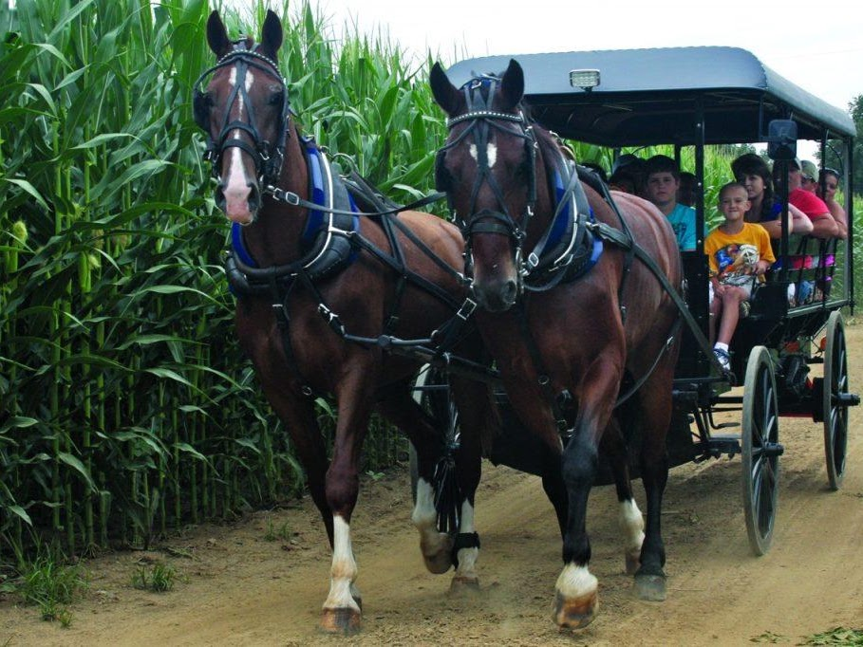

AAA Buggy Rides​
Monday – Saturday 9:00AM – 5:00PM
3461 Old Philadelphia Pike Ronks, PA 17572
(Directions)
Phone: (717) 989-2829
Email: info@aaabuggyrides.com

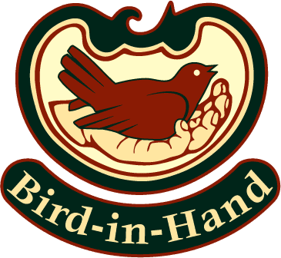

Bird-in-Hand
If you crave Amish fare, home cooking, Dutch comfort food, farm-fresh goodness, and friendly service, the Bird-in-Hand Family Restaurant & Smorgasbord in Lancaster County, Pennsylvania, will satisfy your appetite. Sample your favorite scratch-made dishes and classic recipes from our all-you-can-eat family buffet. Visit our sumptuous soup-and-salad bar – and be sure to save room for our dessert buffet. Prefer menu dining and table service instead of the Amish-style buffet? Select made-to-order dishes from our varied menu. It offers something for everyone.
- 2760 Old Philadelphia Pike Bird-in-Hand, PA 17505
- (717) 768-1500 SmuckerFamily@Bird-in-Hand.com

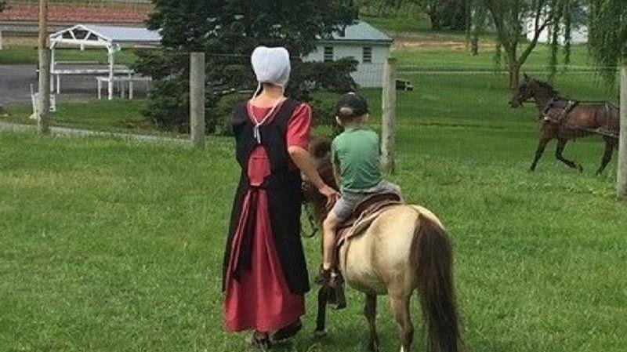

Miniature horse Farm
Free Admission
Monday thru Saturday from 9:00am till 5:00pm
264 Paradise Ln. Ronks PA 17572
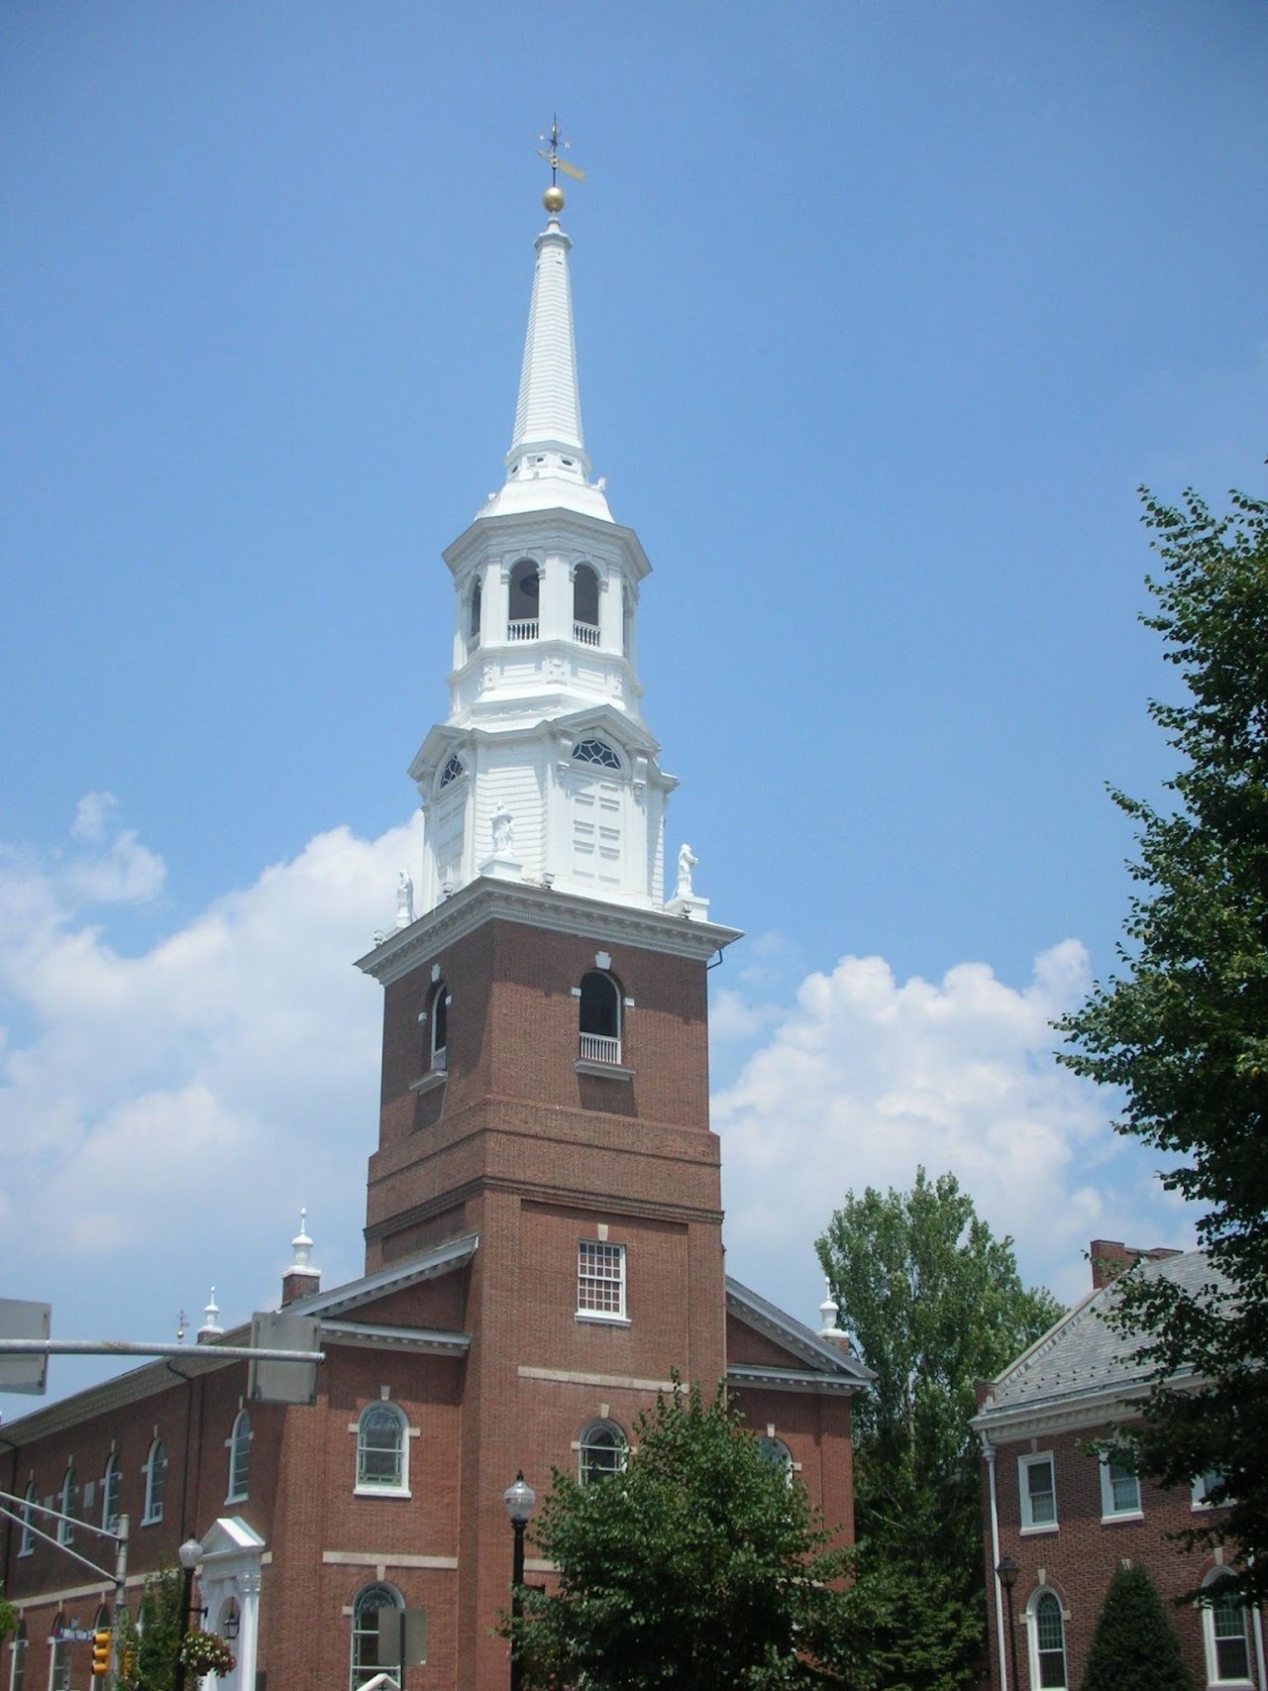
Holy Trinity Lutheran Church
Holy Trinity Lutheran Church is an historic, American Lutheran church that is located at 31 South Duke Street in Lancaster, Pennsylvania. It is one of the oldest churches in the commonwealth. The remains of both Thomas Mifflin and Thomas Wharton were interred at the Holy Trinity Lutheran Church cemetery.
The Sunday Morning Breakfast Fellowship begins with coffee and conversation at 7:00 a.m in The Fondersmith Auditorium. At 7:45am we serve a hot breakfast and at 8:15am, an informal worship service is offered with communion once per month. This weekly ministry wraps up by 8:45. All are invited.
9:30am Worship | 10:30am Fellowship | 10:45am Learning for All Ages
Communion is celebrated on 1st Sundays of the Month and Festivals
31 South Duke Street Lancaster, PA 17602
717-397-2734

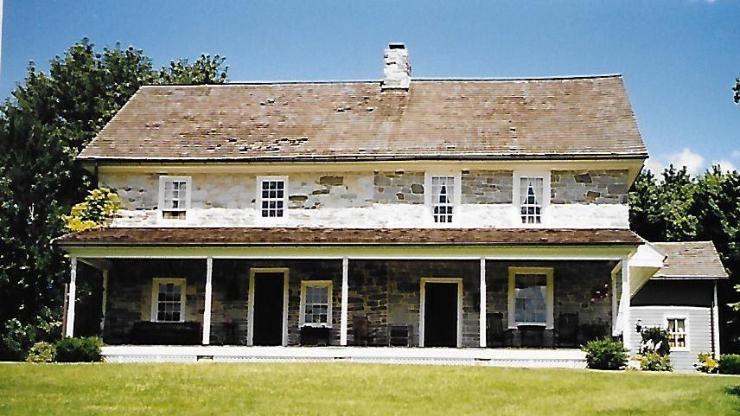
Philip Ferree Stone House
Philip and Leah Ferree Stone House,; in the back of the house is Ferree House Antiques
290 Old Leacock Road, Paradise, Lancaster County, Pennsylvania

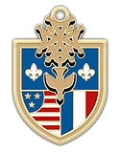

Huguenot Society of Pennsylvania
In 1918 in Reading, Pennsylvania, approximately ten men and women of known Huguenot descent founded The Huguenot Society of Pennsylvania, one of the first societies for the descendants of Huguenots established in the United States. They settled on April 13, 1918 (the 320th anniversary of the Edict of Nantes) for their first official meeting, and set out to write a charter, find interested members, and decide upon the organization's structure. At this meeting, they developed a set of objectives for the organization, which included perpetuating and maintaining the history, principles, and beliefs of the Huguenots; "publicly commemorating at stated times the principal events in the history of the Huguenot;" maintaining a library and museum of materials pertaining to Huguenots in America and specifically in Pennsylvania; promoting scholarly study of their history; and above all, celebrating and preserving the spirit of a people who withstood persecution and intolerance "because of their adherence to the basic tenets of the Protestant faith and their devotion to liberty." This is a list of the original Huguenot Society of Pennsylvania members in 1918. To read the original proceedings of the 1918 meeting, click here.

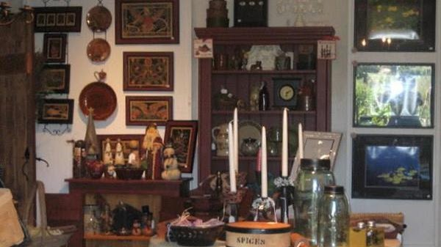

Conestoga Area Historical Society
Fall Harvest Fest
Saturday, September 28, 2023, from 10 am to 4 pm
Sunday, September 29, 2023, from noon to 4 pm
51 Kendig Road, Conestoga, PA 17516 (717) 872-1699

