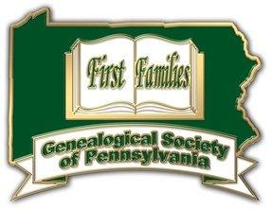

Genealogical Society of Pennsylvania
Colony and Commonwealth: 1638–1790

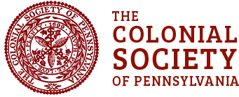

Colonial Society of Pennsylvania

The Colonial Society of Pennsylvania celebrates anniversaries of events connected to the settlement of Pennsylvania which occurred prior to 1700, as well as the collection, preservation, and publishing of records and documents related to the early history of our Commonwealth.



Welcome Society

The purposes of the society are given in its 1906 charter (Listed Above). Though it is not specifically stated in the charter, the Society was founded as nonprofit and educational. Originally, the membership was limited to the descendants (male or female) of those who were passengers on the Welcome. Presently, membership is composed of descendants of those ancestors who traveled with fellow Quakers to America during the course of the year of 1682. This includes 22 ships and 23 crossings of the Atlantic.

