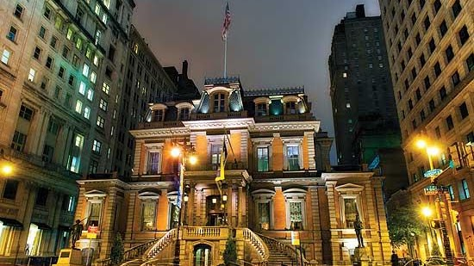

Union League
When making plans to visit Philadelphia, consider using the Union League of Philadelphia as your home away from home. Our newly renovated Four-Diamond hotel, The Inn at the League, located at 1450 Sansom, between Broad and 15th Streets, is centrally located on Philadelphia’s Avenue of the Arts. The Inn at the League has 84 guest rooms and suites, each with its own charm. Truly in a class by itself, The Inn offers an incomparable mix of distinctive history and old world hospitality. Many of our first time guests have referred to us as the “best-kept secret in Center City Philadelphia.”

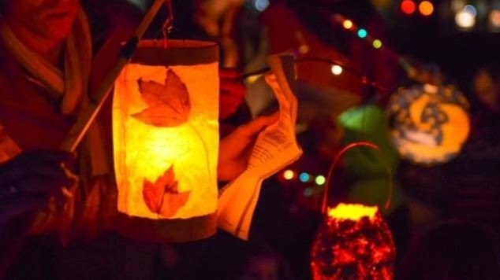

ST. MARTINS PARADE
The feast of St. Martin of Tours is celebrated on November 11th, and in Germany this day is traditionally celebrated with a parade, where children sing songs about St. Martin and walk with decorative lanterns. The German Society's parade is held on the Sunday closest to St. Martin's Day. Children gather at the Society to read stories and have snacks, then march with their lanterns through Northern Liberties neighborhood to Liberty Land Park while singing traditional songs.

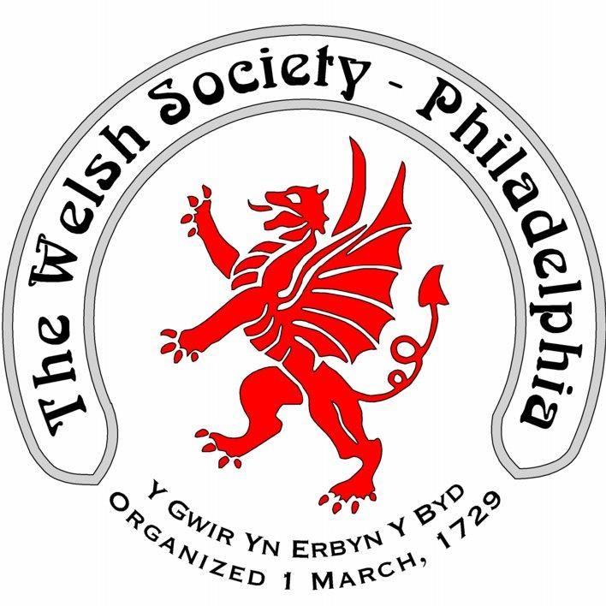

The Welsh Society of Philadelphia
The Welsh Society of Philadelphia has members that have a wide range of ages and interests. Everyone who shares our interest in keeping current with local Welsh American events is most welcome. Membership of the Welsh Society of Philadelphia provides the following opportunities:
A chance to participate in the historic and vibrant Welsh American community
Enjoy a variety of social and heritage events
Singing and community spirit at the Gymanfa Ganu
Receive notifications of upcoming events
Recognize outstanding Welsh Americans through the Robert Morris Award

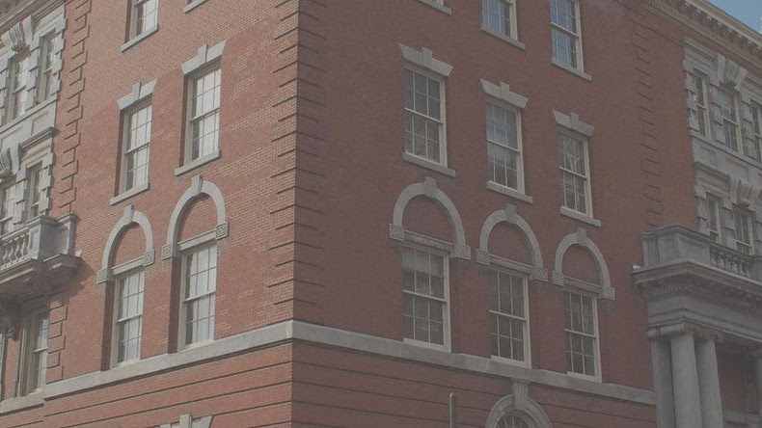

Historical Society of Pennsylvania
Address 1300 Locust Street Philadelphia, PA 19107 (map)
T: (215) 732-6200
The library is open for research by appointment only.y.
​
Click HERE to schedule an appointment

