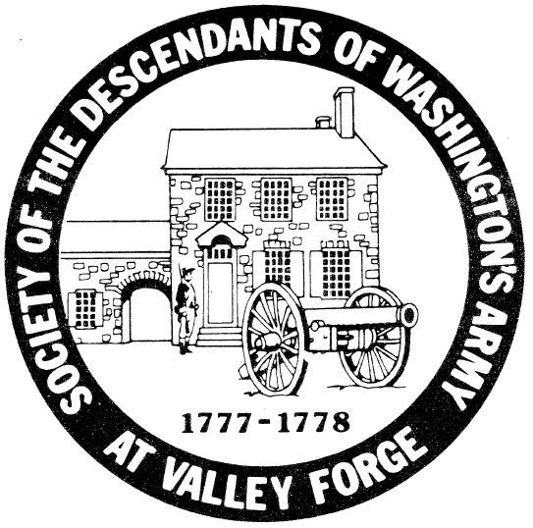

Society of the Descendants of Washington's Army at Valley Forge
The Society of the Descendants of Washington's Army at Valley Forge is a historical & genealogical organization where one must prove descent from a person that spent time at Valley Forge, Pennsylvania with the Continental Army between December 19, 1777 and June 19, 1778.

