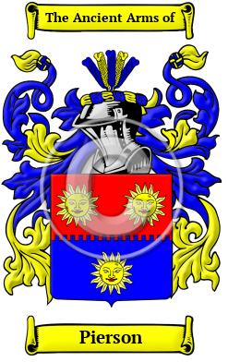
Pierson
The name Pierson reached English shores for the first time with the ancestors of the Pierson family as they migrated following the Norman Conquest of 1066. The name Pierson is based on the French given name Pierre, which is equivalent to the English Peter as in son of Peter or Pierre. The variations of the name Pierson include Pearson, Peerson, Pierson, Peirson and others.
In the United States, the name Pierson is the 1,163rd most popular surname with an estimated 27,357 people with that name

