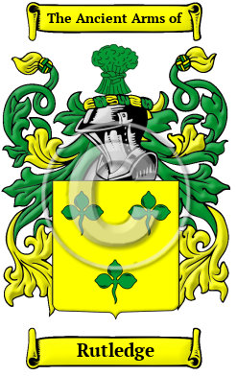
Rutledge
The surname Rutledge was first found in Cumberland. Spelling variations include: Rutledge, Routlege, Routlidge, Routledge, Rutlidge and many more.
In the United States, the name Rutledge is the 920th most popular surname with an estimated 32,331 people with that name

