The Saints
"We teach that the memory of saints may be set before us, that we may follow their faith and good works, according to our calling, as the Emperor may follow the example of David in making war to drive away the Turk from his country. " Dr. Martin Luther

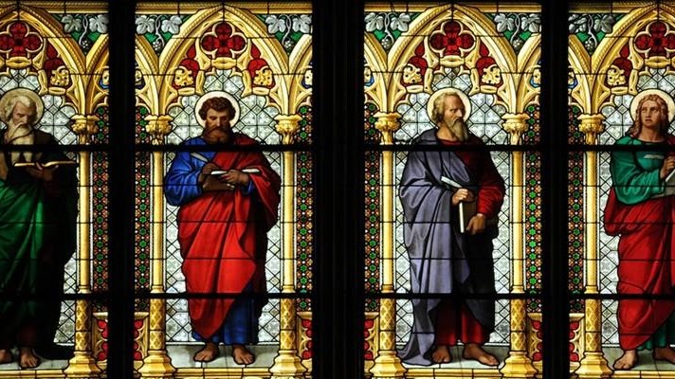

National Society of Saints
Welcome to the National Society of Saints and Sinners website. We are adding new information daily. Please check back with us often, as we enlarge our list of approved Saints. Our first Council meeting on 14 April 2011, was a tremendous success. Several items of import to our members were discussed and resolved. We extend a heartfelt thank you to our members for helping us make the Society an even greater pleasure to join.

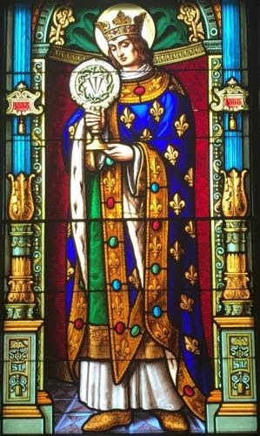

Louis Capet
Son of King Louis VIII and Blanche of Castile. King of France and Count of Artois at age eleven; his mother ruled as regent until he reached 22, and then he reigned for 44 years. Louis made numerous judicial and legislative reforms, promoted Christianity in France, established religious foundations, aided mendicant orders, propagated synodal decrees of the Church, built leper hospitals, and collected relics. Married Marguerite of Provence at age 19, and was the father of eleven children. Supported Pope Innocent IV in war against Emperor Frederick II of Germany. Trinitarian tertiary. Led two Crusades and died on one.
Feast Day is 25 August

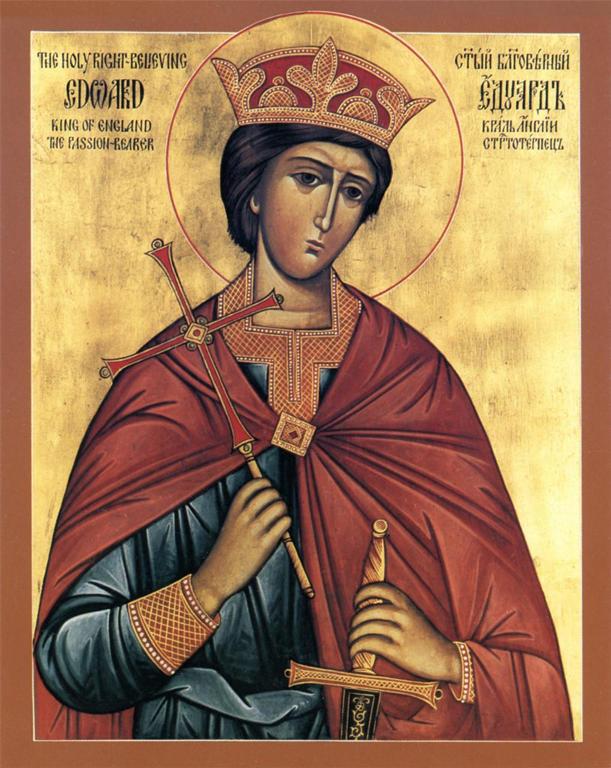

King Edward of Wessex
Born a prince, the son of King Edmund I and Saint Elgiva of Shaftesbury. King of the Mercians and Northumbrians in 957. King of the West Saxons on 1 October 959, which effectively made him king of all England. Efficient and unusually tolerant of local customs; while he spent much time in military actions, his reign was a peaceful period for civilians. Supported his friend Saint Dunstan, Archbishop of Canterbury, Archbishop Oswald of York, and Bishop Aethelwold of Winchester in founding abbeys, encouraged the Benedictine movement, and enacted penalties for nonpayment of tithes and Peter’s pence. Father of Saint Edward the Martyr.
Feast Day 8 July

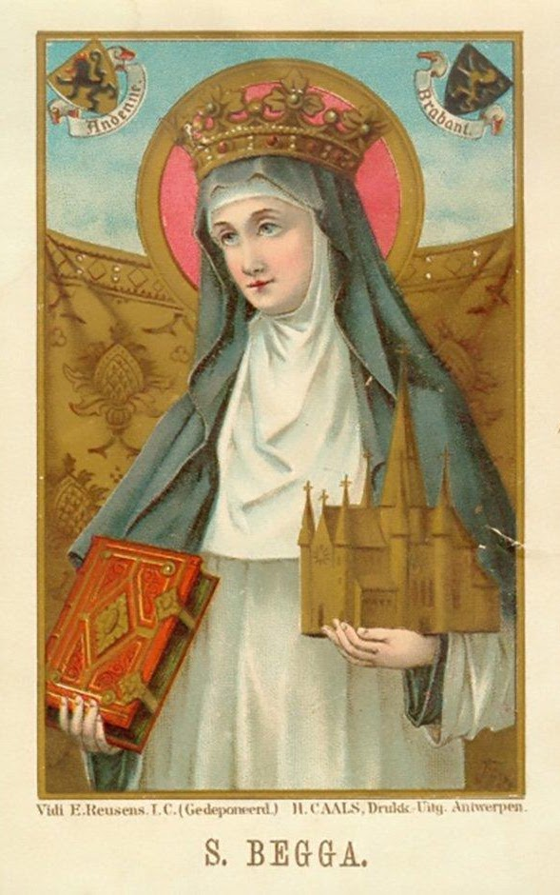

Begga
Some hold that the Beguine movement which came to light in the 12th century was actually founded by St Begga; and the church in the beguinage of Lier, Belgium, has a statue of St Begga standing above the inscription: St. Begga, our foundress. The Lier beguinage dates from the 13th century.
Another popular theory, however, claims that the Beguines derived their name from that of the priest Lambert le Bègue, under whose protection the witness and ministry of the Beguines flourished.
She is commemorated on 17 December.

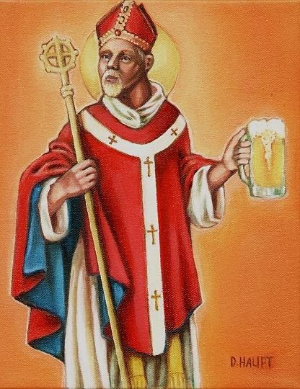

Bishop Arnulf Arnulfing
Arnulf was a courtier of the Austrasian King Theodebert II, a valiant warrior, and a valued adviser. He married the noble Doda (the marriage of his son Ansegisel to Begga, daughter of Blessed Pepin of Landen, produced the Carolingian line of kings of France).
Arnulf desired to become a monk at Lérins. However, when his wife took the veil and Arnulf was at the point of entering Lérins, he was appointed bishop of Metz about 610. He played a prominent role in affairs of state, was one of those instrumental in making Clotaire of Neustria king of Austrasia, and was chief counselor to Dagobert, son of King Clotaire, when the king appointed him king of Austrasia.
About 626, Arnulf resigned his see and retired to a hermitage near the abbey of Remiremont (Benedictines, Delaney, Encyclopedia).
In art, Saint Arnulf is portrayed as a bishop with a coat of mail under his cope. He may also be shown with a fish having a ring in its mouth; blessing a burning castle; or washing the feet of the poor (Roeder). He is venerated at Remiremont. Like Saint Antony, Arnulf is invoked to find lost articles. He is also the patron saint of music, millers, and brewers (Roeder).
Feast Day is 18 July

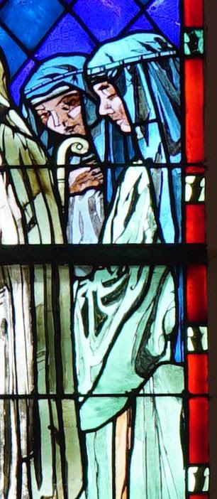

Doda of Reims
Saint Dode (born before 509) was an Abbess of Saint Pierre de Reims and a French Saint. She is reputed to be the daughter of Chloderic, King of the Ripuarian Franks and the sister of Munderic, making her a princess of the Ripuarian Franks.
Doda lived in Reims in the 6th century, she was the second abbess of Saint-Pierre-les-Dames in Reims. There is some confusion regarding her parentage.
Flodoard, in his Historia ecclesiæ Remensis says she was a niece of Balderic, Abbot of Montfaucon and Beuve, founders of the Abbey of Saint-Pierre-les-Dames de Reims and children of a king Sigebert. Flodoard identifies this king as Sigebert I (c. 535 – c. 575), king of Austrasia, when perhaps it is, in fact, Sigobert the Lame (died c. 509), king of Cologne. Although Doda is reputed to be the daughter of Sigobert's son Chlodoric, chronologically, it seems difficult to make of Doda a daughter of Chlodéric. She would more likely be Sigobert the Lame's granddaughter, the daughter of a younger sister of Chloderic, born some time shortly before their father's death.
Doda is raised by her aunt, Beuve. Later, she was promised in marriage to a lord of the court of Sigebert I, but Doda refused the marriage. The lord tried to abduct her, but died as a result of a fall from his horse during the attempt. Dode then took refuge in her aunt's abbey. She succeeded Beuve as abbess. At the end of her life, she obtained from Pepin of Landen, an act designed to protect her community.
Feast Day is 24 April

