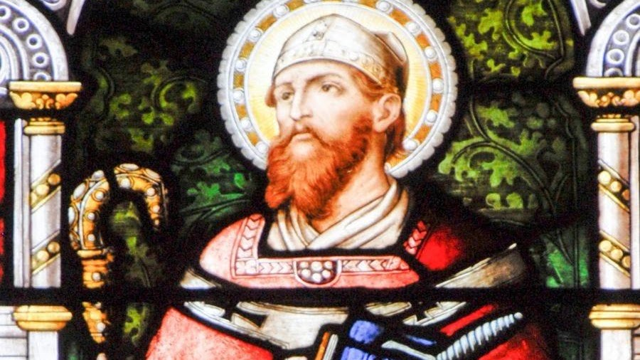

Saint Boniface

St. Boniface was an English Benedictine monk and leading figure in the Anglo-Saxon mission to the Germanic parts of Francia during the eighth century. He organised significant foundations of the church in Germany and was made bishop of Mainz by Pope Gregory III. He was martyred in Frisia in 754, along with 52 others, and his remains were returned to Fulda, where they rest in a sarcophagus which remains a site of Christian pilgrimage.

Boniface's life and death as well as his work became widely known, there being a wealth of material available — a number of vitae, especially the near-contemporary Vita Bonifatii auctore Willibaldi, legal documents, possibly some sermons, and above all his correspondence. He is venerated as a saint in the Christian church and became the patron saint of Germania, known as the "Apostle to the Germans".

