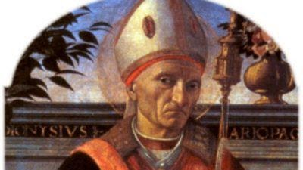

St. Dennis

Denis of Paris was a 3rd-century Christian martyr and saint. According to his hagiographies, he was bishop of Paris (then Lutetia) in the third century and, together with his companions Rusticus and Eleutherius, was martyred for his faith by decapitation. Some accounts placed this during Domitian's persecution and incorrectly identified St Denis of Paris with the Areopagite who was converted by Paul the Apostle and who served as the first bishop of Athens. Assuming Denis's historicity, it is now considered more likely that he suffered under the persecution of the emperor Decius shortly after AD 250. Denis is the most famous cephalophore in Christian history, with a popular story claiming that the decapitated bishop picked up his head and walked several miles while preaching a sermon on repentance. He is venerated in the Catholic Church as the patron saint of France and Paris and is accounted one of the Fourteen Holy Helpers. A chapel was raised at the site of his burial by a local Christian woman; it was later expanded into an abbey and basilica, around which grew up the French city of Saint-Denis, now a suburb of Paris

