

National Guild of St. Margaret of Scotland

The National Guild of St. Margaret of Scotland was founded not only to perpetuate the memory and deeds of St. Margaret but also to act as a genealogical and historical lineage group. The Guild operates for educational purposes by not only educating its members but educating all interested persons world-wide. We invite you to navigate throughout the website to learn more about our lineage group. If you have any questions please feel free to contact any of our Governing Officers.



Margaret of Scotland Feast Day

Pope Innocent IV canonised St. Margaret in 1250 in recognition of her personal holiness, fidelity to the Roman Catholic Church, work for ecclesiastical reform, and charity. On 19 June 1250, after her canonisation, her remains were transferred to a chapel in the eastern apse of Dunfermline Abbey in Fife, Scotland.[12] In 1693 Pope Innocent XII moved her feast day to 10 June in recognition of the birthdate of the son of James VII of Scotland and II of England.[11] In the revision of the General Roman Calendar in 1969, 16 November became free and the Church transferred her feast day to 16 November, the date of her death, on which it always had been observed in Scotland.[13] However, some traditionalist Catholics continue to celebrate her feast day on 10 June.
She is also venerated as a saint in the Anglican Communion. Margaret is honored in the Church of England and in the Episcopal Church on 16 November.

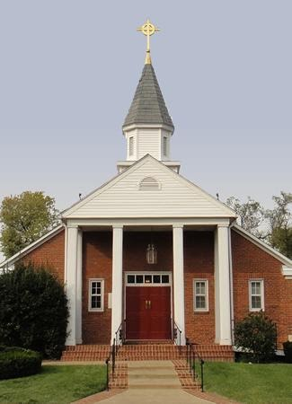

St. Andrew and St. Margaret of Scotland

The Church of St. Andrew and St. Margaret of Scotland is a vibrant, growing parish within the Anglican Catholic Church located just outside our nation’s capitol in the heart of Northern Virginia. We are Anglican because our tradition of prayer and worship is rooted in the Church of England and the Book of Common Prayer. We are Catholic because we believe and practice the universal or catholic faith of the church. We are your friendly neighborhood Traditional Anglican/Episcopal Parish.
Phone: (703) 683-3343
Email: sta_stm@comcast.net
Office Hours: Mon to Wed 9:30AM - 2:30PM
Location: 402 E. Monroe Ave Alexandria, VA 22301 USA

