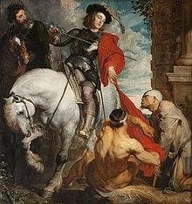

Martin of Tours

On St. Martin's Day, children in Flanders, the southern and northern parts of the Netherlands, and Germany and Austria still participate in paper lantern processions. Often, a man dressed as St. Martin rides on a horse in front of the procession. The children sing songs about St. Martin and about their lanterns. The food traditionally eaten on the day is goose, a rich bird. According to legend, Martin was reluctant to become bishop, which is why he hid in a stable filled with geese. The noise made by the geese betrayed his location to the people who were looking for him.
Feast day is on November 11

