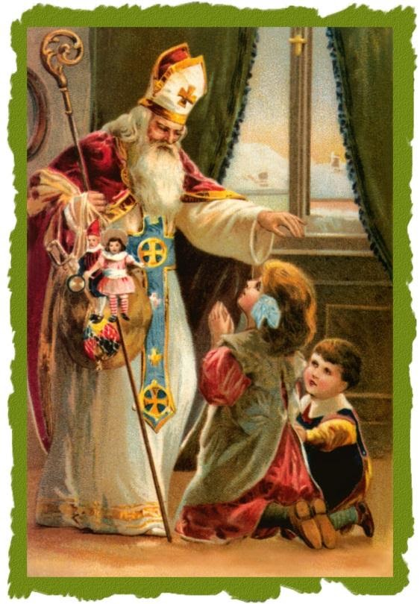

St. Nicholas Day

St. Nicholas is the patron saint of children. His generous spirit and love for youth have led the way to the popular tradition of the gift-giving Santa Claus celebrated throughout the world. Born into a wealthy family and orphaned young, St. Nicholas gave his inheritance to the poor, then dedicated his life to serving God as a priest, and later as a bishop.
The best known story of St. Nicholas is one where he secretly threw bags of gold down a chimney in order to help a poor family’s daughters be able to marry rather than be sold into slavery. St. Nicholas was admired by the people of his town, and his burial site is still a popular place of pilgrimage today. St. Nicholas’ feast day is celebrated on December 6. He is often depicted as a bishop in art, usually surrounded by children.
Most people associate St. Nicholas with Christmas, Santa Claus, and gift-giving. But why? How is this particular saint connected to the legendary character?
St. Nicholas was born in the third century in Patara, which, at the time, was a part of Greece (but is now present-day Turkey). He was brought up in a wealthy and very devout Christian family. While still young, his parents died in an epidemic, leaving Nicholas an orphan. Nicholas gave his large inheritance away to the poor and needy. When he was old enough, he was ordained a priest, and later became the bishop of Myra. The people of Myra admired him for his generosity and love of children. He was also particularly concerned for the safety of sailors, since Myra was a port town, and many of the villagers took to the seas to make a living.
There are many stories about St. Nicholas that show his characteristic selflessness, as well as his devotion to the protection of children. One such story is of an impoverished father who had no money to offer as a dowry for his daughters to get married. In those days, a woman had to offer a dowry to her groom in order to be considered for marriage. When dowry money was unavailable, the woman would be considered unmarriageable, and would often be sold into slavery. This man had three daughters and no money for any of their dowries. Horrified at the thought of having his daughters sold into slavery, the man prayed for help. St. Nicholas heard of the man’s plight, and, on three separate occasions, secretly threw a bag of gold down the man’s chimney. The bags of gold landed in the stockings/shoes of the family members who had placed them near the fireplace to warm. The man was able to offer the dowry his daughters needed in order to marry, saving them from ending up as slaves. Because of this story, children began placing their own stockings and shoes near their fireplaces in hopes that St. Nicholas would leave them a gift.
Feast Day is December 6,

