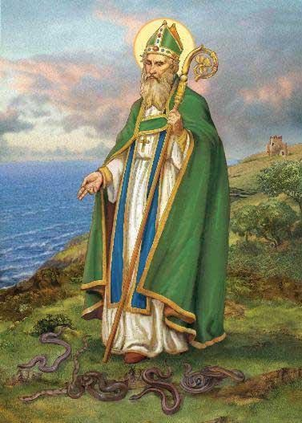

Patrick

St Patrick was born in either Great Britain or Gaul (present day Northern France, the sources do not agree) at a time when the Roman Empire was losing its grip on Western Europe. The Roman Army was being brought back to the center of the Empire, and local leaders were beginning to control their surrounding lands. Patrick had to live near a coast, which were often infiltrated by seaborne pirates raiding to capture young people that they could sell as slaves.
Patrick was raised if not in luxury, living in the benefits of an important Roman family. So when at the age of 16.he was captured by pirates from Ireland and sold into slavery, it had to be a great shock. He lived in captivity for six years, learning the Celtic language and having time to pray as he guarded his cruel master’s sheep throughout the night. The time for prayer led him to make a deep commitment to Christianity.
After six years he escaped, managed to walk 200 miles to a seaport, and convince a local ship master to give him passage back home. But for Patrick home was no longer in the circle of his family. He felt an irresistible call to return to Ireland as a bishop and missionary.
Patrick returned to Ireland about 432, and for the next 30 years or so preached especially to the pagans bringing them the message of Jesus Christ saving all from their sins. Tradition tells the stories of many miracles, much suffering on the part of Patrick as he was imprisoned at least twelve times by his enemies. One time he was bound in heavy chains marked for death. His continual suffering was so great that some of the ancient lists of martyrs include his name. As bishop Patrick not only preached and baptized but also organized the churches in Ireland, taught against heresies as they showed themselves, and left members of his missionary band behind to continue the organization.
St Patrick is one of the most popular saints in Western Christendom. He is the Patron Saint of Ireland. He is said to have banished the snakes from Ireland. In his iconography St Patrick is most often seen in the miter and vestments of a bishop carrying a bishop’s crozier and a shamrock. It is said that he used the shamrock as a teaching aid when preaching on the Trinity.
Feast day on March 17 is celebrated with singing, parades, and dancing

