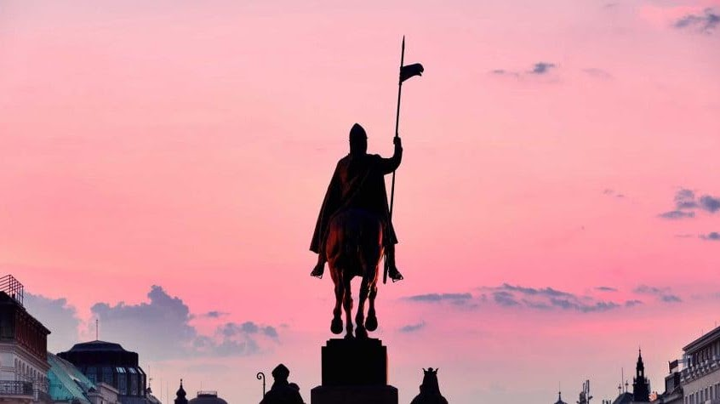

St. Wenceslas Day

This holiday is always celebrated on September 28th. It is the feast day of St. Wenceslas, the patron saint of Bohemia, and commemorates his death in 935 Also known as 'Czech Statehood Day', it is a national holiday in the Czech Republic and has been a public holiday since 2000.

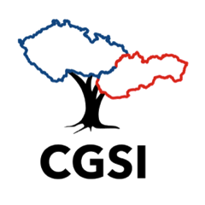

Czechoslovak Genealogical Society International

CGSI focuses on the areas of present-day Czech Republic and Slovakia. This includes Czech (Bohemian), German-Bohemian (Böhmisch), Hungarian, Jewish, Moravian, Rusyn (Ruthenian), Silesian, and Slovak ancestry. CGSI has over 2,000 members residing in the United States, Canada, Czech Republic, Slovakia, and other countries, providing a vast networking opportunity to learn and share information, and connect with fellow members.

