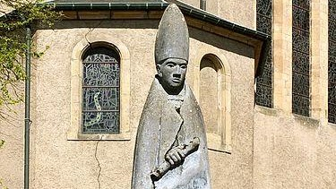

St. Willibrord

Willibrord (658 – 7 November AD 739) was an Anglo-Saxon missionary and saint, known as the "Apostle to the Frisians" in the modern Netherlands. He became the first bishop of Utrecht and died at Echternach, Luxembourg.

