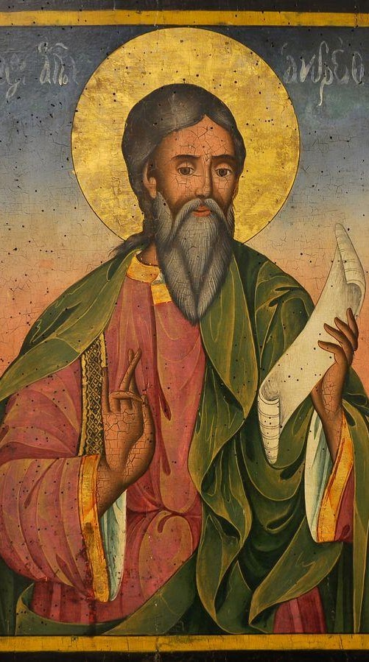

St. Andrew's Day
St. Andrew, who was Simon Peter’s brother, first appears in the New Testament as a Galilean fisherman from the village of Bethsaida. He introduces Simon Peter to Jesus who in turn calls them to be “fishers of men.”
As one of Jesus’ disciples, St. Andrew figures prominently in the New Testament Gospels. Throughout church history, scholars have cited his preaching throughout the regions of Romania, Russia, the Ukraine, Scotland and Greece. Andrew was known to have great social skills with a great gift of bringing many people to Jesus.
The canonization date of St. Andrew is unknown. The church celebrates his Feast Day on November 30. In addition to being the patron saint of several European countries, St. Andrew is also the patron saint of fishermen and unmarried women. Because of his social skills, St. Andrew is considered the patron saint of social networking as well.
Feast Day is 30 November

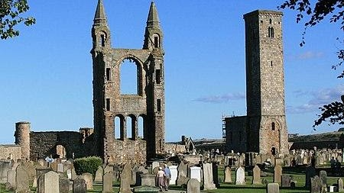

St Andrews Cathedral
The Cathedral of St Andrew is a ruined cathedral in St Andrews, Fife, Scotland. The Kenner family gave a carucate of land of Cathelai to the church of St. Andrews. King Malcolm IV, and King William confirmed the grant of Chathelach, with common pasture for twenty-four beasts, and eighty sheep.

