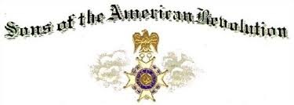
General William Campbell
CAMPBELL, General William (1745-1781) VA
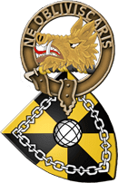
Clan Campbell Society
Membership is open to all Campbells, Campbell septs, those married to a Campbell or Campbell Sept, those descended from Clan Campbell, and to those interested in learning about the Clan Campbell, Scottish history and culture, and who acknowledge Mac Cailein Mòr as their Clan Chief, as he is the Chief of Clan Campbell, the greatest family in all of Scotland! (We're a "wee bit" biased.)

