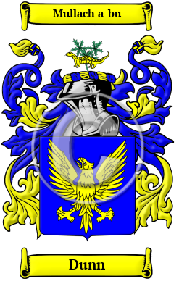
Dunn
Hundreds of years ago, the Gaelic name used by the Dunn family in Ireland was O Duinn or O Doinn. Both Gaelic names are derived from the Gaelic word donn, which means brown. O Doinn is the genitive case of donn. Variations found of the name Dunn include Dunn, Dunne, Dun, O'Dunne, O'Doyne, Doine, Doin, O'Dunn and many more.
In the United States, the name Dunn is the 160th most popular surname with an estimated 144,246 people with that name.

