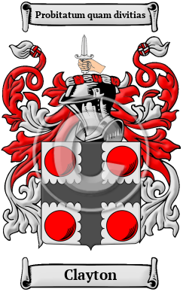

Clayton

Clayton is an ancient Norman name that arrived in England after the Norman Conquest of 1066. The Clayton family lived in one of the many parishes by the name of Clayton in Staffordshire, Sussex, the West Riding of Yorkshire and Lancashire. Cloughton is a small village and civil parish in North Yorkshire. he name has been spelled Clayton, Claydon, Clawton, Claughton and others.
In the United States, the name Clayton is the 468th most popular surname with an estimated 59,688 people with that name

