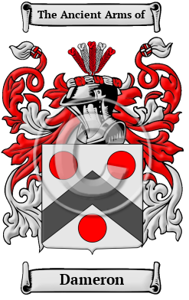

Dameron History

The surname Dameron was first found in Belgium, where the name became noted for its many branches in the region, each house acquiring a status and influence which was envied by the princes of the region. The name was first recorded in West Flanders, a province in Belgium, originally Bruges. Within this province the notable towns are Bruges, the capital city, Ostend, Courtrai, Furnes, Thielt, Ypres and Roulers. In their later history the surname became a power unto themselves and were elevated to the ranks of nobility as they grew into a most influential family. The name was first recorded in Flanders about the 14th century.
In the United States, the name Dameron is the 7,419th most popular surname with an estimated 4,974 people with that name

Dameron Family Association

