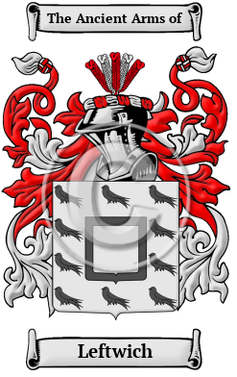

Family Crest & Coats of Arms

The surname Leftwich was first found in Cheshire where they held a family seat as Lords of the Manor. After the Battle of Hastings in 1066, William, Duke of Normandy, having prevailed over King Harold, granted most of Britain to his many victorious Barons. It was not uncommon to find a Baron, or a Bishop, with 60 or more Lordships scattered throughout the country. These he gave to his sons, nephews and other junior lines of his family and they became known as under-tenants. They adopted the Norman system of surnames which identified the under-tenant with his holdings so as to distinguish him from the senior stem of the family. After many rebellious wars between his Barons, Duke William, commissioned a census of all England to determine in 1086, settling once and for all, who held which land. He called the census the Domesday Book, [1] indicating that those holders registered would hold the land until the end of time. Hence, conjecturally, the surname is descended from the tenant of the lands of Lestwich, held by Richard de Vernon, a Norman Baron, who was recorded in the Domesday Book census of 1086. Lestwich was a large village on the banks of the River Dane notable for its Lea Grange Farm.
In the United States, the name Leftwich is the 6,637th most popular surname with an estimated 4,974 people with that name.

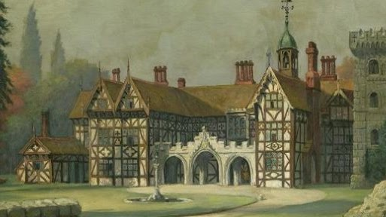

Leftwich Historical Association

Leftwich Historical Association (LHA) was organized on October 10, 1992, in Lynchburg, Virginia, with 16 charter members. The Association was established as a non-profit organization devoted to assembling and preserving genealogical and historical information pertaining to the Leftwich family. LHA was incorporated in the Commonwealth of Virginia on November 3, 2000. LHA annually publishes The Leftwich Heritage, a newsletter dealing with new genealogical finds and family interests. An annual family reunion for all members is also sponsored by the Leftwich Historical Association.



Ralph Leftwich
Ancestor Lineages of Members Texas Society/National Society Colonial Dames Seventeenth Century

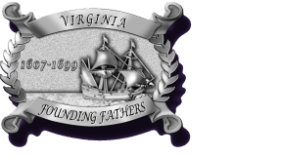

Thomas Leftwich
Leftwich, Sr. Thomas VA, 1660s



Augustine Leftwich Sr.
Service: VIRGINIA Rank(s): PATRIOTIC SERVICE
Birth: CIRCA 1712 NEW KENT CO VIRGINIA
Death: ANTE 6-22-1795 BEDFORD CO VIRGINIA
Service Source: ABERCROMBIE & SLATTEN, VA REV PUB CLAIMS, VOL 1, P 114
Service Description: 1) BEDFORD CO, RENDERED MATERIAL AID

