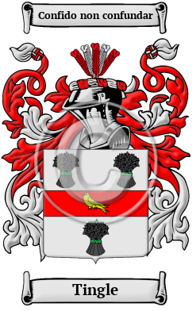
Tingle
The name Tingle, like many surnames, is occupational in origin, referring to the job that the first bearer did for a living. In this case, it is metonymic, coming not from the name of the occupation itself, but rather from the product made. A tingle is a very small nail, often used in the making of shoes. The first Tingle was most likely someone who made such nails. The surname Tingle was first found in Cambridgeshire, where the name first appeared in the early 13th century. In the United States, the name Tingle is the 6,833rd most popular surname with an estimated 4,974 people with that name

