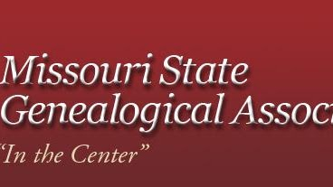

Mary Ann Brown
Pioneer

