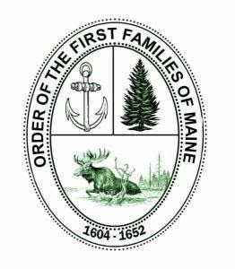
Order of the First Families of Maine
Membership is open to individuals at least eighteen years of age, who are lineal descendants of an ancestor who was a resident of present-day Maine, by the year 1652. Membership is by invitation only and shall be extended by the President General. Membership inquiries are welcome.

