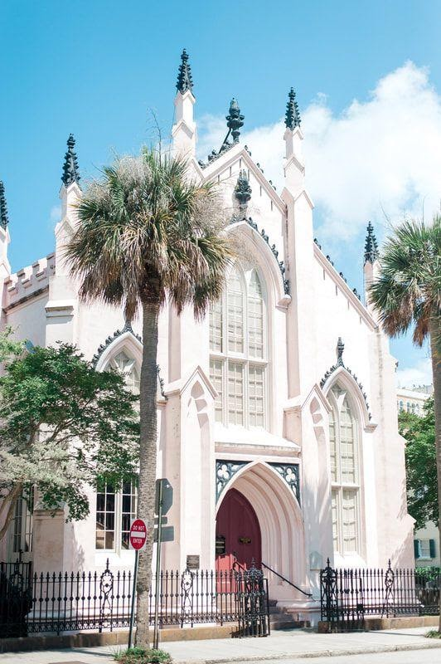

THE FRENCH PROTESTANT (HUGUENOT) CHURCH

Each spring the French Huguenot Society of South Carolina and the French Huguenot Church join together to celebrate the Edict of Nantes, a service celebrating King Henry of Navarre’s decree in 1598 to protect the French Protestants and allow them to read and interpret the scriptures of the New Testament for themselves. This service is conducted in French.

In the fall, the Huguenot Church service recognizes the revocation of the Edict of Nantes and the suffering the French Protestants endured because of their opposition to Catholic teachings and determination to interpret for themselves. At this time in history, the French Protestants left France for fear of death. Many came to America seeking a new life and settled along the coast.

