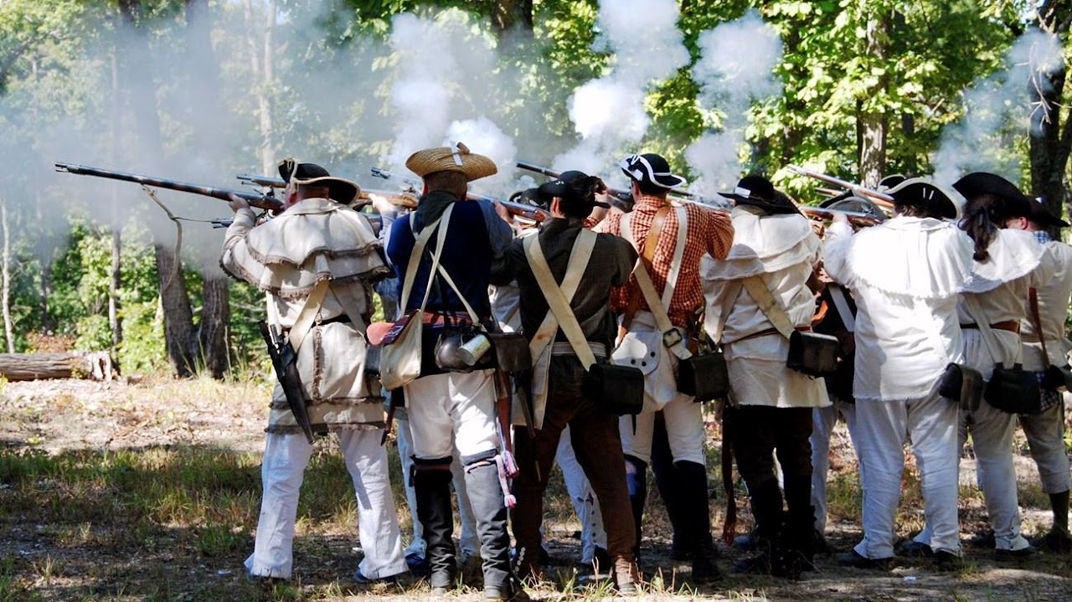
Kings Mountain National Military Park

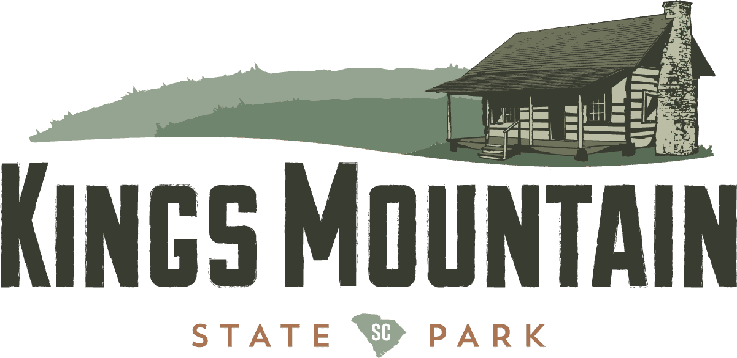

Kings Mountain State Park

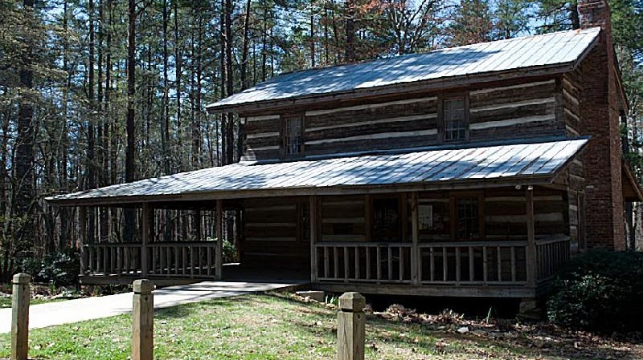

Capt. John Dickey's Home
Moved to Kings Mountain State Park
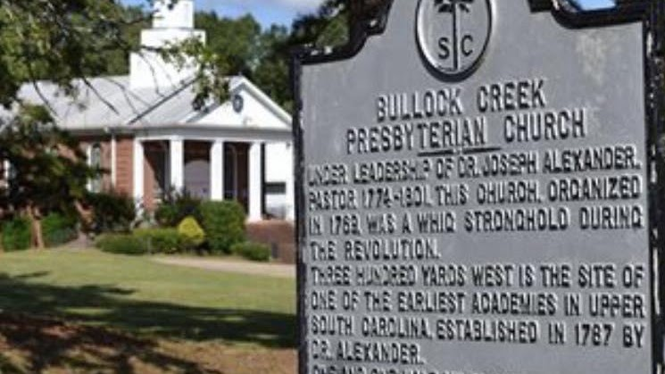
Bullock Creek Presbyterian Church in America
7386 Lockhart Rd, Sharon, SC, United States, 29742
- +1 803-280-4618 craiggmarshall@aol.com

