Resources
York County, Maine - Wikipedia
York County, Maine Genealogy • FamilySearch
National Register of Historic Places
Kittery, Maine - Wikipedia
Kittery Point, Maine - Wikipedia
Portsmouth Naval Shipyard - Wikipedia
Berwick, Maine - Wikipedia
Town of Berwick, ME

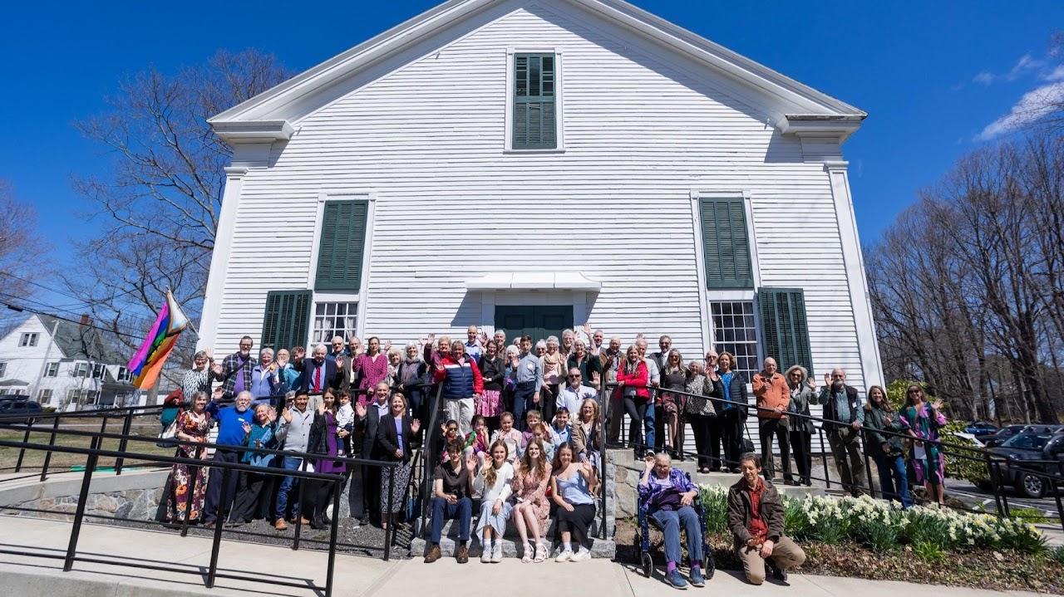

First Congregational Church

possibly the oldest church building in Maine, built in 1703 (Congregational).
23 Pepperrell Rd, Kittery Point, ME 03905
+12074390650
Calendar

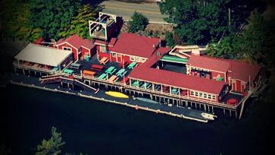

Chauncey Creek Lobster Pier
16 Chauncey Creek Rd, Kittery Point, ME 03905
+12074391030

