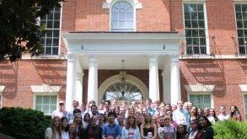

Congressional Seminar Essay Contest for High School Students

The Congressional Essay Contest is run by NSCDA Corporate Societies and Town Committees across the United States. Freshman, sophomore, junior, or senior year high school students submit essays that are then judged and awarded. The essay topic changes annually.

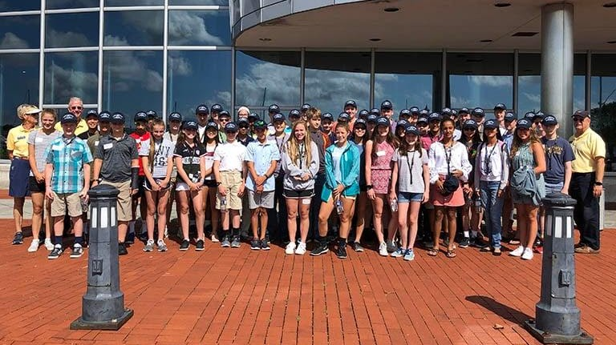

Youth Leadership Program

Developing leaders for tomorrow begins today! Give students ages 13-15 a taste of robust leadership training. Equip them for the future they'd like to pursue. Students will spend a half-day in the Student Youth Leadership Program learning and developing applicable leadership skills from some of the brightest of today's leaders at the U.S. Naval Academy.

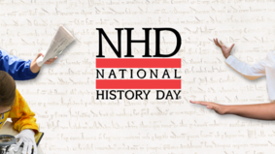

National History Day

National History Day®(NHD) is a non-profit education organization based in College Park, Maryland. NHD sponsors the National History Day Contest that encourages more than half a million students around the world to conduct historical research on a topic of their choice. Students enter these projects at the local and affiliate levels, with top students advancing to the National Contest at the University of Maryland at College Park. The 2022-2023 theme is Frontiers in History: People, Places, Ideas.

