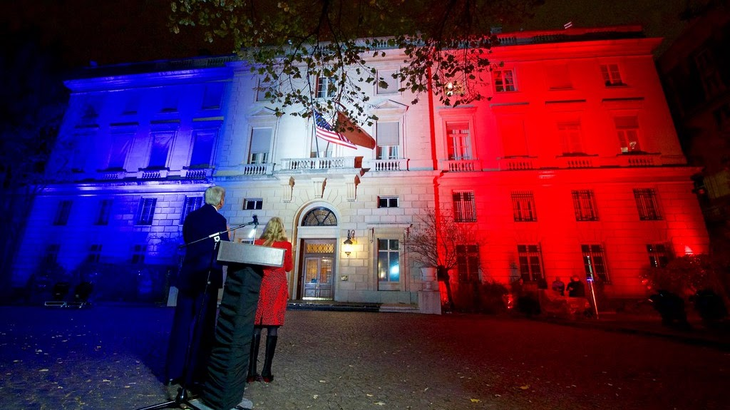

Internships at the Embassy of France

Only Students from a local school/university, whatever the nationality (including French) or those candidates studying within an American institution, can apply to one of the open positions. The procedure for students in France is different (please see below).
The Press and Communication Office accepts interns adherent to the fall, spring and summer semester schedule. Interns must be currently enrolled, full-time students in an American university to be considered. A proficiency in French and native speaking/ writing level in English is required.



German Embassy
The embassy is the official representation of the Federal Government of Germany in the United States. Our Visa, Passport and Legal Section provides services for US residents and German citizens within the Embassy's area of consular jurisdiction: Delaware, Maryland, Virginia, West Virginia and the District of Columbia.

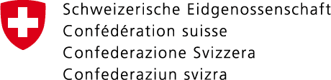

Academic internships

The Embassy of Switzerland is looking for motivated candidates for internships covering many departments and aspects of the work of the Embassy of Switzerland in Washington, D.C.
The Consulate General in New York offers 3 internship positions to qualified candidates in the following sections:
- Economic Affairs and Communication
- Culture and Education
- Swiss Business Hub in San Francisco
The purpose of these academic internships is to offer students or recent graduates an opportunity to discover the activities of a Swiss representation abroad and to become familiar with the diverse aspects of a diplomatic career. All positions are full-time (40 hours per week) and run for 6 months. Remuneration for the positions is USD 3,400 per month. For details and how to apply, read the document on internships.
Internships (PDF, 3 Pages, 665.3 kB, English)

