Training the next generation of the Prosterity is a Top Priority!



Sea Cadets
Sea Cadets are young men and women aged 10 through the end of high school who choose adventure, seek challenges, and step outside of their comfort zones. There are two programs within Sea Cadets.
The Navy League Cadet Corps (NLCC) is for middle school students aged 10 to 13.
The Naval Sea Cadet Corps (NSCC) is for ages 13 through the end of high school.



Navy Junior Officer Training
The NJROTC program was established by Public Law in 1964 and may be found in Title 10, U.S. Code, Chapter 102. The program is conducted at accredited secondary schools throughout the nation, by instructors who are retired Navy, Marine Corps, and Coast Guard officers and enlisted personnel. The NJROTC curriculum emphasizes citizenship and leadership development, as well as our maritime heritage, the significance of sea power, and naval topics such as the fundamentals of naval operations, seamanship, navigation and meteorology. Classroom instruction is augmented throughout the year by community service activities, drill competition, field meets, flights, visits to naval activities, marksmanship training, and other military training. Uniforms, textbooks, training aids, travel allowance, and a substantial portion of instructors' salaries are provided by the Navy.
Be enrolled in and attending a regular course of instruction in a grade 9 through 12 at the school hosting the unit.



Army JROTC
U.S. Army Reserve Officers’ Training Corps (ROTC) scholarships provide full financial assistance for college tuition and mandatory education fees (or room and board). Additionally, scholarship winners receive tax free subsistence allowance for up to 10 months a year at a rate of $420.00 per month and $1200 annually for textbooks, classroom supplies, and equipment. Must have a GPA 2.5 High School Age 17-26

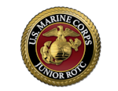

Marine JROTC
Congress established the Junior ROTC under the National Defense Act of 1916. Certain requirements as stipulated by Congress under U.S. Code: Title 10, Section 2031 must be satisfied in order to participate in a JROTC program. The criteria for determining eligibility to participate in MCJROTC are:
1. High school enrollment
2. Citizenship
3. Physical fitness

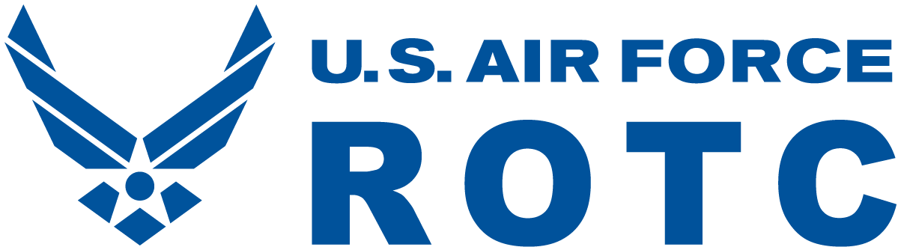

Air Force ROTC
After completing all Air Force ROTC and academic degree requirements, cadets accept a commission as second lieutenants in the Air Force or Space Force, appointed by the President of the United States.

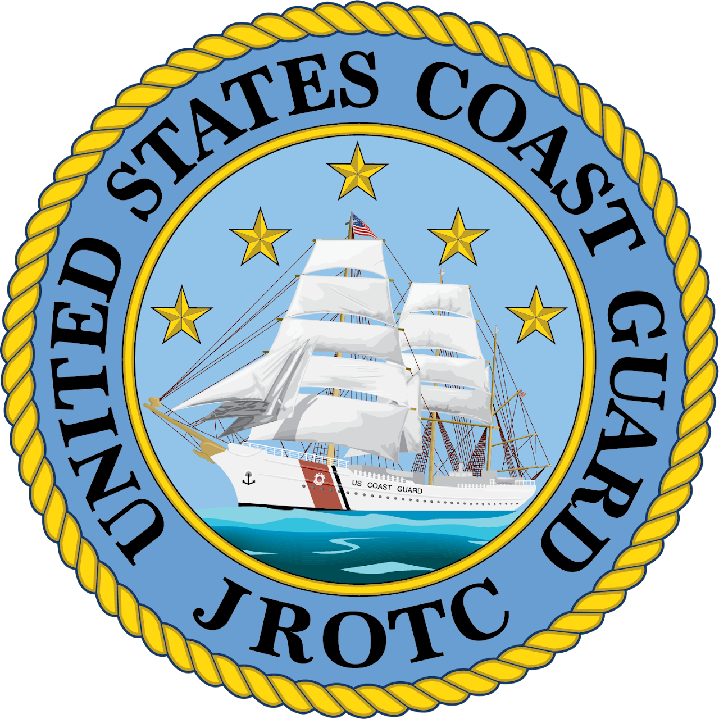

Coast Guard JROTC
The Coast Guard established its first JROTC unit in 1992, in Miami, FL. Under recent federal legislation, the Coast Guard is expanding the JROTC program to every Coast Guard District by 2025.
Per 10 USC Chapter 102, the flagship purpose of JROTC is “to instill in students in United States secondary educational institutions the values of citizenship, service to the United States, and personal responsibility and a sense of accomplishment.”
In light of this, the mission of Coast Guard JROTC is: Developing Service-Minded Citizens of Character. To accomplish the mission, the program develops cadets on the COAST:



Law Enforcement Cadet
The program is available to male and female high school students who have completed their junior year of high school and are in good academic standing. They should be of good moral character and possess a desire to learn more about the law enforcement profession. Their high school should recommend students who meet these qualifications to local posts who are sponsoring the Junior Law Cadet Program.

