Posterity is the Top Priority!

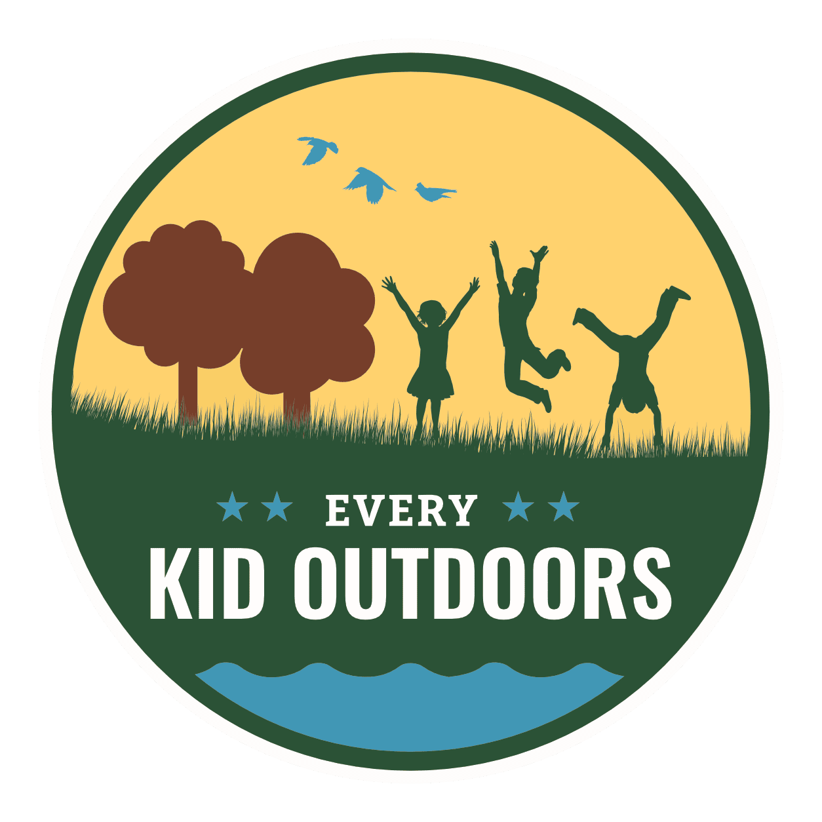

4th Graders National Parks

You and your family get free access to hundreds of parks, lands, and waters for an entire year. Best to sign up Sept. 1.

Parks With Junior Ranger Programs

Yorktown Junior Ranger

