
Macmillan Scholarship
The Agnes and Margaret Macmillan Scholarship is made possible through a grant from the estate of the Society’s first female member, Margaret ‘Peggy Macmillan’. In 2006, Peggy began support of the Scholarship Fund through annual donations made in the memory of her departed sister Agnes. In the ensuing years, Peggy contributed significantly to the fund to establish the Macmillan - St. Andrew's Society Scholarship. Sadly, she passed away in April 2013. In her continued generosity, Peggy thoughtfully remembered the Society in her estate planning; guaranteeing The Macmillan Scholarship in perpetuity. It is now aptly renamed The Agnes and Margaret Macmillan-St. Andrew's Society Scholarship.
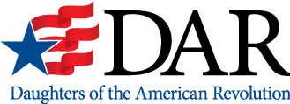
Lillian and Arthur Dunn Scholarship
The Lillian and Arthur Dunn Scholarship is a $2,500 scholarship awarded for up to four years to two well-qualified, deserving sons and daughters of members of the NSDAR for four years of college. Renewal is conditional upon maintenance of a GPA of 3.25. Outstanding recipients pursuing graduate study may reapply each year for an additional period of up to four years of study. The DAR member number of the mother, who is a current-dues paying member, must be included with the application.
Questions? Contact the National Vice Chairman for the Lillian and Arthur Dunn Scholarship: LillianArthurDunnScholarship@NSDAR.org

Dr. Aura-Lee A. and James Hobbs Pittenger American History
The Dr. Aura-Lee A. and James Hobbs Pittenger American History Scholarship is awarded to graduating high school students who will pursue an undergraduate degree with a concentrated study of a minimum of 24 credit hours in American History and American Government. Renewal is conditional upon maintenance of a GPA of 3.25. This scholarship is renewable. This award is intended to promote the study of our country's history among our finest students. U.S. Citizens residing abroad may apply through a Units Overseas Chapter.
The Dr. Aura-Lee A. and James Hobbs Pittenger American History Scholarship is an award of $2,000 each year for up to four years with annual transcript review by the National Chairman required for renewal.
Questions? Contact the National Vice Chairman for the Dr. Aura-Lee and James Hobbs Pittenger Scholarship: PittengerAmerHistoryScholarship@NSDAR.org

DAR Centennial
The DAR Centennial Scholarship is awarded to two outstanding students pursuing a course of graduate study in the field of historic preservation at a college or university in the United States. This scholarship was established from a portion of the proceeds from the sale of the Centennial Pin. This is a one-time award in the amount of $2,500.
Questions? Contact the National Vice Chairman for the DAR Centennial Scholarship: DARCentennialScholarship@NSDAR.org

Lucinda Beneventi Findley History
A one-time $2,000 scholarship awarded to two graduating high school seniors that have demonstrated advance interest in history and are planning to major in or pursue the study of history in a full-time accredited college or university in the United States. The applicant must have a GPA of 3.25.
Questions? Contact the National Vice Chairman for the Lucinda Beneventi Findley History Scholarship: LBFindleyHistoryScholarship@NSDAR.org

Dr. Francis Anthony Beneventi Medical
A preferred amount $5,000 scholarship awarded to one student either attending or planning to attend an approved, accredited medical school, college, or university. The applicant must have a minimum GPA of 3.25. This scholarship is not automatically renewable; however, recipients may reapply for consideration each year for up to four consecutive years, pending receipt of proof of continued enrollment (no pre–med, veterinarian, or physician assistant), and after the first semester, an annual transcript review indicating a minimum GPA of 3.25.
Questions? Contact the National Vice Chairman for the Dr. Francis Anthony Beneventi Medical Scholarship: DrFABeneventiScholarship@NSDAR.org

Irene and Daisy MacGregor Memorial
The Irene and Daisy MacGregor Memorial Scholarship is awarded to two students of high scholastic standing and character who have been accepted into or are pursuing an approved course of study to become a medical doctor (no pre-med, veterinarian or physician assistant) at an approved, accredited medical school. Renewal is conditional upon maintenance of a GPA of 3.25.
This scholarship is also available to students who have been accepted into or who are pursuing an approved course of study in the field of psychiatric nursing at the graduate level at accredited medical schools, colleges, or universities. There is a preference to females "if equally qualified."
Questions? Contact the National Vice Chairman for the Irene and Daisy MacGregor Memorial Scholarship: MacGregorScholarship@NSDAR.org

Leslie Andree Hanna Medical
A one-time preferred amount of $5,000 to a deserving female student who is a US citizen attending medical school. The selection process is based on academic merit with a minimum GPA of 3.25 on a 4.0 scale or the equivalent GPA on the scale used by the applicable educational institution. The recipient may reapply for the scholarship each year, but is not guaranteed the award.
Questions? Contact the National Vice Chairman for the Leslie Andee Hanna Medical Scholarship: LAHannaMedicalScholarship@NSDAR.org

Alice W. Rooke
A $5,000 scholarship awarded to one student who has been accepted into or who are pursuing an approved course of study to become a medical doctor (no pre–med, veterinarian, or physician assistant) at approved, accredited medical schools, colleges, and universities. The scholarship is not automatically renewable; however, applicant may reapply for up to four years.
Questions? Contact the National Vice Chairman for the Alice W. Rooke Medical Scholarship: AliceWRookeScholarship@NSDAR.org

Caroline E. Holt Nursing
A one-time $2,500 award is given to three students who are in financial need and who have been accepted or is currently enrolled in an accredited school of nursing. A letter of acceptance into a nursing program or a transcript stating the applicant is in a nursing program must be included with the application.
Questions? Contact the National Vice Chairman for the Caroline E. Holt Nursing Scholarship: CarolineEHoltScholarship@NSDAR.org

DAR–Lena Ferguson
A one-time $5,000 award given annually to two students who graduated from a District of Columbia Public School or Public Charter School who have been accepted or are currently enrolled in a two-year, undergraduate or graduate degree nursing program at the University of the District of Columbia. A minimum GPA of 3.00 on a 4.0 scale or the equivalent GPA on the scale used by the institution is required. This scholarship is administered by the University of the District of Columbia and UDC students can find more information about applying at their Scholarship Universe online portal
Questions? Contact the National Vice Chairman for the DAR–Lena Ferguson Scholarship: DCScholarship@NSDAR.org

Occupational/Physical Therapy
The Occupational/Physical Therapy Scholarship, in the amount of $2,000, is awarded to two students who are in financial need and have been accepted or are attending an accredited school of occupational therapy (including art, music, or physical therapy).
Questions? Contact the National Vice Chairman for the Occupational/Physical Therapy Scholarship: OccupationalPhysicalTherapyScholarship@NSDAR.org

Edward G. and Helen A. Borgens Elementary Teacher
The Edward G. and Helen A. Borgens Elementary Teacher Scholarship is a one-time preferred amount of up to $1,500 awarded to one student who is twenty-five (25) years of age or older. Applicants must be studying to teach at the elementary school level. Applicants must have at least a 3.5 GPA, be at least a college sophomore, and attend or plan on attending an accredited college or university. The award is based on academic merit and is not automatically renewable, however, recipients may reapply for consideration as long as they meet the eligibility requirements.
Questions? Contact the National Vice Chairman for the Edward G. and Helen A. Borgens Elementary Teacher Scholarship: BorgensElementaryScholarship@NSDAR.org

Edward G. and Helen A. Borgens Secondary Teacher
The Edward G. and Helen A. Borgens Secondary Teacher Scholarship is a one-time preferred amount of up to $1,500 awarded to one student who is twenty-five (25) years of age or older. Applicants must be studying to teach at the secondary school level. Applicants must have at least a 3.5 GPA, be at least a college sophomore, and attend or plan on attending an accredited college or university. The award is based on academic merit and is not automatically renewable, however, recipients may reapply for consideration as long as they meet the eligibility requirements.
Questions? Contact the National Vice Chairman for the Edward G. and Helen A. Borgens Secondary Teacher Scholarship: BorgensSecondaryEducationScholarship@NSDAR.org

Arthur Lockwood Beneventi Law
The Arthur Lockwood Beneventi Law Scholarship is a one-time preferred amount $2,000 scholarship awarded to a student who is either enrolled in or attends an accredited law school and has a minimum GPA of 3.25. The scholarship is not automatically renewable; however, recipients may reapply for consideration each year.
Questions? Contact the National Vice Chairman for the Arthur Lockwood Beneventi Scholarship: ALBeneventiLawScholarship@NSDAR.org

Mary Elizabeth Lockwood Beneventi MBA
The Mary Elizabeth Lockwood Beneventi MBA Scholarship is a one-time preferred amount $2,000 scholarship for a student attending graduate school full time in an accredited college or university and majoring in business administration. The applicant must have a minimum GPA of 3.25. The scholarship is not automatically renewable, however, recipients may reapply for consideration each year.
Questions? Contact the National Vice Chairman for the Mary Elizabeth Lockwood Beneventi MBA Scholarship: MELBeneventiMBAScholarship@NSDAR.org

Margaret Howard Hamilton
The Margaret Howard Hamilton Scholarship is awarded to a graduating high school senior who has been accepted into the Harvey and Bernice Jones Learning Center, housing the Ben Caudle Learning Program at the University of the Ozarks, Clarksville, Arkansas. Applications must be requested directly through the Learning Center upon acceptance into this program for learning disabled students. This award is $1,000 annually for up to four years with annual transcript review by the National Chairman required for renewal.
Margaret Howard Hamilton Scholarship Checklist
Margaret Howard Hamilton Scholarship Application Cover Sheet
Questions? Contact the National Vice Chairman for the Margaret Howard Hamilton Scholarship: MHHamiltonScholarship@NSDAR.org

Robert Hunter Swadley Horticulture
The Robert Hunter Swadley Horticulture Scholarship is for graduating high school seniors with a minimum 3.0 GPA on 4.0 scale who will be entering an accredited college or university located in the United States as a freshman with a major in horticulture. The applicant must be a United States citizen residing in the state of California. The scholarship shall cover full or partial tuition funding for room and board, books and educational supplies. The actual amount of the scholarship will be determined each year based on the income generated by the principal of the fund.
Questions? Contact the National Vice Chairman for the Robert Hunter Swadley Horticulture Scholarship: RobertHunterSwadleyHortScholarship@NSDAR.org

Nellie Love Butcher Music
The Nellie Love Butcher Music Scholarship is a one-time preferred amount of up to $5,000 awarded annually to a male and female music student who is pursuing an education in piano or voice. Special consideration shall be given to students currently attending the Duke Ellington School of the Performing Arts in Washington, D.C. Performance material on a mp3 file must be submitted with the application. The scholarship is for one year, and is not automatically renewable; however, recipients may reapply for consideration each year, for four based on maintaining a minimum of a 3.0 GPA. Click here for mp3 file submission instructions.
Questions? Contact the National Vice Chairman for the Nellie Love Butcher Music Scholarship: NLButcherMusicScholarship@NSDAR.org

William Robert Findley Graduate Chemistry
The William Robert Findley Graduate Chemistry Scholarship is a one-time preferred amount $2,000 scholarship for a student attending graduate school full time in an accredited college or university and majoring in chemistry. The applicant must have a minimum GPA of 3.25. The scholarship is not automatically renewable, however, recipients may reapply for consideration each year.
Questions? Contact the National Vice Chairman for the William Robert Findley Graduate Chemistry Scholarship: WRFindleyChemistryScholarship@NSDAR.org

Leo W. and Alberta V. Thomas Utz
The Leo W. and Alberta V. Thomas Utz Scholarship – English is a scholarship in the amount of $4,000 year for up to four consecutive years to students who are pursing undergraduate or graduate degrees in English. Renewal is conditional upon maintenance of a GPA of 3.25 based on a 4.0 scale used by the educational institution. An official transcript must be submitted to the Office of the Reporter General each year by July 10th or the scholarship is forfeited.
Questions? Contact the National Vice Chairman for the Leo W. and Alberta V. Thomas Utz Scholarship – English Scholarship: UtzEnglishScholarship@NSDAR.org
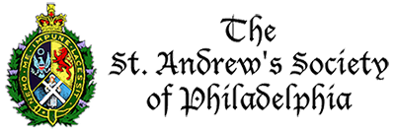
St. Andrew’s Society of Philadelphia
The Scholarship program of the St. Andrew’s Society of Philadelphia is designed to foster better understanding and relations between the United States and Scotland through the exchange of the best and brightest university students from our respective countries. Each year, the Society provides funds to send a small group of American students to attend a full year at one of the “Four Ancients”: the Universities of Aberdeen, Edinburgh, Glasgow, and St. Andrew’s. These U.S. scholars are chosen from a pool of applicants nominated by 30 participating colleges and universities in the Philadelphia region. In return, the Universities of Aberdeen and St. Andrew’s each select a Scottish student to spend a year at Drexel University and the University of Pennsylvania, respectively. The current amount of each scholarship is $35,000. This amount increases from time to time as our funds and circumstances allow.

German Society of Pennsylania
We are pleased to announce the opening of the application process of the German Society’s Scholarship Program for the upcoming academic year. The scholarship award is intended to provide financial assistance to selected undergraduate students studying German language and literature. Awards are based primarily on the student’s achievement and promise, although financial need may also be considered. Typical awards in recent years have been $2,000 to $5,000, with the dollar amount and number of recipients varying from year to year. The awards may be applied only to tuition, are paid in two installments at the beginnings of the fall and spring semesters, and are transmitted directly to the recipient’s college or university upon certification of enrollment by that institution. Students are expected to enroll in at least one German course during each semester for which they receive support.
Click here to download a 2023/2024 Scholarship Application Form
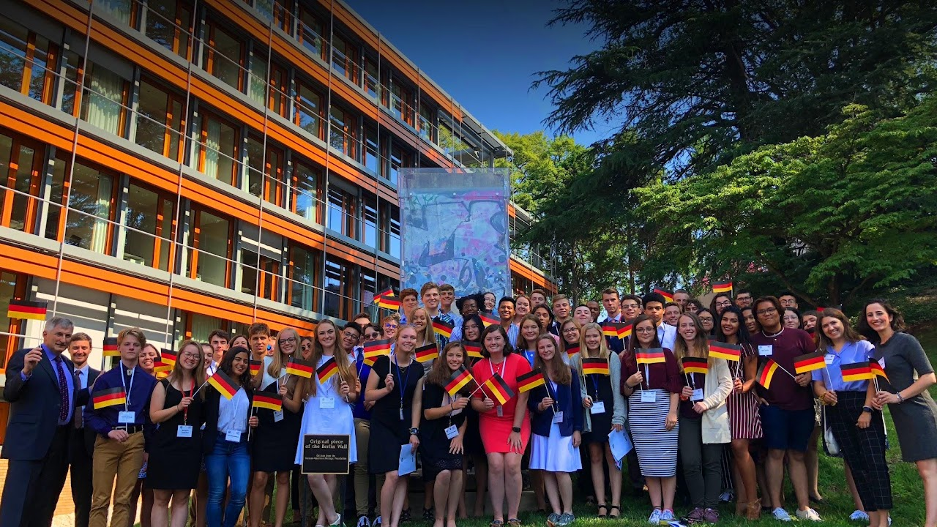
Congress-Bundestag Youth Exchange (CBYX)
The Congress-Bundestag Youth Exchange (CBYX) scholarship is for motivated high school students who want to experience a culture and learn a language through a full immersion experience. Learn about German culture first-hand by living with a host family and attending a German high school. Embark on an adventure that is unlike any other. The CBYX program additionally offers vocational and young professional scholarship opportunities; visit the Programs page to learn more.

Jamestowne Society Fellowship
The Jamestowne Society offers an Annual Fellowship to support completion of a graduate thesis or essay on the history and culture of Virginia before 1700. Applicants may be candidates for graduate degrees in any relevant discipline such as History, American Studies, Literature, Archaeology, Anthropology, Fine Arts, etc., if their research is devoted either exclusively or very substantially to Colonial Virginia prior to 1700. The Fellowship amount awarded is determined by the project, and applicant proposal. The amount will not exceed $10,000
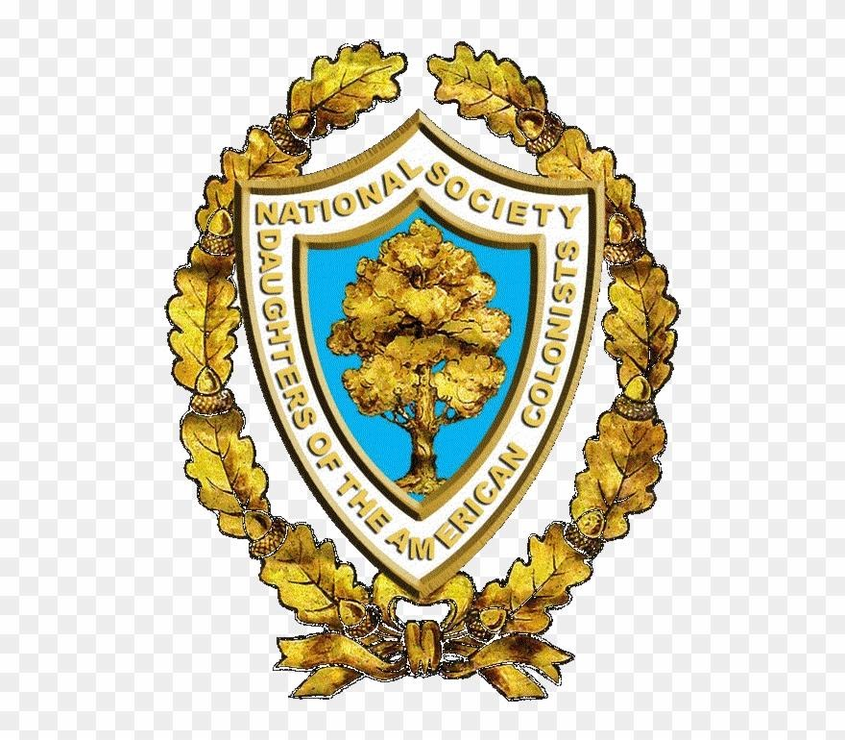
National Awards
The National Awards Committee has a fascinating history of more than fifty years as a vital activity of the National Society Daughters of the American Colonists. Medals of Award may be presented by state societies and chapters on college and high school campuses for proficiency in academic subjects, ROTC activities, and Good Citizenship. Through this committee, the National Society sponsors awards presented to honor graduates at the military academies and special training facilities of the United States of America. These awards are financed with generous contributions from state societies, chapters, and individual members. The committee presents the listed National Awards below annually:
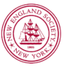
NES Scholarship Program
The New England Society in the City of New York (NES) awards scholarships each year to deserving New York City high school students who will be attending a college or university in New England. To qualify for consideration, the candidate must:
- be an incoming freshman to an eligible New England college or university as described below (in the states of Connecticut, Maine, Massachusetts, New Hampshire, Rhode Island, or Vermont),
- live and attend high school in one of the five boroughs of New York City, and
- have a demonstrated need of financial aid.
Eligible Institutions
New England Society scholarships are sent directly to the recipient’s college or university to be utilized solely for the benefit of the student to reduce his or her financial burden. NES scholarships cannot be used to displace other grants or aid packages awarded by the institution. They are only available to supplement, not displace, grants from the college and university. For this reason, applications will not be considered from students who will be attending schools with financial aid policies under which they meet full demonstrated financial need without using loans (i.e., “no loan” schools). It is the responsibility of each student to become thoroughly familiar with the policies and guidelines of their institution. Questions relating to eligible institutions should be directed to the NES office.

