Training the next generation of the Prosterity is a Top Priority!

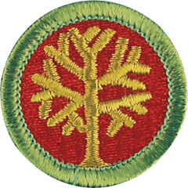

Genealogy Merit Badge

Genealogy Exploring your roots—where your family name came from, why your family lives where it does, what your parents and grandparents did for fun when they were your age—can be fascinating. Discovering your ancestors back through history is what genealogy is all about.

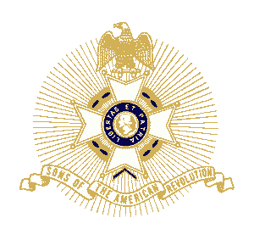

ARTHUR M. AND BERDENA KING EAGLE SCOUT SCHOLARSHIP CONTEST

Open to all Eagle Scouts who are currently registered in an active unit and have not reached their 19th birthday during the year of application. he application consists of three parts:
- Eagle Scout Application
- Eagle Scout Ancestor Chart
- 500 word Patriotic Themed Essay

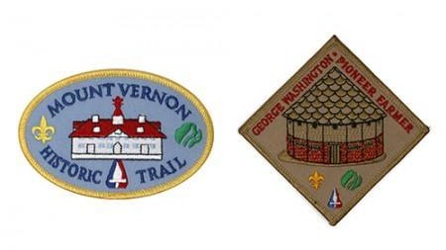

Mount Vernon Scouting Booklet

This guide takes scouts on a scavenger hunt around the estate while learning about George Washington. Completion of the route included in the booklet will earn scouts the Mount Vernon Historic Trail patch and the George Washington: Farmer patch.
DOWNLOAD SCOUTING BOOKLET

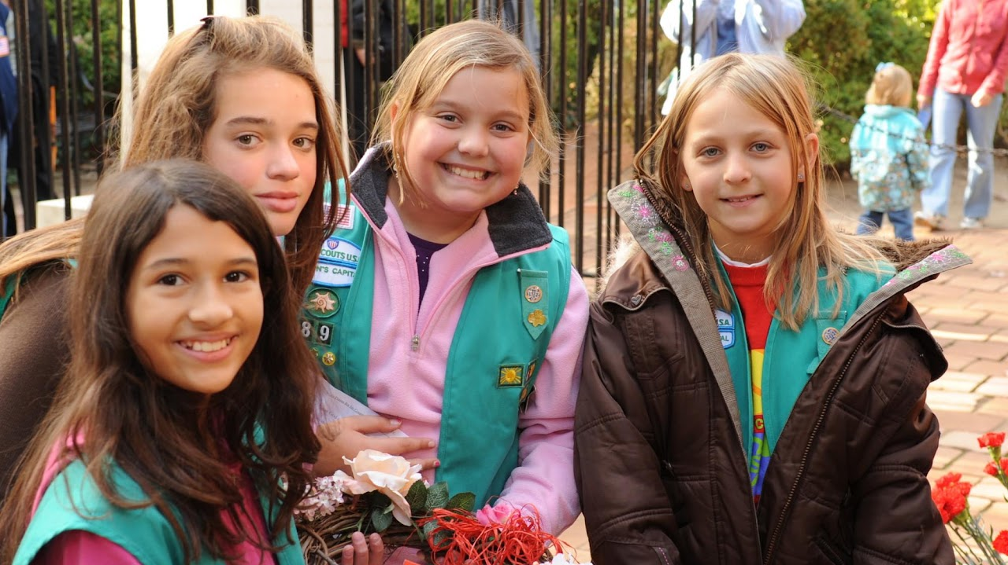

Brownie and Girl Scout Badge Activities
These Mount Vernon related activities can help your Brownie or Girl Scout earn badges at their grade level.
DOWNLOAD SCOUTING BOOKLET

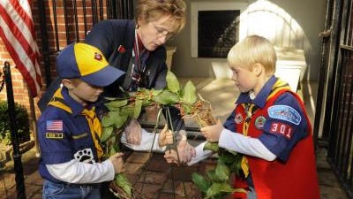

Scouts BSA Badge Activities
These Mount Vernon-related activities can help scouts earn merit badges at their grade level.
DOWNLOAD SCOUTING BOOKLET



My Family Story (Brownie)

Use the DAR Museum collections to explore how family histories are collected and preserved. Share stories about your family with other Brownies and play a game to see how stories change over time. Then, write about your day and life in a brand-new diary and create a family tree to tell your family story! This program results in earning the "My Family Story" badge, which is included in the registration price.



Playing the Past (Junior)

Travel back to 1913 to join the Women's Suffrage March! Create your own "Votes for Women" sash and write a speech advocating for a woman's right to vote. Learn about some of the heroines of the movement, including women that participated in the march right here in DC. What would it be like to be a girl at this time? Why is it important that women have the right to vote? This program results in the "Playing the Past" badge, which is included in the registration price. (2 hours, $10/scout).

