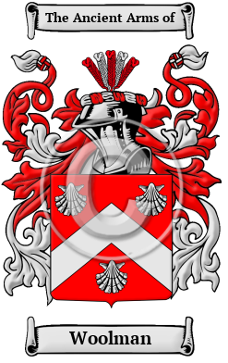
Woolman
The surname Woolman was first found in Hampshire at Woolmer, between Liphook and Bordon. The surrounding Woolmer (Wolmer) Forest, is a Royal forest. Woolmer Green is a small village and civil parish in Hertfordshire. Variations of the family name include: Wolmer, Woolmer, Wollmore, Woolman, Ullmer, Ulmer, Wollmer, Wulmar, Wulmare, Wilmore, Wilmer, Wilmere, Wulmere, Woolmore, Woolmore, Wollmor and many more.

