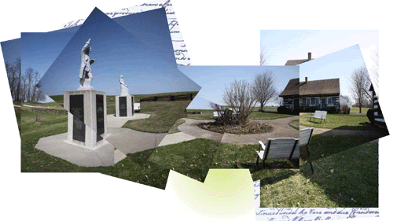
Strawbridge Shrine
The original home (circa 1760) of Robert & Elizabeth Strawbridge. It is in this modest farmhouse that Methodism in America was first established. From here, Robert Strawbridge rode the circuit and planted the seeds of what would become a new denomination. The Strawbridge Shrine historic buildings and Visitors Center can be made available most days by scheduling your personal or group visit with the Curator. In addition, we are open for drop-in visits April through October during the following regular hours:
- Fridays 10:00 AM - 4:00 PM
- Saturdays 10:00 AM - 4:00 PM
- Sundays 1:00 PM - 4:00 PM
For information, or to arrange your tour, contact us at:
- 443-289-0191 (New phone number as of, January 2023)
- Tours@StrawbridgeShrine.org
2650 Strawbridge Lane New Windsor, Maryland 21776

