As the hometown of George Washington, Alexandria and its surrounding areas is no stranger to history. Washington, D.C., beautiful Mount Vernon, Arlington Cemetery and the National Masonic Temple are all just minutes away. Before or after their visit, guests have easy access to famous Old Town sites such as Robert E. Lee's boyhood home, George Washington's Townhouse and Market Square, one of the oldest market places in the whole country.

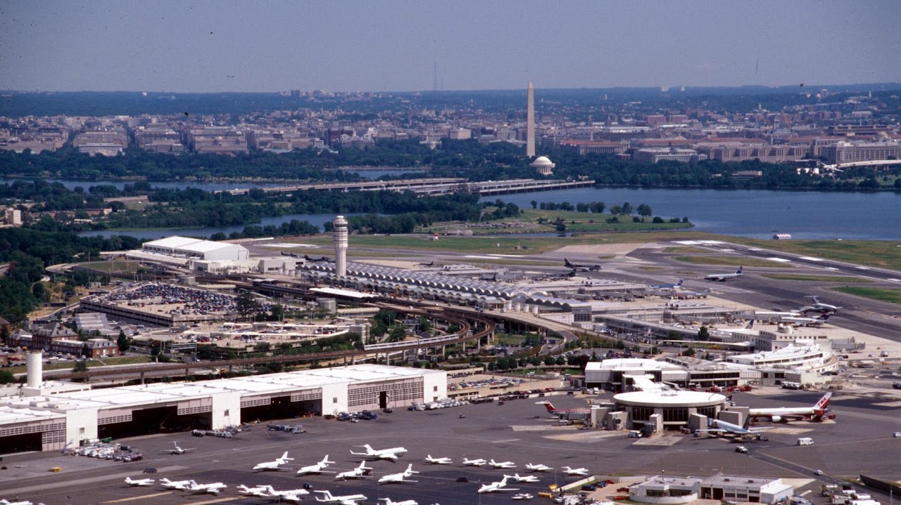

Reagan National Airport
From here you can go just about anywhere in the greater Washington DC area

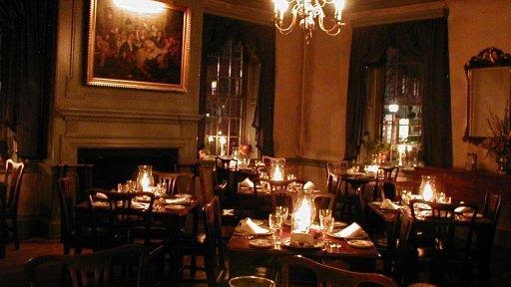

Gadsby’s Tavern
138 N. Royal Street Alexandria, Virginia 22314 info@gadsbystavernrestaurant.com (703) 548-1288
Nearly all of the founders of American Independence enjoyed the warm tavern hospitality of Gadsby’s Tavern. No public building in America is more intimately associated with the struggle for independence and establishment of national sovereignty. For nearly a century, it was a center of political, social and cultural life in this important colonial seaport community. OpenTable.
Sunday Brunch 11:30am to 2:30pm
Wednesday through Saturday Lunch 11:30am to 2:30pm
Wednesday through Sunday Dinner from 5:30pm

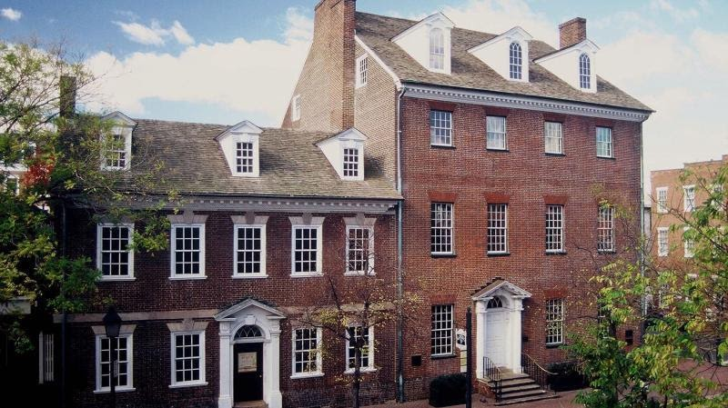

Gadsby’s Tavern Museum

Regular admission can only be purchased in-person at the Museum at the time of your visit.
Adults: $5 Children (ages 5 -12): $3 Children four and under are free with a paying adult.
Sunday Family Day with Young Historians 2:00 PM - 5:00 PM
A $1 discounts on regular admission is available to AAA Members and visitors who have dined at Gadsby's Tavern Restaurant.
Gadsby's Tavern Museum, 134 N. Royal St

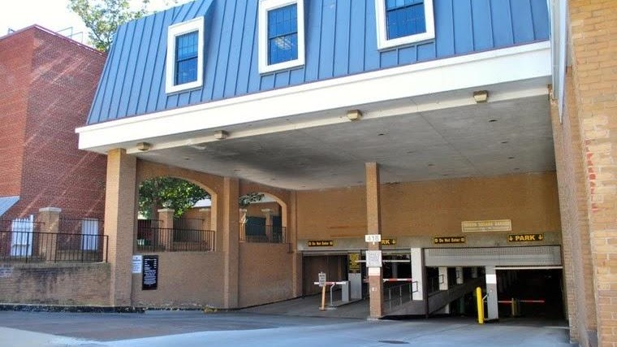

Tavern Square Parking
418 CAMERON STREET ALEXANDRIA, VIRGINIA.
Parking Map.

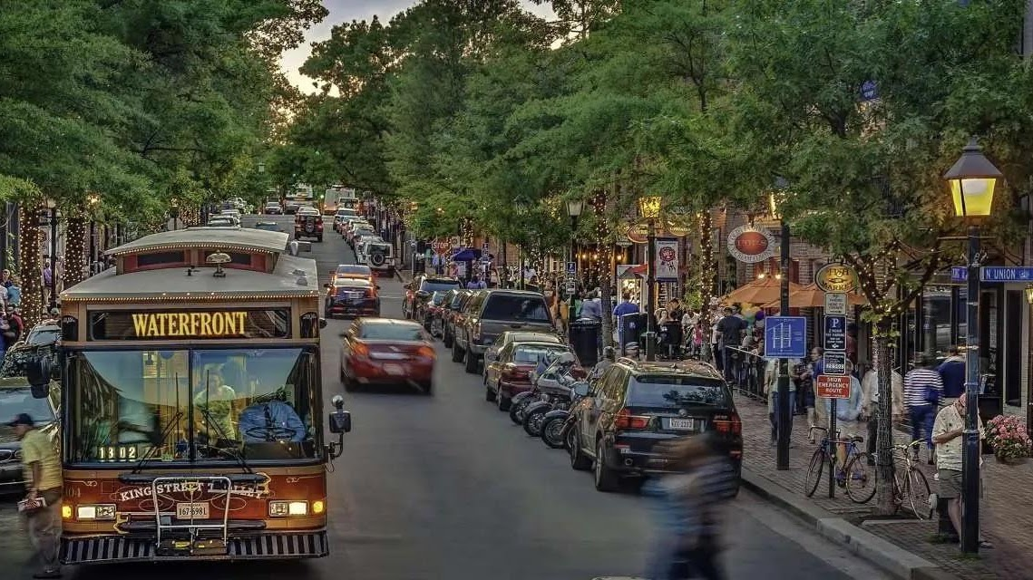

King Street Trolley
For making your way along historic King Street in the heart of , there’s no easier, quicker way than the FREE King Street Trolley. With stops every two to three blocks from to the King St – Old Town Metrorail station, trolleys provide easy on-off access to the more than 200 , and found in Old Town Alexandria. Download the map.

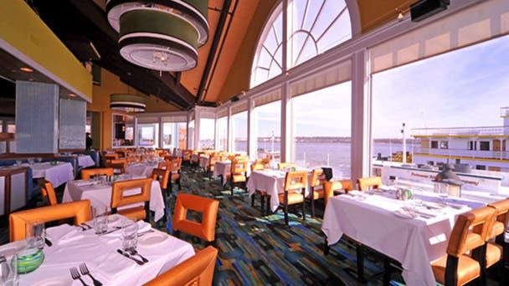

Chart House
Chart House Alexandria is still the sight to see. Hands down, Chart House is the best river view restaurant in the city. Whether dining outside on the patio or indoors, our seafood restaurant gives gorgeous panoramic views of the waterfront and the sparkling city. Brunch is EVERY SUNDAY | 11 AM - 2 PM. Kids meals are currently $12. Discounts for AARP. Parking next door at Thomason Alley currently $5 for Sunday
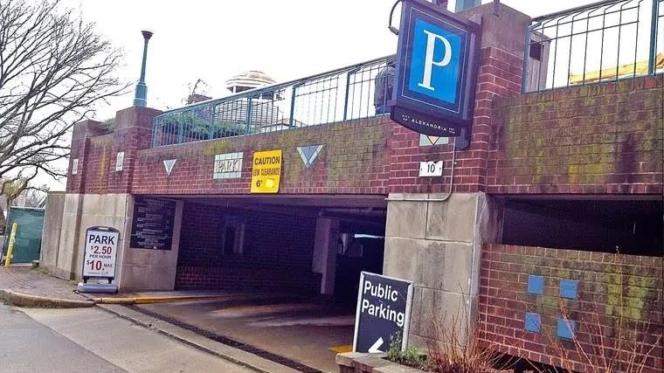

Thompson’s Alley Parking
10 THOMPSON’S ALLEY ALEXANDRIA, VIRGINIA
Weekend and Holidays: one hour $2.50; max $5
More Info.

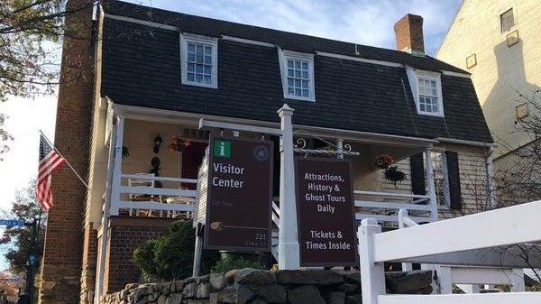

Visitor Center
Alexandria Visitor Center (703) 746-3301
visitalexandria.com
221 King St, Alexandria, VA 22314
Closes 6 PM

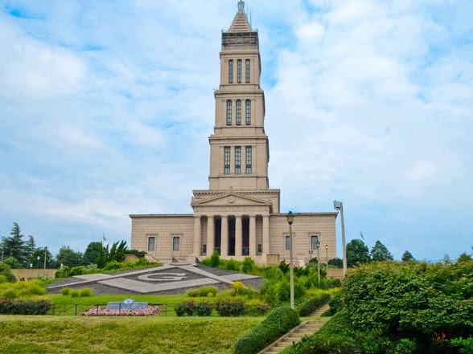

George Washington Masonic Temple
The Memorial is now open on Monday, Thursday, Friday, Saturday, and Sunday (closed on major holidays). Four tours run daily at 9:30 a.m., 11:00 a.m., 1:30 p.m., & 3:30 p.m. The guided tour is one hour in length. Currently the price is $20 per adult and FREE for Children 12 and under. Advance reservations are required.


Pentagon Visitor Center
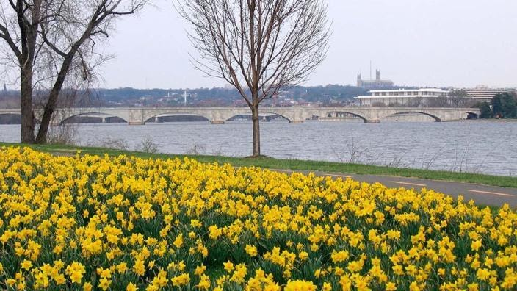

George Washington Memorial Parkway

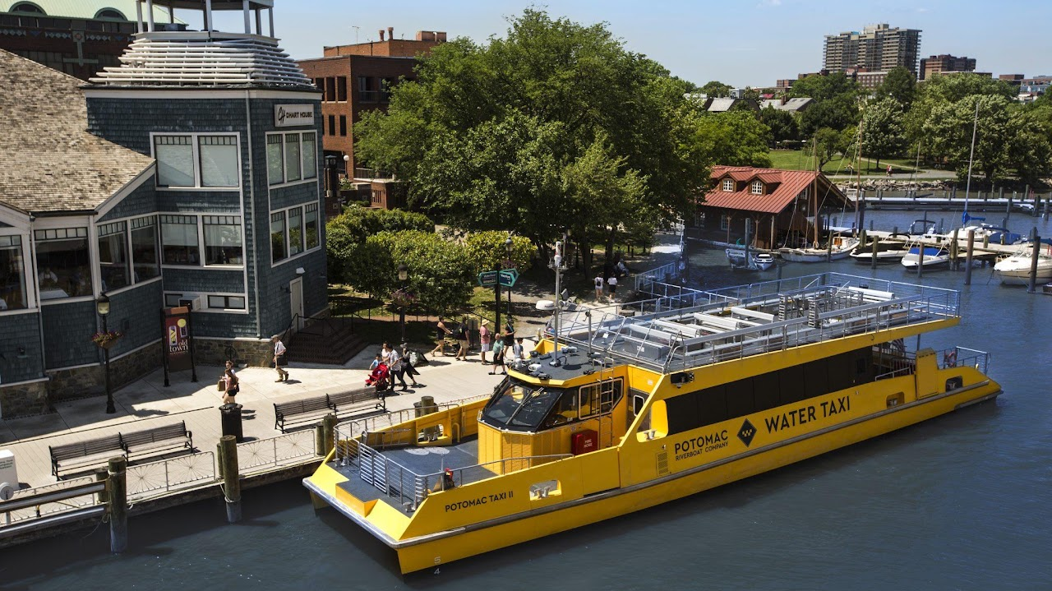

Water Taxi
Starting at $22 hour per person. To book.
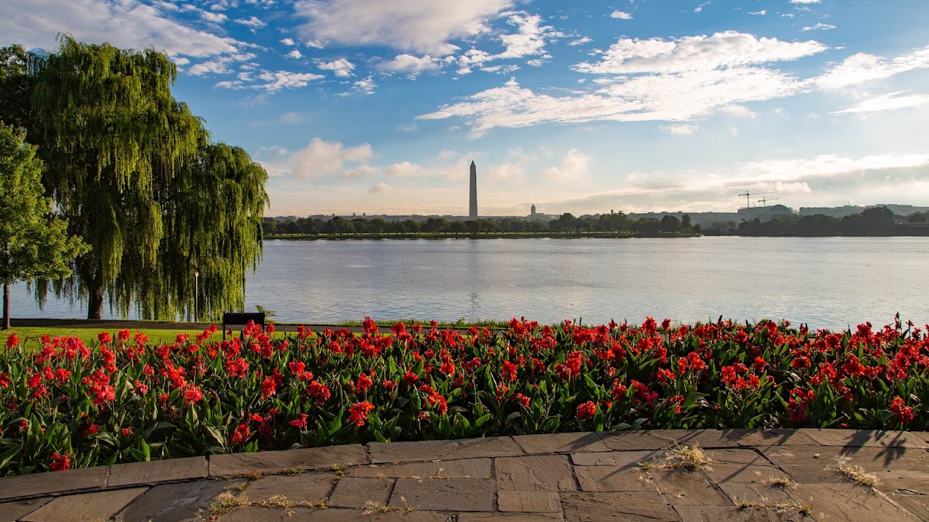

Lady Bird Johnson Park

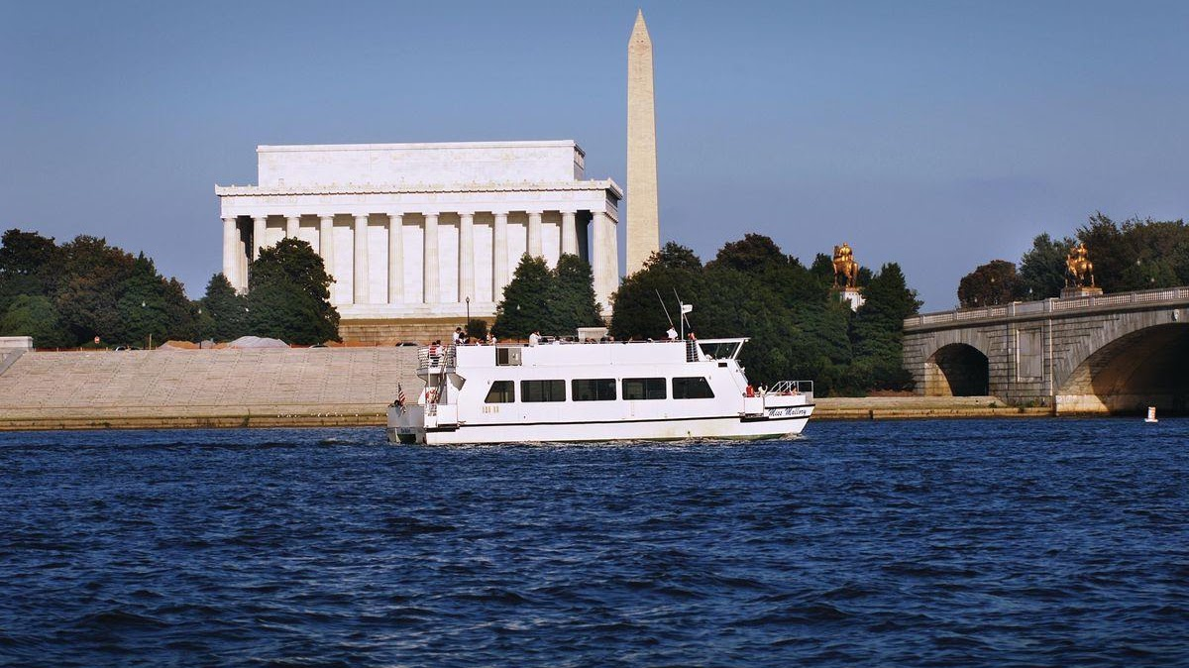

Monuments Sightseeing Tour From Alexandria
See the famous monuments of Washington, D.C. from an entirely new perspective on this narrated sightseeing cruise. Travel along the Potomac River to see the plethora of famous monuments and landmarks, with stunning reflective views of the Thomas Jefferson Memorial, the John F. Kennedy Center for the Performing Arts, the Washington Monument, the Arlington Memorial Bridge, and more. The docks for this tour are not ADA Compliant. Please visit our Potomac Water Taxi page which offers cruise options to the Wharf and National Harbor. We also offer an option to Mount Vernon From DC.

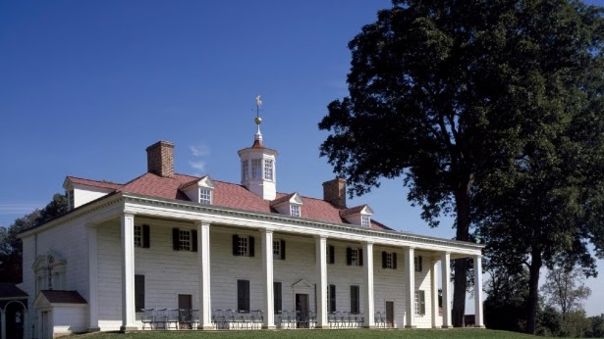

Mount Vernon
Scout Days start on November 1
All children that are Boy Scouts, Girl Scouts, and Camp Fire Club members, in uniform or wearing an official pin, are admitted FREE to the estate through Feb. 17. The Mansion tour is limited and subject to availability. Two leaders from each group will receive discounted admission. During this time period the Farm will not be staffed, however, we invite your troops to:
Tour the Mansion.
Lay a wreath at the General's Tomb (must be reserved in advance by contacting our Reservations Office at 703-799-8688 or groups@mountvernon.org).
Explore our state-of-the-art galleries and theaters in the Donald W. Reynolds Museum and Education Center.

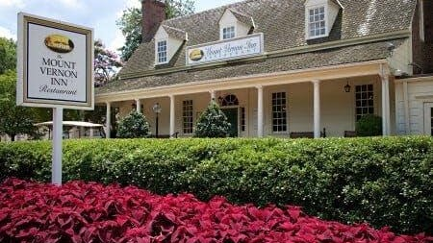

Mount Vernon Inn
3200 Mount Vernon Memorial Highway, Mount Vernon, VA 22121
703.799.5296
Sunday: 10 a.m. to 5 p.m.
Monday: 11 a.m. to 5 p.m.
Tuesday - Friday: 11 a.m. to 8 p.m.
Saturday: 10 a.m. to 8 p.m.

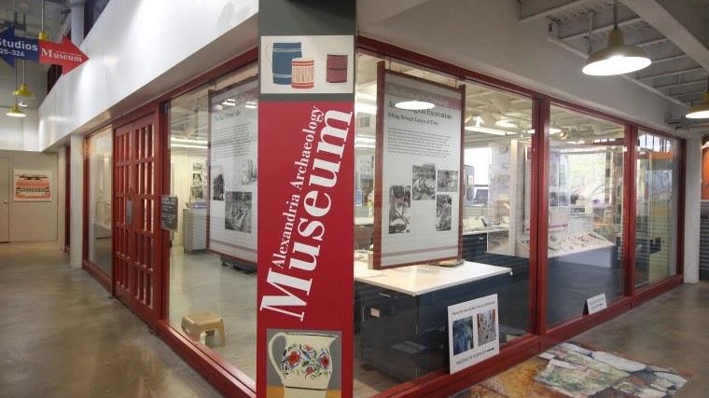

Archaeology Museum

105 N. UNION STREET, TORPEDO FACTORY ART CENTER THIRD FLOOR, #327 ALEXANDRIA, VIRGINIA
Step right into the museum’s laboratory where archaeologists reconstruct Alexandria’s history, fragment by fragment. The museum’s exhibits highlight the process of archaeology and the latest Alexandria finds. A Community Digs its Past: The Lee Street Site, the museum’s main exhibit, weaves the story of the wharves, taverns, bakery and Civil War privy excavated at the corner of Lee and Queen Streets together with the story of archaeologists at work, from excavation and historical research to artifact processing and archaeological conservation. In the Museum’s Public Laboratory, you may find volunteers washing, marking and cataloging artifacts from the latest dig. Participate in hands-on activities, and explore small temporary exhibits highlighting archaeological research. The museum is open Fridays and Saturdays 11 a.m.-4 p.m., and Sundays 1-4 p.m.

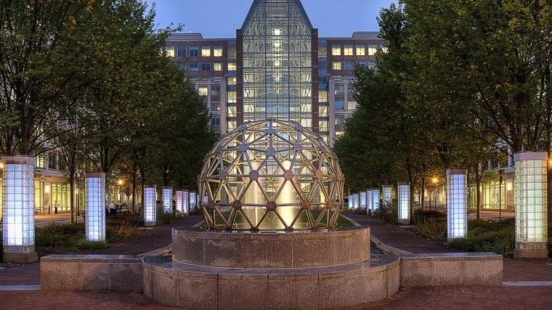

National Inventors Hall of Fame
600 DULANY STREET ALEXANDRIA, VIRGINIA.
Experience the past, present and future of American ingenuity as you are introduced to more than 600 world-changing Inductees and immersed in stories of passion, perseverance and progress. Admission to the museum is always FREE — the perfect way to add a fun, kid-friendly learning experience to your trip to the Washington, D.C., area. Monday - Friday, 10 a.m. to 4 p.m.
The first Saturday of every month, 11 a.m. to 3 p.m.*
Sundays and federal holidays, CLOSED



St. Andrew & St. Margaret
The Church of St. Andrew and St. Margaret of Scotland is a vibrant, growing parish within the Anglican Catholic Church located just outside our nation’s capitol in the heart of Northern Virginia. We are Anglican because our tradition of prayer and worship is rooted in the Church of England and the Book of Common Prayer. We are Catholic because we believe and practice the universal or catholic faith of the church. We are your friendly neighborhood Traditional Anglican/Episcopal Parish.
402 E. Monroe Ave Alexandria, VA 22301
Phone: (703) 683-3343
Fax: (703) 683-2645
Email: sta_stm@comcast.net

