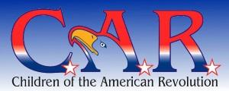
Children of the American Revolution
"Any boy or girl under the age of twenty-two is eligible for membership in the National Society of the Children of the American Revolution who is lineally descended from a man or woman who, with unfailing loyalty, rendered material aid to the cause of American Independence as a soldier, sailor, civil officer, or recognized patriot in one of the several Colonies or States, or of the United States, provided that the applicant is personally acceptable to the Society."
The N.S.C.A.R. Application for Membership

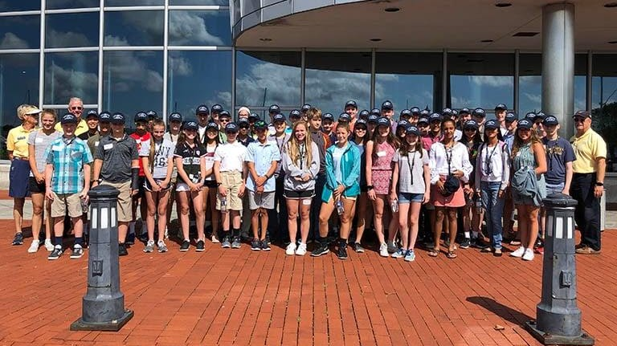

Youth Leadership Program
Developing leaders for tomorrow begins today! Give students ages 13-15 a taste of robust leadership training. Equip them for the future they'd like to pursue. Students will spend a half-day in the Student Youth Leadership Program learning and developing applicable leadership skills from some of the brightest of today's leaders at the U.S. Naval Academy.



National History Day
National History Day®(NHD) is a non-profit education organization based in College Park, Maryland. NHD sponsors the National History Day Contest that encourages more than half a million students around the world to conduct historical research on a topic of their choice. Students enter these projects at the local and affiliate levels, with top students advancing to the National Contest at the University of Maryland at College Park. The 2022-2023 theme is Frontiers in History: People, Places, Ideas.

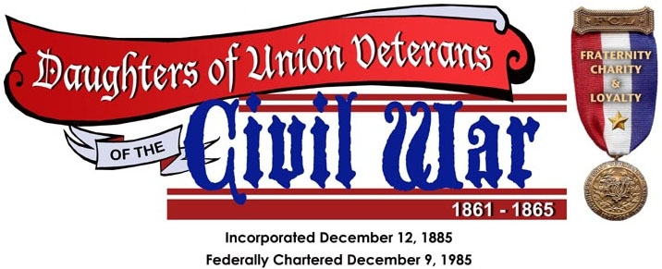

Daughters of Union Veterans of the Civil War
Eligibility for membership in the Daughters of Union Veterans of the Civil War, 1861 – 1865 is based on the eligibility as formerly required for membership in the Grand Army of the Republic and shall be limited to daughters, granddaughters, and great granddaughters of any generation through lineal descent only. As stated in our National Constitutions and Bylaws, this shall never be changed. The minimum age for membership shall be eight years of age


Wreaths Across America
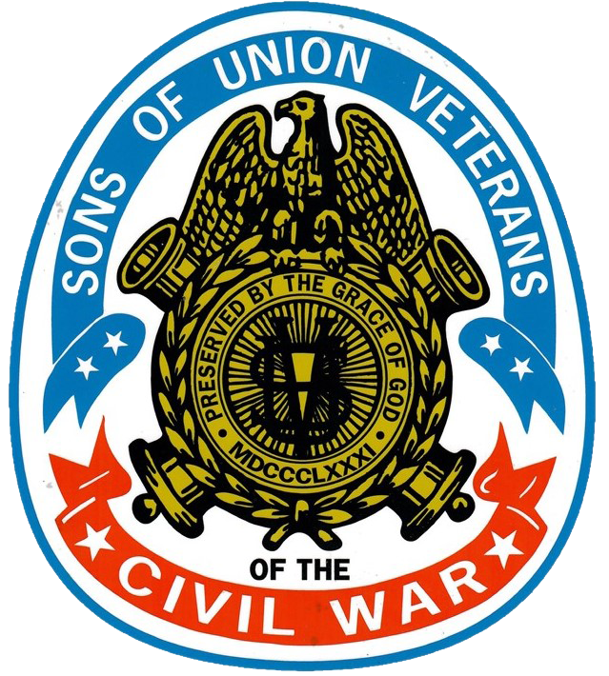

SUV Junior Membership

Hereditary membership is available to a male descendant, 14 years of age (6 to 14 for Juniors), who meets the following requirements:
- You must directly descend from a Soldier, Sailor, Marine or member of the Revenue Cutter Service (or directly descend from a brother, sister, half-brother, or half-sister of such Soldier, etc.) who was regularly mustered and served honorably in, was honorably discharged from, or died in the service of, the Army, Navy, Marine Corps or Revenue Cutter Service of the United States of America or in such state regiments called to active service and was subject to the orders of United States general officers, between April 12, 1861 and April 9, 1865.
- You must never have been convicted of any infamous or heinous crime.
- You, or the ancestor through whom membership is claimed, must never have voluntarily borne arms against the government of the United States.

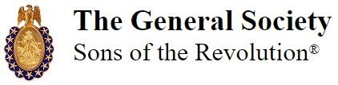
Sons of the Revolution
Any male person of good character, and lineal descendant of one who, as a military, naval or marine officer, soldier, sailor, or marine, in actual service, under the authority of any of the thirteen Colonies or States or of the Continental Congress, and remaining always loyal to such authority, or a lineal descendant of one who signed the Declaration of Independence, or of one who, as a member of the Continental Congress, or of the Congress of any of the Colonies or States, or as an official appointed by or under the authority of any such legislative bodies, actually assisted in the establishment of American Independence by services rendered during the War of the Revolution, becoming thereby liable to conviction of treason against the Government of Great Britain, but remaining always loyal to the authority of the Colonies or States, or, who served honorably in a military or naval expedition against the British during the War of the Revolution under the authority of the French or Spanish Governments shall be eligible to membership in the Society. Both Senior and Junior (the latter under the age of eighteen years) memberships are available.

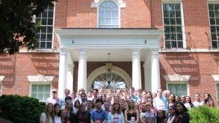

Congressional Seminar Essay Contest for High School Students
The Congressional Essay Contest is run by NSCDA Corporate Societies and Town Committees across the United States. Freshman, sophomore, junior, or senior year high school students submit essays that are then judged and awarded. The essay topic changes annually.



Job’s Daughters International
Job’s Daughters International is where shy girls turn into confident young women. Our members grow alongside their peers and find their voice in a safe and supportive environment. The girls lead themselves and plan their own activities, learning teamwork and problem solving along the way

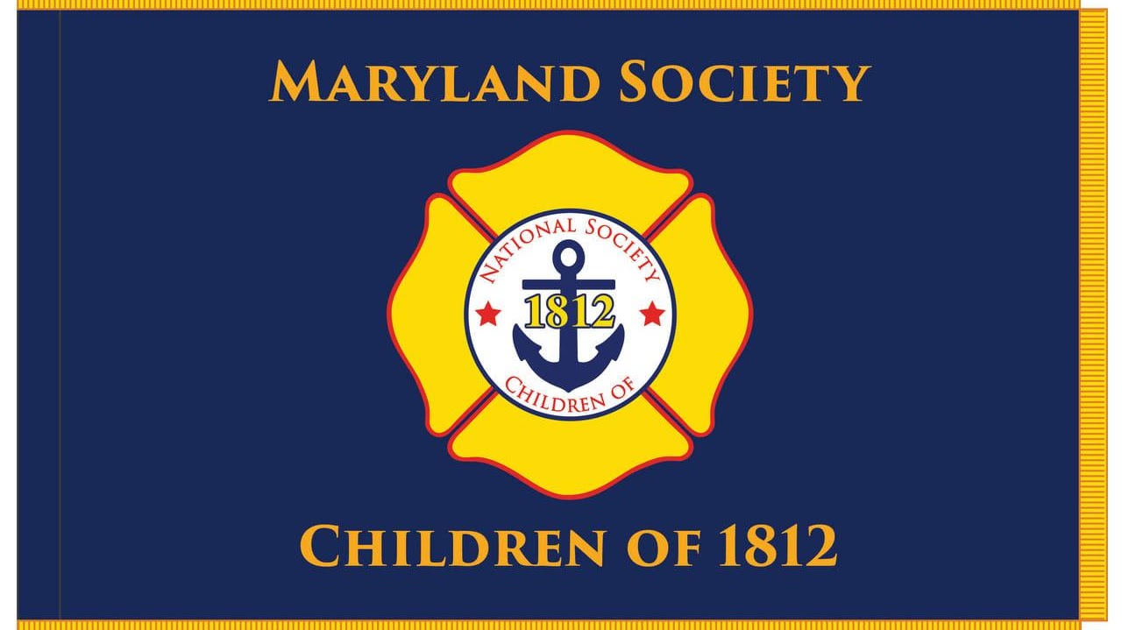

Maryland Society Children of 1812

