Ecumenical

This National Council of Churches members include Evangelical Lutheran Church in America, American Baptist Churches USA, Moravian Church in America, Polish National Catholic Church, Presbyterian Church USA, Friends United Meeting, Philadelphia Yearly Meeting, United Church of Christ, Reformed Church in America, United Methodist Church and the Episcopal Church USA

List of Historical Churches:
Chester Friends Meetinghouse 520 East 24th Street in Chester, Delaware County, Pennsylvania, United States
Hopewell Friends Meeting House 604 Hopewell Road, Clear Brook, VA 22624
Springfield Friends Meeting High Point North Carolina
Cane Creek Friends Meeting 719 W Greensboro Chapel Hill Rd, Snow Camp, NC, United States, 27349
Deep River Friends Meeting 5300 West Wendover Avenue High Point, NC 27265
New Garden Friends Meeting 801 New Garden Road Greensboro, N.C. 27410
Third Haven Friends Meeting (Quaker) 405 S. Washington St., Easton, MD 21601; (410) 822-0293

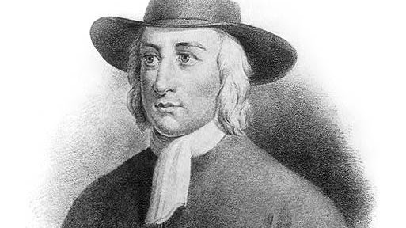

George Fox
Commemoration Day: 13 January
Renewer of Society 1691
Barclay Catechism
Faith and Practice



Friends Committee on Scouting
Friends Committee on Scouting serves to encourage and promote the faith, history, and testimonies of the Religious Society of Friends (Quakers) through religious education programs for Quaker Scouts/Guides.

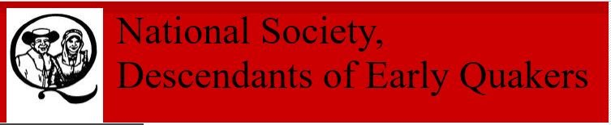

Early Quaker Descendants
Men, Women and children who establish descent, either lineal or collateral, from an early member of the Society of Friends (1835 or before), throughout the world, shall be eligible for membership. Junior members are eligible from birth to age 25 years.

