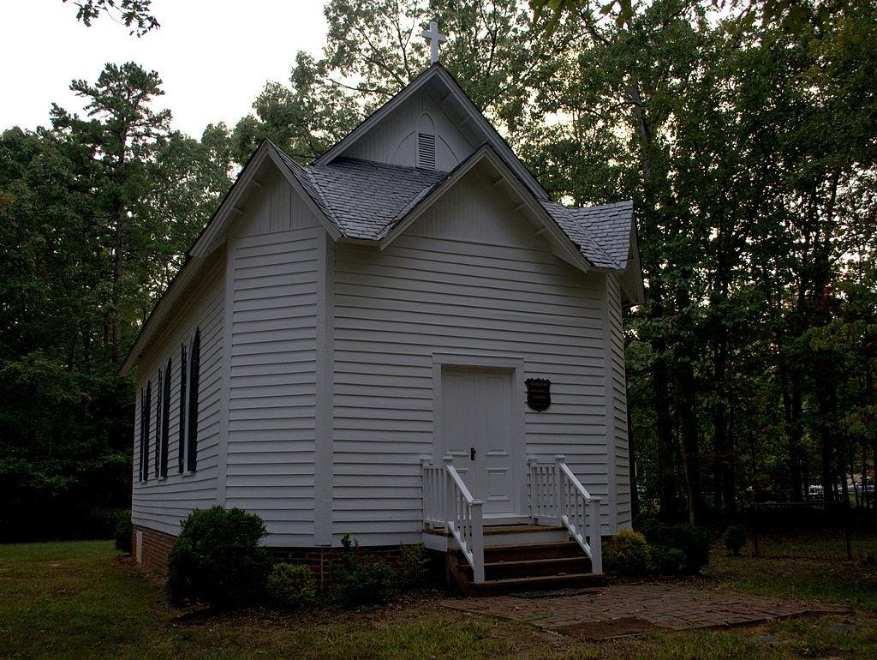
Huguenot Memorial Chapel and Monument
Huguenot Memorial Chapel and Monument is a historic church located at Manakin, Powhatan County, Virginia. Built in 1700 by French Huguenots, Protestant refugees, it was moved to its current location in 1710. It burned down in the Revolutionary War and was later rebuilt with parts of the original building. It is in what is called the Carpenter Gothic style. A new church was built next to this in 1954, and is the one still currently used. It was added to the National Register of Historic Places in 1988
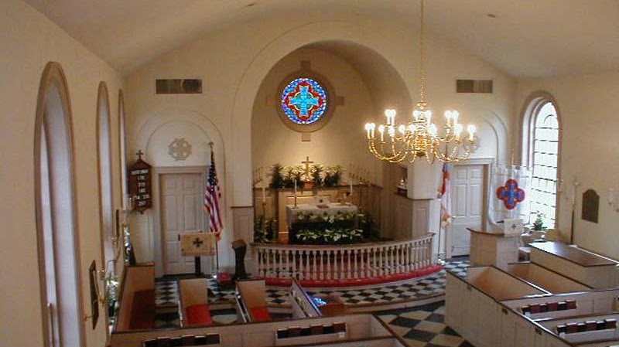
Manakin Episcopal Church
Our church origins extend back over three hundred years to the year 1701. The founding community of Huguenots was made up of French Protestants who followed the teachings of John Calvin. They had been forced to leave their homeland by the religious persecution that followed Louis XIV’s revocation of the Edict of Nantes in 1685. Fleeing to England, they became ardent supporters of William of Orange and helped him defeat James II. In gratitude for their support, William made it possible, in 1700, for many of them to move to the American Colonies by providing them with both land and financial aid. On June 23, 1700, the first shipload of Huguenots arrived in Virginia, followed later that same year by two more shiploads of refugees. Further aided by William Byrd, they settled on land along the James River about twenty miles west of Richmond. Formerly a Monacan Indian settlement, the new community was known as Manakintowne. In December 1700, the Virginia House of Burgesses passed an act stating that the French settlers constituted a “distinct parish themselves” that would be called King William Parish. Additionally, they were exempted from having to pay any parish taxes and were allowed to determine the appropriate salary for their clergy. “The parish was duly organized and, by common consent or agreement, the liturgy of the Church of England was used in their services. There seems no reason to doubt that they might have retained a dissenting status and held services in their own language if they had so desired, as did the German Lutherans who came into the Shenandoah Valley forty years later. But certainly the Huguenots adopted the wiser course in holding their services in the language of the country in which they expected to make their future home.”

