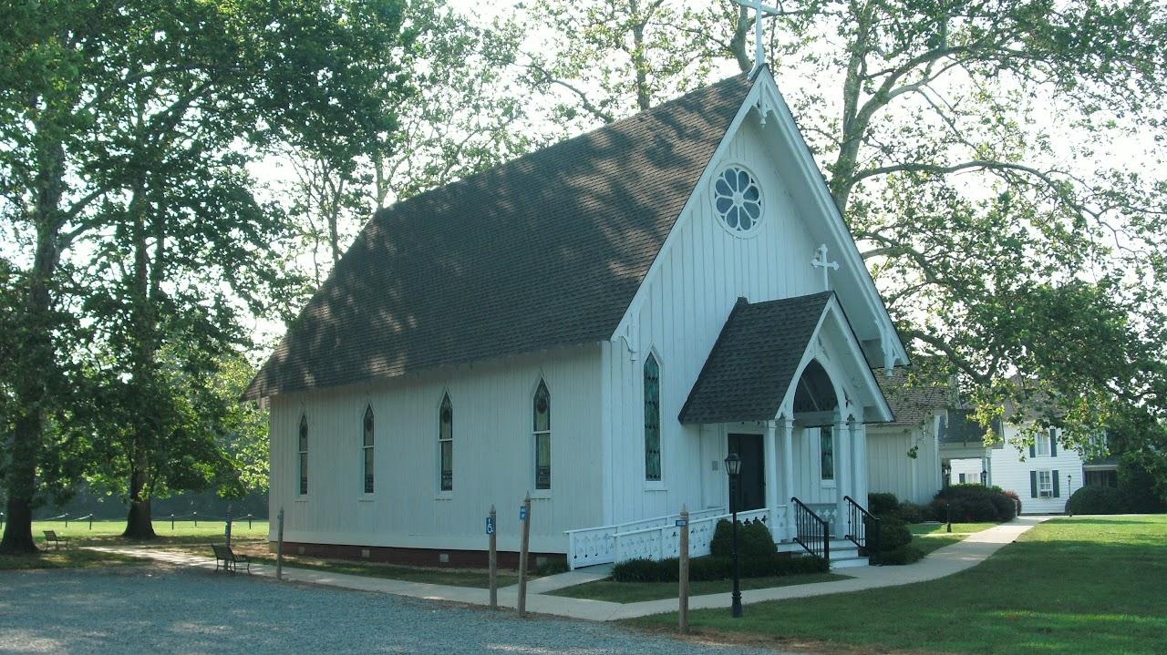

St. Stephens Episcopal
The original St. Stephen's Parish was formed in 1698 by combining Bowtracy and Fairfield parishes. Fairfield, earlier known as Chickacoan Parish, embraced the area to the north of the Wicomico River, dated from 1648. St. Stephen's was represented in the first convention of the Episcopal Church of Virginia in 1785, and the parish sent representatives to the Council Conventions intermittently until 1799. National Register of Historic Places (#79003060
6807 NORTHUMBERLAND HIGHWAY, HEATHSVILLE, VA 22473

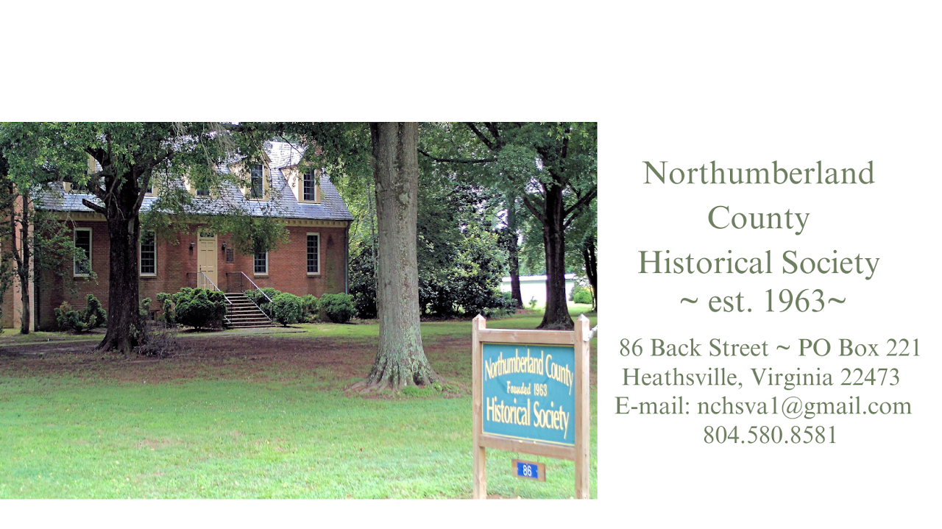

Northumberland County Historical Society
Northumberland County Historical Society
86 Back Street • P.O. Box 221 Heathsville, Virginia 22473
Please call us at 804.580.8581 or contact us
Surname List

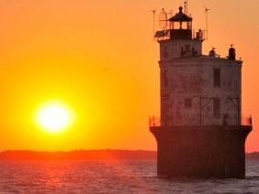
Bay and River Cruises
We offer a wide variety of cruises for any occasion. If you don’t see it on the following list – just ask!
- Tangier Island Cruises
- Waterfront Dining Cruises
- Lighthouse Tours
- Creek Peek Tours
- Sunset Cruises
- Moonlight Cruises
- Chesapeake Bay

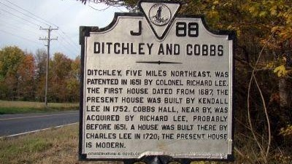

Ditchley and Cobbs
Ditchley, five miles northeast, was patented in 1651 by Colonel Richard Lee. The first house dated from 1687, the present house was built by Kendall Lee in 1752. Cobbs Hall, near by, was acquired by Richard Lee, probably before 1651. A house was built there by Charles Lee in 1720; the present house is modern.
map

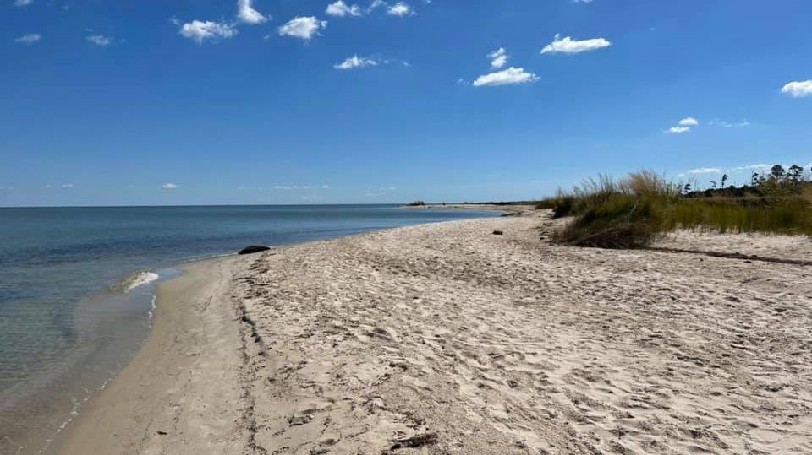
Dameron Marsh Natural Area
The 316-acre Dameron Marsh Natural Area Preserve is one in a series of protected lands that line the western and eastern shore of the Chesapeake Bay in Virginia. This preserve contains one of the most significant wetlands on the Chesapeake Bay for marsh-bird communities, and its pristine beach habitat is highly important for the federally threatened northeastern beach tiger beetle (Cicindela dorsalis dorsalis). DCR's efforts to conserve sites like Dameron Marsh are an effective means to sustain these important coastal ecosystems and both rare and common species. Dameron Marsh supports impressive salt marsh communities, sand beach, and upland forest habitats.
QMMX+3C Kilmarnock, Virginia
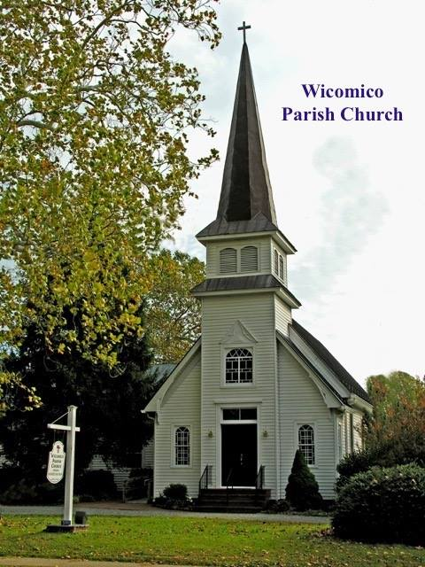

Wicomico Parish Church
In 1646 during the government of Sir William Berkeley, an Act of the Assembly: . . "Whereas, the inhabitants of Chicawane, alias Northumberland, being members of this Colony," etc. The following year an Act . . ."That the ninth Act of Assembly of 1647, for reducing the inhabitants of Chickoun and other parts of the neck of land Rappahannock and Potomacke Rivers, be repealed, and that the said tract of land be hereafter called and known by the name of the county of Northumberland."
On May 9, 1753, to replace the second church. Work was to be completed in five years. It was to be an explicit copy of Christ Church, Irvington/Weems, only five feet bigger. (A little society thing, what with the LEE family at Wicomico and the CARTERS at Christ Church.) Serious delays and modifications set back the start of the third church until 1766, ten years before the American Revolution began.
5191 Jessie Ball DuPont Memorial Hwy, PO Box 70, Wicomico Church, VA 22579
804-580-6445
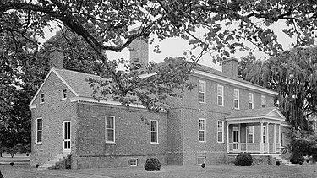

Ditchley
Ditchley is a historic plantation house located near Kilmarnock, Northumberland County, Virginia. It was built in 1762, and is a two-story, Georgian style brick mansion with a hipped roof. It consists of a five bay main block flanked by one-story wings. Original built in 1687. This plantation was a grant to Col. Richard Lee I and was named for a Lee estate near Oxford, England. It was listed on the National Register of Historic Places 92001272
37°44′03″N 76°20′05″W

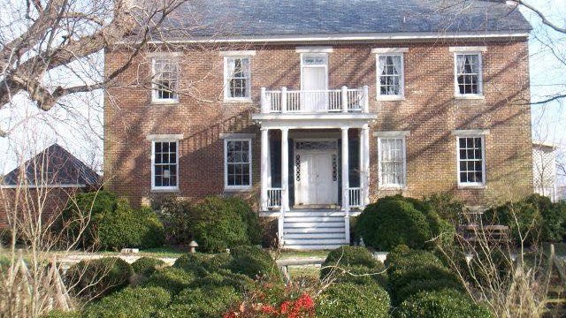
Cobb's Hall
Cobbs Hall is a historic plantation house located at Kilmarnock, Northumberland County, Virginia. It was built in 1853, on the foundations of an earlier dwelling of the same design. It is a two-story, five-bay, double pile brick dwelling with a gable roof. The front and rear facades feature similar porches supported by Tuscan order columns. The ends have two semi-exterior end chimneys flanking the peak of the gable. Also on the property are the contributing Cobbs Hall graveyard containing Lee family remains, the remains of a 1+1⁄2-story brick dwelling, and a brick meat house. Cobbs Hall is one of the noted Northern Neck plantations associated with the Lee family of Virginia since the middle of the 17th century. It was listed on the National Register of Historic Places 0100069
582 Cobbs Hall Ln., Kilmarnock, Virginia
Northern Neck Driving Tour

