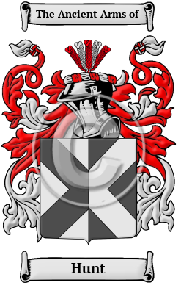

Hunt

The name Hunt finds its origins with the ancient Anglo-Saxons of England. It was given to one who worked as a hunter. The surname Hunt is derived from the Old English word hunta, which means hunter. Hunt has been recorded under many different variations, including Hunt, Hunter, Huntar and others.
In the United States, the name Hunt is the 148th most popular surname with an estimated 156,681 people with that name

