Full Communion

The Episcopal Church is in Full Communion with Lutheran Church through the Porvoo Communion.

The Episcopal Church is in Full Communion with Old Catholics through the Bonn Agreement.

This National Council of Churches members include Evangelical Lutheran Church in America, American Baptist Churches USA, Moravian Church in America, Polish National Catholic Church, Presbyterian Church USA, Friends United Meeting, Philadelphia Yearly Meeting, United Church of Christ, Reformed Church in America, United Methodist Church and the Episcopal Church USA

List of Historical Churches

St. John’s, Lafayette Square
Yeocomico Church
Historic Christ Church Lancaster County Virginia
St. Mary's White Chapel
St. Stephens Episcopal
Manakin Episcopal Church
Christ Episcopal Church of Kent Island. Maryland oldest Christian congregation, 3rd oldest English speaking Church in the entire Western Hemisphere!

Anglican Communion
The Anglican Communion is the third largest Christian communion after the Roman Catholic and Eastern Orthodox churches. Formally founded in 1867 in London, the communion has more than 85 million members within the Church of England and other autocephalous national and regional churches in full communion. The traditional origins of Anglican doctrine are summarised in the Thirty-nine Articles (1571). The archbishop of Canterbury (as of 2024, Justin Welby) in England acts as a focus of unity, recognised as primus inter pares ("first among equals"), but does not exercise authority in Anglican provinces outside of the Church of England. Most, but not all, member churches of the communion are the historic national or regional Anglican churches.

King Henry VIII
(28 June 1491 – 28 January 1547) was King of England from 22 April 1509 until his death in 1547. Henry is best known for his six marriages, and his efforts to have his first marriage (to Catherine of Aragon) annulled. His disagreement with Pope Clement VII about such an annulment led Henry to initiate the English Reformation, separating the Church of England from papal authority. He appointed himself Supreme Head of the Church of England and dissolved convents and monasteries, for which he was excommunicated by the pope.

King James Bible

Book of Common Prayer

The above Book of Common Prayer includes the original Catechism for the Anglican (Episcopal) Church



Lay Preacher Training Initiative

The Lay Preacher Training Initiative (LPTI) of the Episcopal Preaching Foundation is completing a two-year training pilot program funded by a three-year, $400,000 grant from Trinity Church Wall Street in New York City.
Download a brochure about the program.

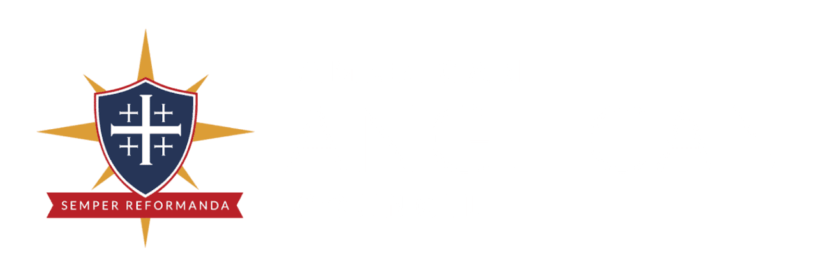

Lay Leadership Academy

The Lay Leadership Academy equips the saints for the work of ministry in their congregations and communities as they engage the culture around them. Its main conference, Formed, is held regionally across the Anglican Church in North America to encourage lay people to engage our culture around the full, four-chapter Gospel of creation, fall, redemption, and restoration. In addition, videos for vestries and chancellors equip those in these leadership roles to effectively lead in their congregations and dioceses. Our evangelism and renewal videos equip all laity to transform their communities in mission for the Kingdom of Christ. Search our resources below to find the support you need to fulfill God’s call on your life.

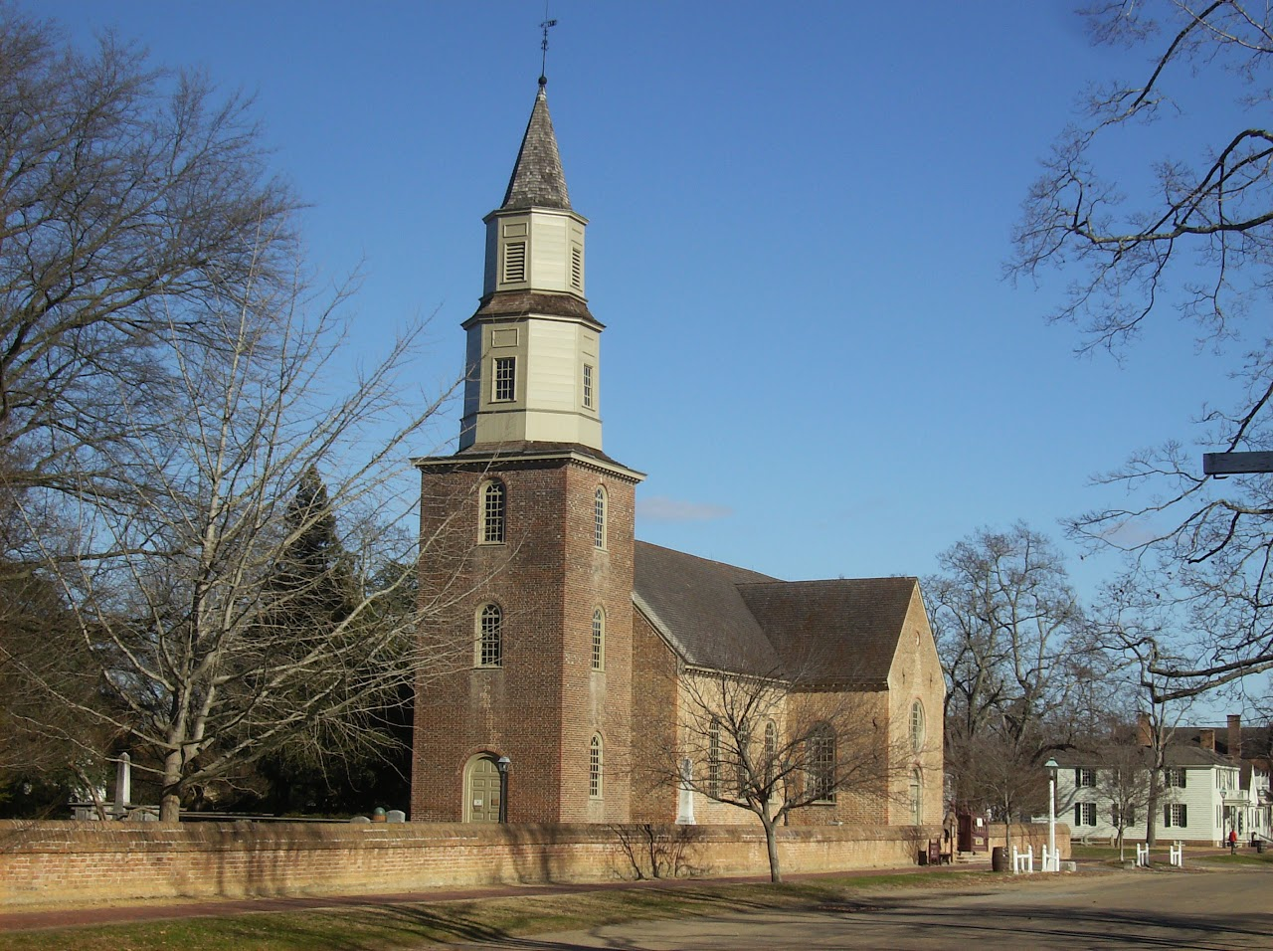

Bruton Parish

When they were members of the Virginia House of Burgesses, men who would lead the fight for independence and for creating a new government worshiped at Bruton. George Washington, Thomas Jefferson, and Patrick Henry attended when the legislature was in session. As emotions and rhetoric heated during the years before the American Revolution, special services took place at Bruton. After the Stamp Act passed in 1765, burgesses expressed their distress in a service at Bruton. The closing of the port of Boston in 1774 touched off another protest when the burgesses marched in solemn procession to the church for a Day of Fasting, Humiliation, and Prayer.
Bruton Parish Church Williamsburg, VA 23187-3520. 757-229-2891.

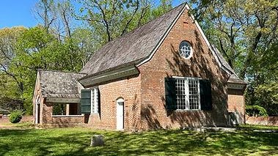

Yeocomico Church

The history of Yeocomico Church begins in 1655 with an order of the Northumberland County Court appointing the Vestry for the Yeocomico Congregation: Mr Nicholas Jurnew, Jno Powell. and Church-Warden, Richard Holden. At that time, the congregation was in Chicacoan Parish of Northumberland County. In 1655, Virginia was in its third year under the rule of Oliver Cromwell’s Commonwealth of England. The offices of King, Lords, and Bishops had been abolished, and were not reestablished until the Restoration of the King in 1660. Tradition says that the building was erected in 1655. If there were a vestry as noted in the order, then there may have been a church of some variety. The earliest mention of a church building is in a patent (grant) of August 1, 1663, on the Northwest Yeocomico granted to Luke Dyne and Thomas Beadles, in which one of the landmarks is a Horse and foot path which goeth to Yeocomico Church." No deed to the church land has ever been located. Whatever church building there was would have been a Spartan affair. In 1664, that part of Northumberland was transferred into Westmoreland County, and a new Parish called Cople was established. The name came from the Bedfordshire, England parish of the prominent Westmoreland resident and Secretary of the Colony, Nicholas Spencer (1633-1689).
1219 Old Yeocomico Rd, Kinsale, VA 22488
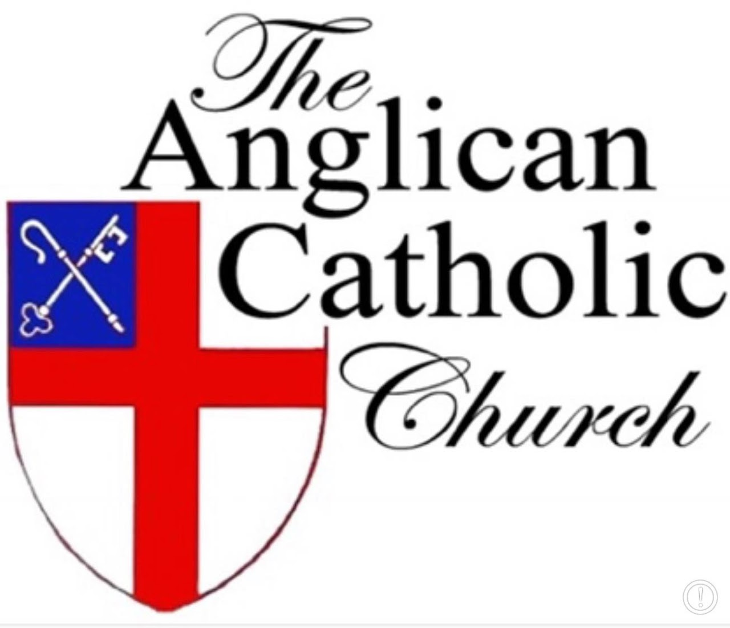

Anglican Catholic Church

Our historical roots extend back to the Church of England, but our more recent origins lie in the religious upheaval of the late-twentieth century. Starting in the 1970s, a number of churches within the Anglican communion began to question and renounce what we consider to be the catholic and apostolic faith. This is why in 1977, an international congress of nearly 2,000 Anglican clergy and lay people met in St. Louis, Missouri, to take the actions necessary to establish an orthodox jurisdiction in which traditional Anglicanism could be maintained. Acting according to the principles determined in the Ecumenical Councils of the ancient Church and adopting initially the name "Anglican Church of North America," they placed themselves under the jurisdiction of the retired Episcopal bishop of Springfield, Illinois, the Right Reverend Albert Chambers. In 1978 at a ceremony in Denver, Colorado, Bishop Chambers expanded that jurisdiction and devolved it upon others by consecrating four more bishops, and the Anglican Catholic Church was born. In decades since, the ACC has spread beyond its North American homeland to most places where the English lanugage and Book of Common Prayer had taken root, and even a few locations where they had not.
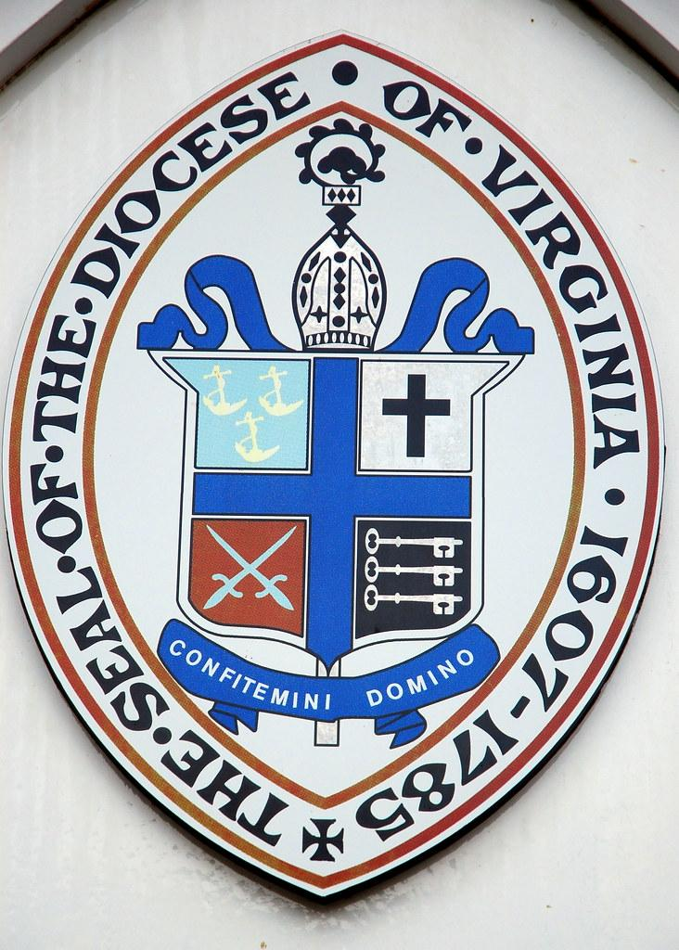

Episcopal Diocese of Virginia

Lay Leader Guidelines and Licenses
Please note: All of these ministries except for Eucharistic Ministers who do not take the sacraments out of the church are required to take some form of Safe Church misconduct prevention training.
- Lay Leader Guidelines
NOTE: Each of the following documents is a fillable form PDF file. In order to complete the form on your computer, you must first save the file on your computer. Once it is saved, you can open and complete the form.
- Catechist – Information & Application
- Eucharistic Minister – Information & Application
- Eucharistic Visitor – Information & Application
- Pastoral Leader – Information
- Preacher – Information & Application
- Worship Leader – Information & Application
Licenses are not required for Lectors who read the Scriptures or for Litanists who lead the Prayers of the People in worship.

