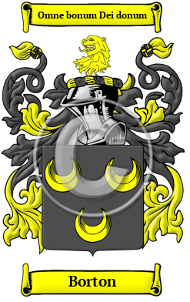

Borton

In ancient Anglo-Saxon England, the ancestors of the Borton surname lived in one of many places called Boughton throughout England. Settlements named Boughton were found in Huntingdonshire, Lincolnshire, Nottinghamshire, and Northamptonshire. Great Boughton is found in Cheshire, and Kent was home to settlements called Boughton Aluph, Boughton Malherbe, Boughton Monchelsea, and Boughton under Blean. The variations of the name Borton include: Boughton, Bourton, Borton, Boughten, Bourten, Borten, Bouton, Broughton, Portan and many more.
In the United States, the name Borton is the 10,387th most popular surname with an estimated 2,487 people with that name

