Blue Ridge Parkway Driving Tour

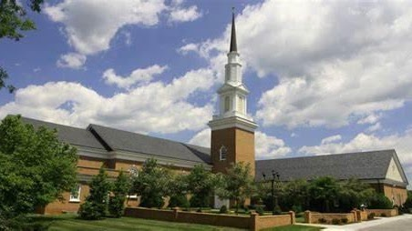

Bedford Baptist Church

Bedford Baptist Church is a traditional church. Located at the foot of the Peaks of Otter in beautiful Bedford, Virginia. Our town is seeped in history as is our church. Bedford Baptist Church was organized in 1797 under the name of Little Otter Baptist Church. In 1854 the Little Otter Baptist Church changed its name to Liberty Baptist Church. In 1901 the Liberty Baptist Church changed its name to Bedford City Baptist Church. In 1923 the Bedford City Baptist Church changed its name to Bedford Baptist Church. We are located at 1516 Oakwood Street.

