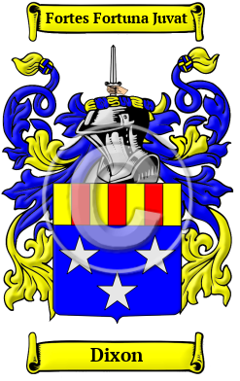
Dixon
The name Dixon originated among the descendants of the ancient Pictish clans. It is derived from son of Dick which is a derivative of the personal name Richard. Dixon include Dixon, Dickson, Dixoun, Dikson, Dyxson, Dyckson, Dicksoun, Dicson and many more.
In the United States, the name Dixon is the 139th most popular surname with an estimated 164,142 people with that name

