References
Baltimore County, Maryland Genealogy • FamilySearch
Baltimore County, Maryland - Wikipedia
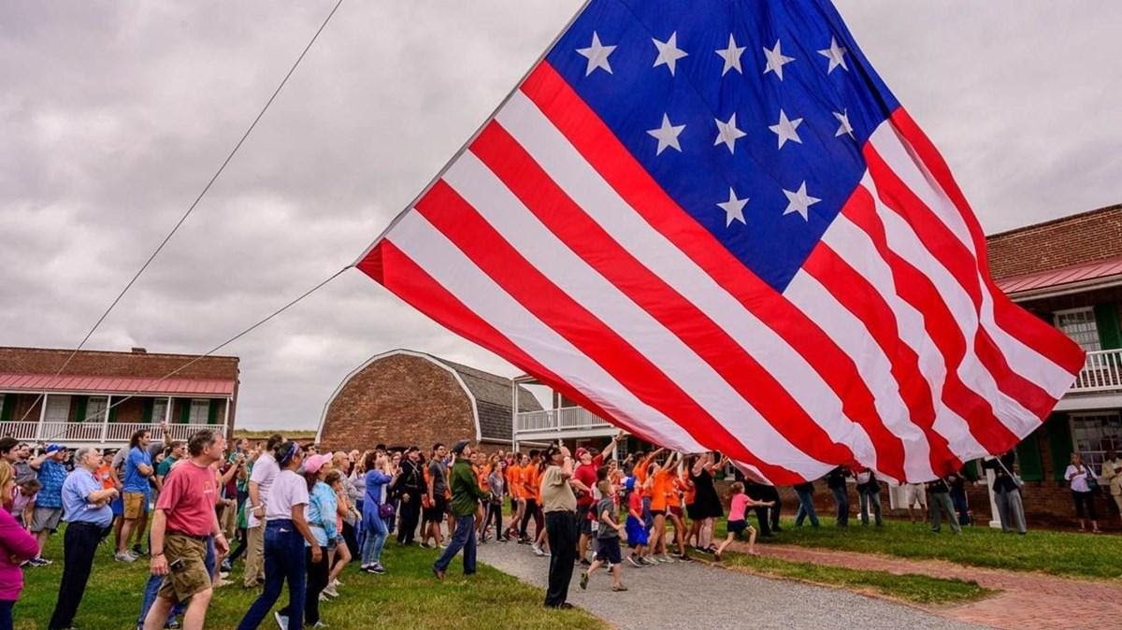

Fort McHenry
Fort McHenry National Monument and Historic Shrine is located at 2400 East Fort Avenue, Baltimore MD 21230.
Flag Change is Saturday mornings at 10 AM

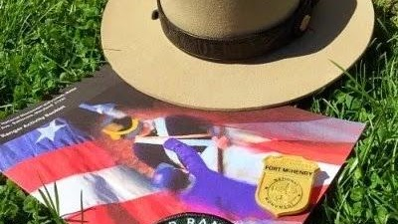
Junior Ranger
Complete Fort McHenry's Junior Ranger activity booklet during your visit and receive an official Junior Ranger badge and certificate! At this time, you can download the booklet or request the booklet by email and mail. Booklets may be available onsite. You can also complete online Junior Ranger books and activities from other parks! Attend a ranger program or assist in changing the morning or evening flag. Every year Fort McHenry hosts the War of 1812 Fife and Drum Camp. Kids ages 11 and up can register for the day camp and learn how to play the fife or drum.

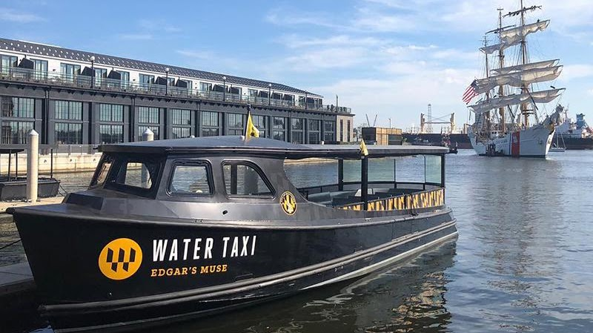
Water Taxi
Hop on board the most exciting way to navigate the sparkling waters of the harbor! The Water Taxi is your ticket to a journey filled with laughter, adventure, and unforgettable scenery. Whether you're a first-time visitor or a seasoned local, there's no better way to explore the many vibrant neighborhoods lining the shoreline. So sit back, relax, and enjoy the ride – your next adventure is just a splash away! Current price is $20 for adults, $11 for kids.

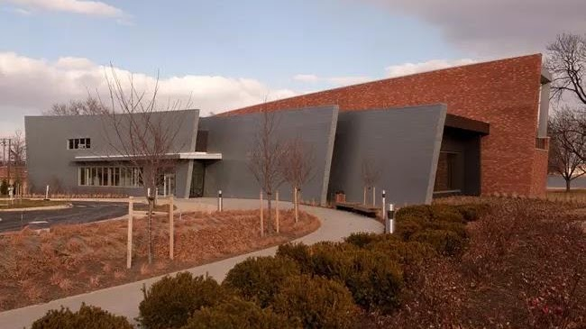
Visitor Center
The Visitor and Education Center is located near the main parking lot and is the best place to start your visit to Fort McHenry. Entrance to the Visitor and Education Center's film and exhibits is free. Admission to the Star Fort can only be purchased at the front desk of the Visitor and Education Center.
Hours
Regular Hours
9:00 am - 4:45 pm
Summer Hours
(Saturday of Memorial Day weekend through Labor Day)
9:00 am - 5:45 pm

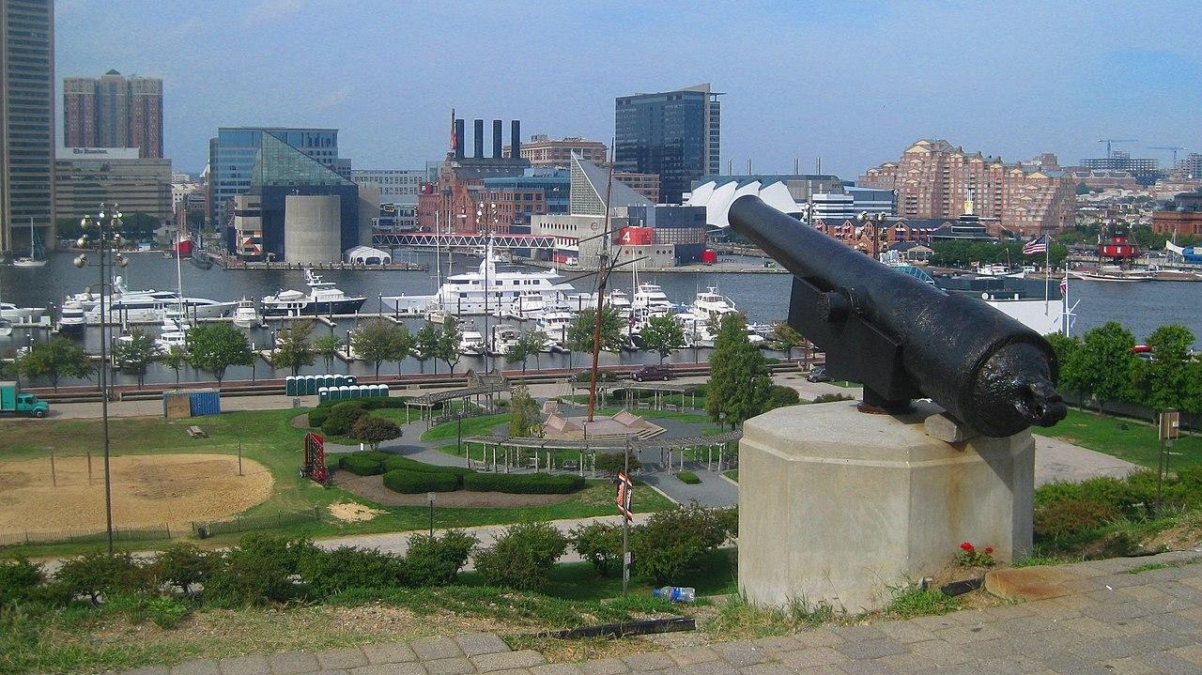
Federal Hill Historic District
Enjoy the spectacular view of downtown while casually strolling through Federal Hill Park or another one of the area’s green spaces like nearby Riverside or Swann. During the warmer months, you’ll almost always find a street fair happening in the heart of the neighborhood surrounding the historic Cross Street Market, a 19th century marketplace with plenty of modern day eats and drinks. Must-sees in Federal Hill include the American Visionary Art Museum and the Baltimore Museum of Industry. Federal Hill is also located right next to Locust Point, where Fort McHenry calls to history buffs. Art aficionados will appreciate the number of independent art galleries in this neighborhood, including School 33 Art Center and Tradestone Gallery.
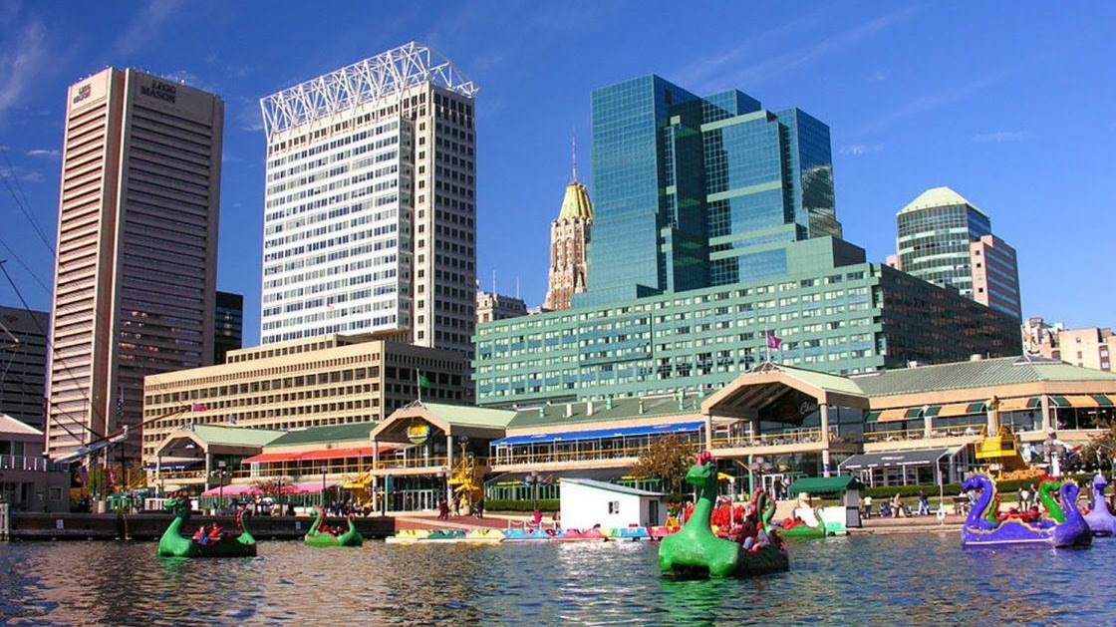

Haborplace
Harborplace is located on the waterfront in the heart of Downtown Baltimore's Inner Harbor. Harborplace features two pavilions located at Pratt Street and Light Street that surround the Harborplace Amphitheatre whose terraced steps provide seating for live performances throughout the year.
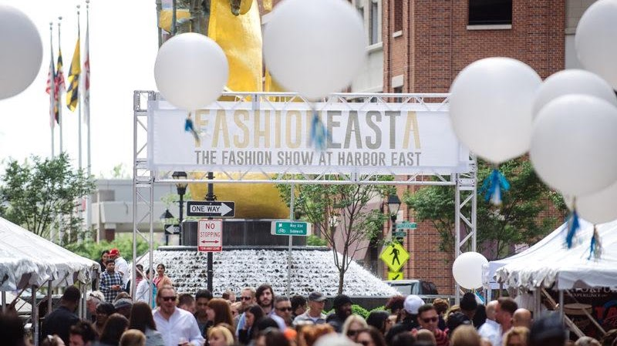

Harbor East
Since 1996, Harbor East has built its reputation as a premier destination for national employers, successful retailers, and sophisticated visitors and residents. Once an area known for its ghosted warehouses dating back to Baltimore’s 19th-century industrial boom, we worked patiently to rebuild this iconic waterfront neighborhood into a beautiful skyline. The vision was accomplished with integrity, persistence, and a genuine desire to thoughtfully elevate Baltimore. It is with these same values we continue our growth.

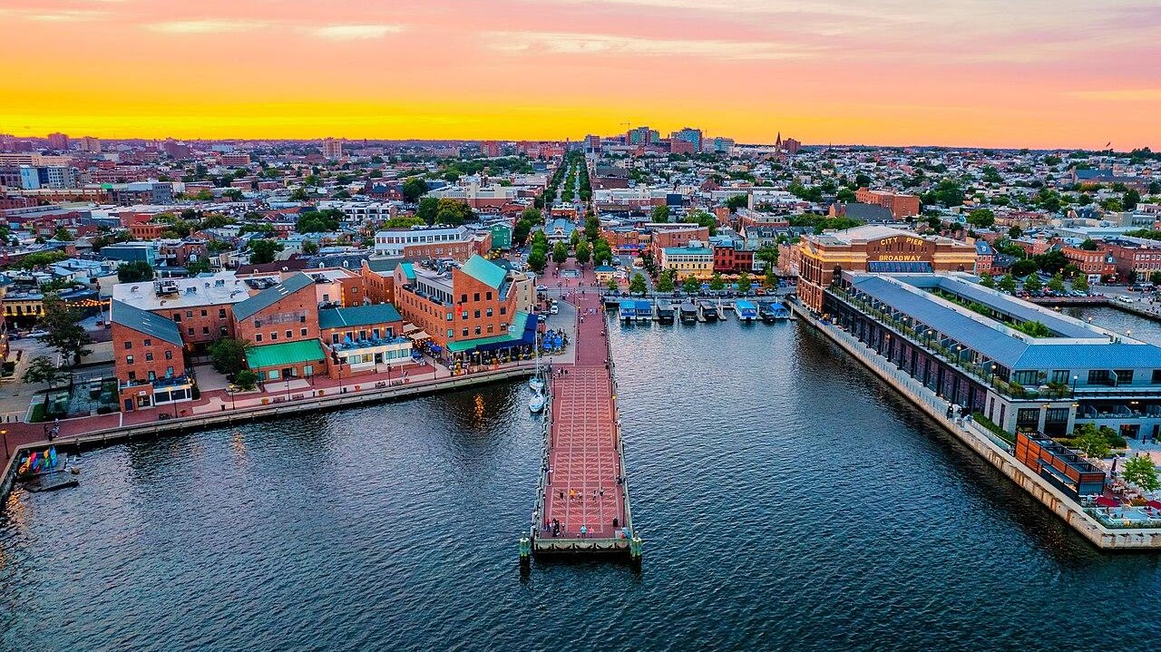
Fells Point
Fell's Point is a historic waterfront neighborhood in southeastern Baltimore, Maryland. It was established around 1763 along the north shore of the Baltimore Harbor and the Northwest Branch of the Patapsco River. The area has many antique, music, and other stores, restaurants, coffee bars, a municipal markethouse with individual stalls, and over 120 pubs. Located 1.5 miles east of Baltimore's downtown central business district and the Jones Falls stream (which splits the city, running from northern Baltimore County), Fells Point has a maritime past and the air of a seafaring town. It also has the greatest concentration of drinking establishments and restaurants in the city.

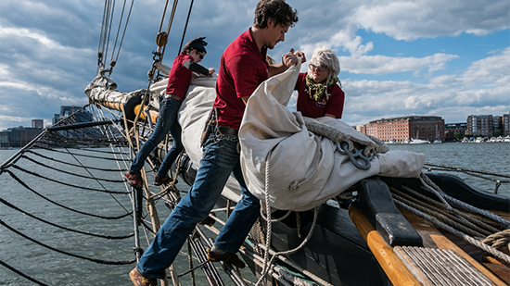
Pride of Baltimore
Cross the gangway and come aboard to learn about Baltimore’s tall ship, Pride of Baltimore II. Explore the deck and talk to her captain and crew. Learn about the history of Baltimore Clippers and Pride II; or hear from a crew member what it is like to sail a tall ship today. Tours are open to guests of all ages. Groups are welcome, too.
If you would like to schedule a private tour, please contact us at 410.539.1151. Accessibility is addressed on a case-by-case basis, so please talk to us ahead of time to be sure we can accommodate your needs.
Please note that dates and times for deck tours are subject to change with short notice.

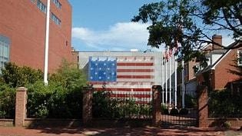
Star Spangled Banner House
The Star-Spangled Banner Flag House is a National Historic Landmark and historic house museum in Baltimore, Maryland. The Museum preserves the historic 1793 structure and interprets the life of Mary Young Pickersgill, a nineteenth-century female entrepreneur and craftswoman of the flag that inspired the National Anthem.

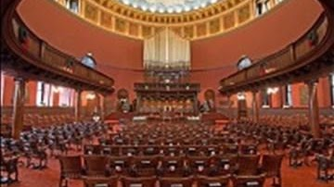

Lovely Lane UMC & Museum
The Original Lovely Lane Meeting House was built in 1774. Ten years later, the Methodist Societies hosted the famous Christmas Conference at Lovely Lane Meeting House, where a new denomination was born: the Methodist Episcopal Church. John Wesley had reluctantly agreed to the American Methodists’ desire to organize their own church. He sent Thomas Coke to supervise the process and to consecrate Francis Asbury as “general superintendent” of the Methodists in America. When Coke and Asbury met at Barrats Chapel in November 1784, Asbury refused the appointment unless the preachers elected him. The meeting was scheduled for the next month, December, at Lovely Lane Meeting House in Baltimore.
2200 St. Paul Street | Baltimore, MD 21218

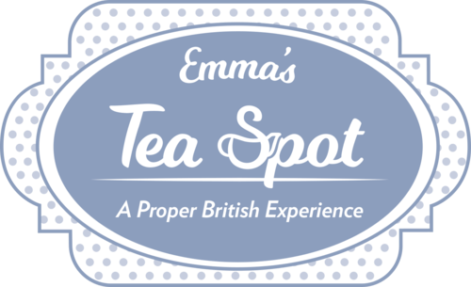
Emma Tea Spot
Emma and Benjamin's dream is to reach a wider audience with the same ethics, reintroducing people to their vital and symbiotic relationship to their environment. Good, clean living practices increase empathy and compassion for our own neighbors and forges deeper and more responsible and meaningful relationships with one another, thereby increasing the integrity in our own lives. Through living and serving you this way, we hope to nurture our community and bring some British hospitality to the charm of Baltimore City. We are committed to Hamilton and Baltimore and hope we can complement the local initiatives by providing clean and sustainable business practices alongside authentic British goods to elevate the soup, salad and sandwich dining experience. We also aim to assist those with a similar interest around the city. Come have a Proper British Experience with us.
5500 HARFORD ROAD HAMILTON, MD 21214
410-444-1718

